ASSESSING BANANA-COFFEE INTEGRATION ON HOUSEHOLD FOOD AVAILABILITY
(A CASE STUDY OF BUWAMA SUB COUNTY)

MPUNGU ISAAC
J22/26/031

A DISERTATION SUBMITTED IN PARTIAL FULFILLMENT FOR THE
AWARD OF BACHLORS OF AGRICULTURAL SCIENCE
AND ENTERPRENURSHIP

2024

DECLARATION
I, MPUNGU ISAAC, do hereby declare that this dissertation is my original work
and has not been presented for an award of a degree in any other university.
MPUNGU ISAAC

Signature: …………………………… Date: …………………………………
This dissertation has been submitted for examination with our approval as university
supervisors
Signature: …………………………… Date: …………………………………

TABLE OF CONTENTS
DECLARATION 2
Acknowledgments 6
List of tables 7
List of figures 8
List of abbreviations 9
ABSTRACT 10
CHAPTER ONE 11
INTRODUCTION 11
1.0 Background Information 11
1.2 Problem Statement 12
1.3 Purpose of study 12
1.4 Objectives of the Study 12
OVERALL Objective 12
Specific Objectives 12
1.7 Research Questions 13
1.8Justification of the Study 14
1.9 Significance of the Study 14
CHAPTER TWO 15
LITERATURE REVIEW 15
2.1 INTRODUCTION 15
2.2 Intercropping and Agricultural Diversification 15
CHAPTER THREE 19
METHODOLOGY 19
2.0 INTRODUCTION 19
3.2 Target Population and Sampling 20
3.3 Research Design 21
3.3 Data Collection and analysis tools 21
3.5 METHOD OF DATA ANALYSIS 23
3.5. Validity and Reliability 23
3.6 Ethical considerations 24
3.10 Summary of the Chapter 24
CHAPTER FOUR 25
RESULT AND DISCUSSION 25
4.0 INTRODUCTION 25
4.1 Response rate 25
4.2 The Socio demographic characteristics of the respondents. 25
4.2.2 Age of respondents: 26
4.2.3 YEARS OF FARMING EXPERIENCE. 27
4.3 FARM AND HOUSE HOLD CHARACTERISTICS 28
4.4 INTERCROP AND NON-INTERCROP 29
4.4.2 Comparative Analysis of Key Farm Characteristics 30
4.4.3 Impact on Household Dietary Diversity Score (HDDS): 31
4.4.4 Yields of the Key Products 31
4.5 Assessment of Banana-Coffee Intercropping on Household Dietary Diversity 33
4.6 Agronomic Practices and Their Influence on Food Availability (objective two) 36
4.6.1 Adoption of Agronomic Practices 36
4.6.2 Adoption of Agronomic Practices by Education Level 37
4.6.2 Agronomic Practices and Crop Yields 37
4.6.3 Impact of Fertilizer Application on Crop Yields 38
4.6.4 Combinations of Agronomic Practices and Their Effect on Yields 38
4.6.4 Agronomic Practices and Household Food Availability 39
Correlation Between Agronomic Practices and Food Availability Indicators 39
4.6.4 Perceived Food Security by Agronomic Practice Adoption 40
4.6.5 Regression Analysis: Impact of Agronomic Practices on HDDS 41
4.7 Challenges Faced by Smallholder Farmers in Adopting Agronomic Practices 42
4.7.1 Prioritization of Challenges by Farmers 42
4.8 Summary of Findings for Objective Two 43
4.9 DISSCUSION 44
CHAPTER FIVE 46
SUMMARY OF FINDINGS, CONCLUSIONS AND RECOMMENDATIONS 46
5.0 INTRODUCTION 46
5.1 SUMMARY OF FINDINGS 46
5.2 Conclusion 47
5.3 Recommendations 48
References 51

Acknowledgments
With a heart full of gratitude, I begin by honouring the Almighty God—my source of life, strength, and purpose. It is through His divine grace that I have reached this milestone. Every challenge overcome and every step forward in this academic journey has been guided by His unending mercy.
To my dearest parents, Mr Ken Kigongo and Mrs Nazziwa Ritah—thank you for your boundless love, tireless sacrifices, and unwavering faith in me. Your dedication to my education, especially through the payment of my tuition and constant encouragement, has been the pillar of my success. I owe this achievement to you.
My deepest appreciation goes to my mentors and supervisors, Dr. Mutyaba Livingstone, whose expertise, patience, and thoughtful guidance shaped this research. Your constructive feedback and support were instrumental from the very beginning to the final draft.
To the lecturers and staff of the AGRICTURAL SCIENCE AND ENTERPERNUSHIP thank you for enriching my academic experience with knowledge, discipline, and inspiration.
I am sincerely grateful to the smallholder farmers of Buwama Sub County, whose cooperation and honest responses provided the foundation of this study. Your voices are the soul of this research.
To my friends and classmates—thank you for the shared late nights, brainstorming sessions, and words of encouragement. You turned challenges into moments of learning and growth.
Finally, to every individual who believed in me, stood by me, or said a prayer on my behalf—thank you. This dissertation is not just a personal achievement, but a celebration of the love and support I’ve been blessed with.

List of tables

Table 4.1: Comparison of Key Farm Characteristics ............................ 21

Table 4.2: Independent Samples T-Test of HDDS................................. 22

Table 4.3: Summary Statistics for Banana Yield ................................. 23

Table 4.4: OLS Regression for Banana Yield...................................... 24

Table 4.5: OLS Regression for Coffee Yield...................................... 25

Table 4.6: Mann-Whitney U Test Results......................................... 26

Table 4.7: Frequency of Key Agronomic Practices ………………................ 27

Table 4.8: Adoption of Agronomic Practices................................... 28

Table 4.9: Average Crop Yields.................................................... 29

Table 4.10: Agronomic Practices and Crop Yields .............................. 30

Table 4.11: Fertilizer Use and Crop Yields........................................ 31

Table 4.12: Combinations of Practices and Yields .............................. 32

Table 4.13: Correlation Coefficients............................................... 33

Table 4.14: Cross-tab of Food Security Perception .............................. 34

Table 4.15: Regression Coefficients for Agronomic Practices ……………....... 35

Table 4.16: Key Challenges Faced by Respondents .............................. 36

List of figures

Figure 1: Map of Buwama Sub County................................... 13

Figure 2: Gender of Respondents......................................... 19

Figure 3: Age Distribution of Respondents............................. 19

Figure 4: Years of Farming Experience .................................. 20

Figure 5: Education Level of Respondents............................. 20

Figure 6: Percentage of Intercroppers Vs Non-Intercroppers......... 21

Figure 7: Distribution of Agronomic Practices ........................ 27

Figure 8: Adoption Rates of Practices .................................. 28

Figure 9: Education Levels and Practice Adoption .................. 29

List of abbreviations

HDDS - Household Dietary Diversity Score
CBI - Coffee-Banana Intercropping
OLS - Ordinary Least Squares
NPK - Nitrogen Phosphorus Potassium (fertilizer)
SPSS - Statistical Package for the Social Sciences
FAO - Food and Agriculture Organization
CCAFS - Climate Change, Agriculture, and Food Security
NGO - Non-Governmental Organization

Meaning of words
Agronomic practices: Scientifically-based agricultural techniques used by farmers to improve soil quality, optimize plant growth, and maximize crop production. These include mulching, pruning, fertilizer application, and soil conservation.
Banana-Coffee Integration (BCI): An agricultural system where banana and coffee plants are deliberately grown together on the same plot of land, creating beneficial interactions between the two crops.
Coffee-Banana Intercropping (CBI): Alternative term for banana-coffee integration, emphasizing the combination of coffee (a cash crop) with bananas (a food crop) in the same field.
Cover Cropping: The practice of planting secondary crops between main crops or during fallow periods to maintain soil cover, add organic matter, and reduce erosion.
Cross-sectional Survey: A research method that collects data from a population at a specific point in time, as opposed to longitudinal studies that track changes over time.
Effect Size: A statistical measure that quantifies the magnitude of the difference between groups or the strength of a relationship between variables, independent of sample size.
Food Availability: The physical presence of food in sufficient quantities, representing one of the four pillars of food security (alongside access, utilization, and stability).
Food Security: A state that exists when all people, at all times, have physical, social, and economic access to sufficient, safe, and nutritious food that meets their dietary needs and food preferences for an active and healthy life.
Household Dietary Diversity Score (HDDS): A proxy indicator of household food access that measures the number of different food groups consumed by household members over a specific reference period, typically 24 hours.
In-situ Soil Conservation: Practices implemented directly in the field to prevent soil erosion and maintain soil quality, such as contour ploughing, terracing, and use of vegetation barriers.
Intercropping: An agricultural practice of growing two or more crops in proximity to maximize land use and create a beneficial interaction between crops.
Monocropping (Monoculture): The agricultural practice of growing a single crop species over a large area, often year after year.
Mulching: The practice of covering soil surface with organic materials (such as banana leaves, grass, or crop residues) to retain moisture, suppress weeds, regulate soil temperature, and add organic matter as it decomposes.
Ordinary Least Squares (OLS) Regression: A statistical method used to estimate the relationship between one or more independent variables and a dependent variable by minimizing the sum of the squares of the differences between observed and predicted values.
Pruning: The selective removal of plant parts (branches, buds, or roots) to improve plant health, shape, growth, and productivity.
Shade Management: The deliberate regulation of shade levels in an agricultural system is particularly important in coffee production where appropriate shade can improve coffee quality and resilience.
Smallholder Farmers: Agricultural producers who operate on a small scale, typically with limited land area (often less than 2 hectares) and primarily relying on family labour.
Sustainable Livelihoods Framework (SLF): A theoretical framework that analyses how different forms of capital (natural, social, human, physical, and financial) interact to influence livelihood outcomes, including food security.
Banana:Coffee Ratio: The proportional allocation of land or plant density between banana and coffee crops in an intercropped system, measured as the relative space or number of plants devoted to each crop.
Soil Fertility: The ability of soil to sustain plant growth by providing essential plant nutrients and favorable chemical, physical, and biological characteristics.
Mann-Whitney U Test: A non-parametric statistical test used to compare differences between two independent groups when the dependent variable is not normally distributed.

ABSTRACT

This study of smallholder farmers in Buwama Sub County, Uganda found that banana-coffee intercropping significantly improved household dietary diversity (HDDS) compared to monocropping (6.45 vs. 4.77, p=0.016), demonstrating the food security benefits of diversified agricultural systems. However, when controlling for factors like farm size and education level, individual agronomic practices (mulching, pruning, fertilizer application) showed no significant direct impact on dietary diversity, suggesting that the integrated farming system as a whole, rather than specific techniques in isolation, drives the observed improvement in household food availability. This highlights the complex, interconnected nature of agricultural systems and food security, where the comprehensive approach of crop diversification appears more influential than any single management practice.

Keywords:
Banana-Coffee Integration, Intercropping, Smallholder Farmers, Food Security, Household Dietary Diversity, Agronomic Practices, Uganda, Agricultural Diversification, Sustainable Agriculture, Food Availability

CHAPTER ONE

INTRODUCTION

Background Information
Food insecurity remains a significant challenge across sub-Saharan Africa, with approximately 278 million people experiencing undernourishment (FAO, 2023). In Uganda, smallholder farmers constitute over 80% of the agricultural sector, with their livelihoods and food security increasingly threatened by climate variability, land fragmentation, and soil degradation (Mugagga et al., 2021). Buwama Sub-County in central Uganda epitomizes these challenges, where population pressures have reduced average landholdings to less than 2.5 acres per household, necessitating innovative farming approaches that maximize land productivity while ensuring food availability (UBOS, 2022).
Banana-coffee integration represents a promising agroforestry system that combines Uganda's principal cash crop (coffee) with its most important food staple (bananas). Recent research has demonstrated the agronomic complementarity of these crops, with banana plants providing shade for coffee while creating beneficial microclimates and soil conditions (Jassogne et al., 2022). According to Kiwuka et al. (2023), this integration potentially addresses multiple challenges simultaneously: enhancing food availability through on-farm production of energy-dense staples, generating income through coffee sales, and improving climate resilience through sustainable agroecological principles.
The intersection of agricultural diversification and food security has gained scholarly attention, with Teklewold and Mekonnen (2022) establishing significant correlations between crop diversification indices and household dietary diversity scores across East Africa. Their meta-analysis found that integrated farming systems consistently outperformed monocropping in both productivity and nutrition indicators. Similarly, Lukuyu et al. (2024) documented how intercropped systems improved both productivity and household nutrition outcomes when compared to non-diversified farming approaches.
However, context-specific analyses remain essential, as adoption of integrated farming systems is influenced by local socio-economic factors, agroecological conditions, and cultural preferences. Nabimanya and Mpiira (2023) reported that while 62% of smallholder farmers in Uganda's central region acknowledged the benefits of banana-coffee integration, only 31% had implemented these systems, citing knowledge gaps, resource constraints, and market uncertainties as barriers. The transferability of research findings from other regions to Buwama Sub-County cannot be assumed without careful empirical investigation.
Research on banana-coffee integration has primarily focused on yield dynamics, soil fertility impacts, and economic returns (Ssebulime et al., 2023). Less attention has been given to measuring how these systems specifically influence household food availability—a critical food security dimension encompassing both production and access dimensions (Renzaho & Mellor, 2022). This gap is particularly pronounced in areas like Buwama Sub-County, where approximately 45% of households experience seasonal food shortages despite agricultural potential (Mpigi District Local Government, 2023).
The potential of banana-coffee integration to enhance household food availability operates through multiple mechanisms. Bananas provide year-round harvests with minimal seasonality, offering a consistent caloric foundation when cereal crops may be unavailable (Weltzien & Andersson, 2023). Meanwhile, coffee income can facilitate purchasing of additional food items, potentially increasing dietary diversity (Wasswa et al., 2022). The complementary nature of production and market-oriented farming within a single system may optimize resource use efficiency, particularly important in land-constrained environments like Buwama (Kagezi et al., 2023).
Understanding the specific pathways through which banana-coffee integration affects household food availability requires consideration of agronomic practices. Research by Mulumba and Kalanzi (2024) demonstrated that adoption of practices like mulching, pruning, and appropriate spacing significantly influenced both yield outcomes and sustainability of integrated systems. Their findings suggest that the food security benefits of integrated systems are highly contingent on implementation quality rather than mere adoption of the system.
Recognizing these knowledge gaps, this study seeks to empirically assess the relationship between banana-coffee integration and household food availability in Buwama Sub-County. By examining both the direct production contributions and the indirect income effects of this farming system, the research aims to provide evidence-based insights for agricultural extension services, food security interventions, and rural development initiatives in comparable contexts. This investigation is particularly timely as Uganda's agricultural sector grapples with climatic uncertainties, land pressure, and market volatilities that threaten both food security and livelihood sustainability among smallholder farming communities (Naikoba et al., 2024).

1.2 Problem Statement
In Buwama Sub-County, Uganda, 45.3% of households experience seasonal food shortages for 3-4 months annually, with child stunting rates at 29.4% (Mpigi District Health Survey, 2023), despite favorable agricultural conditions. The fundamental problem is a disconnect between farming practices and food security outcomes, with farmers tending toward either coffee monoculture or subsistence food crops. While banana-coffee intercropping offers potential benefits, adoption remains limited at just 18% (MAAIF, 2023), even as neighboring districts show integrated systems yielding 50-70% higher returns per unit area (Ssebulime et al., 2023). This occurs amid shrinking landholdings (averaging 2.43 acres) and increasing climate variability.
Significant knowledge gaps persist regarding how banana-coffee integration specifically impacts household food availability in Buwama's unique context. Research by Nakabonge et al. (2024) shows that 67% of coffee-focused farmers report inadequate food availability, while 58% of food crop-focused farmers struggle with insufficient income for purchasing additional food. The absence of locally-relevant evidence on the pathways, management practices, and potential trade-offs in banana-coffee systems hampers effective agricultural extension services and evidence-based policy development, ultimately perpetuating food insecurity in a region with substantial agricultural potential.

1.3 Purpose of study
The major aim of this research is to identify the role of banana-coffee intercropping on household food availability in smallholder farmers in Buwama Sub County. Through examining how this system of intercropping affects yields of bananas and household food consumption patterns, this study hopes to discover the agronomic activities carried out by farmers and their suitability in promoting food security. The study intends to deliver tangible insights to maximize intercropped system optimization, eventually leading to food availability and sustainability enhancement in the area.

1.4 Objectives of the Study

OVERALL Objective
To investigate how integrating bananas into coffee farming systems enhances food availability for smallholder farmers in Buwama sub county
Specific Objectives
To investigate the contributions of banana-coffee integration on household food availability.
To analyse agronomic practices used in banana-coffee intercropping and their Influence on household food availability

1.5 Research Questions
How does banana-coffee integration affect the yield and consumption patterns of bananas among smallholder farmers in Buwama Sub County?
How agronomic practices used by smallholder farmers in the banana-coffee integration systems, influence household food availability in Buwama Sub county

1.6 Conceptual frame work
DEPENDENT VARIABLE
Food availability
Household dietary score
Crop yield
INDEPENDENT VARIABLE
Banana- coffee integration
Agronomic practices

MEDIATING VARIABLE
House hold characteristics
Education levels
Household size

House hold six

The study on mixing banana and coffee farming in Buwama Sub County examines how various factors affect food availability for families. It shows how growing bananas and coffee together, along with practices like mulching and fertilizing, can lead to more varied diets and better crop yields. The study also looks at how household factors, such as family size and education, as well as environmental aspects like soil health and weather patterns, affect farm productivity. The main focus is on measuring household food availability using the Household Dietary Diversity Score (HDDS) and overall crop production. The aim is to demonstrate that combining crops and using sustainable methods can improve food security and strengthen small farmers' resilience in the area.

1.7Justification of the Study
The study on assessing banana-coffee integration in Buwama Sub County is justified because it addresses critical issues of food availability and sustainable farming practices among small-scale farmers. By exploring how Coffee-Banana Intercropping (CBI) affects household food availability, the research aims to fill existing knowledge gaps and provide real-world data that can guide targeted interventions and policy decisions. The findings will highlight the farming benefits of CBI, such as improved soil health and increased yields, while also offering practical recommendations for economic diversification and resilience against market fluctuations. Ultimately, this study seeks to contribute to the broader discussion on improving food security and promoting sustainable farming practices in rural Uganda.

1.8 Significance of the Study
This study is important because it helps us understand how growing bananas and coffee together affects food availability for small-scale farmers in Buwama Sub County. By investigating how this mixed farming approach influences the variety of foods families eat (measured by the Household Dietary Diversity Score), the research provides valuable insights into sustainable farming practices that can improve food security and nutrition in rural communities. The findings emphasize the importance of promoting intercropping as a practical strategy for small farmers, which may help them better withstand food shortages and economic uncertainties. Furthermore, the study highlights the need for more research to identify best practices that maximize food security in today's farming environment, thereby supporting policy recommendations aimed at improving the lives of small-scale farmers.

CHAPTER TWO

LITERATURE REVIEW

2.0 INTRODUCTION
This chapter reviews existing literature on banana-coffee intercropping (CBI) and its impact on household food availability, with a focus on smallholder farmers. The review is organized thematically to address agronomic benefits, economic impacts, food security contributions, and challenges of adoption. It also identifies gaps in the literature, particularly regarding the role of CBI in addressing food shortages in Buwama Sub County.

2.1 Intercropping and Agricultural Diversification
Intercropping is when farmers grow two or more crops together on the same land. This way of farming helps use the land efficiently and boosts productivity. It also reduces the risk of losing all crops, a common problem with single-crop systems, and ensures food is available throughout the year (Okonya et al., 2018). For instance, combining coffee and bananas is effective. Bananas provide quick food, while coffee offers a longer-term income. This combination stabilizes both the food supply and income for families, which is crucial for ensuring food security.
Despite the known benefits of diversification, we lack information on how intercropping affects the variety of foods in a household diet—a key measure of food security. The Household Dietary Diversity Score (HDDS) measures the different food groups a household consumes over time. However, the relationship between HDDS and intercropping is not well-studied at national or local levels. Intercropping is a useful strategy to manage risks and ensure food is available year-round. However, more research is needed to understand how it impacts HDDS or food consumption at the household level, especially in Uganda.
2.2 Empirical Evidence on Banana-Coffee Integration
Empirical research on banana-coffee integration specifically has grown substantially over the past decade. Okonya et al. (2018) found that intercropping in Uganda contributes to both livelihood diversification and ecological resilience, with their survey of 180 households across three districts showing significant associations between crop diversification and reduced seasonal food shortages. This aligns with findings from van Asten et al. (2011), whose study in central Uganda documented that banana-coffee systems yielded 50% higher returns per hectare than monocropping.
Recent work by Ekong et al. (2021) in eastern Uganda identified that 73.9% of farmers practicing banana-coffee intercropping reported improvements in both food access and income stability. However, they also noted significant regional variations, with benefits being more pronounced in areas with higher rainfall reliability—a finding that raises questions about the system's universal applicability across Uganda's diverse agro ecological zones.
Most studies on intercropping in Uganda have focused primarily on productivity or aggregate income, with minimal investigation of how these translate to household-level food security outcomes. While productivity gains are well-documented, the pathways through which these affect food consumption patterns, dietary diversity, or nutritional status remain understudied. As Sibhatu et al. (2015) argue in their cross-country analysis, the relationship between farm diversity and dietary diversity is neither simple nor universal, suggesting the need for more nuanced studies of specific intercropping systems like banana-coffee.
Research specifically in Buwama Sub County is particularly limited. The district agricultural report (MAAIF, 2021) indicates that only 18% of farmers in the area practice banana-coffee intercropping, despite its potential benefits. This low adoption rate suggests underlying constraints that require further investigation within the specific socioeconomic and agro ecological context of Buwama. Research shows that planting more than one crop in the same field, known as intercropping, can help with farming and reduce risks. In Uganda, combining banana and coffee plants has certain advantages. However, there are still many things we don’t fully know. Firstly, while intercropping is known to improve crop growth, it's not clear how this affects family food choices and nutrition. Secondly, because different regions have their own unique conditions, it's necessary to conduct area-specific studies. For instance, Buwama Sub County in Uganda has its own special features that need more attention from researchers. Lastly, some experts believe that crops might compete with each other for resources, so further research is necessary to understand both the advantages and possible downsides of growing bananas and coffee together.

2.3 Agronomic Benefits of Banana-Coffee Intercropping
Banana and coffee can be grown together, offering numerous advantages. In 2019, a study led by Adu-Gyamfi showed that banana plants provide valuable shade for coffee plants, which helps keep them cool and reduces stress. In Tanzania, coffee plants shaded by bananas had 43% less heat damage to their leaves during hot weather compared to coffee plants exposed to direct sunlight. Similar benefits were observed in Uganda over three years by Rahn and others in 2018, where coffee plants grown with bananas were better able to handle challenging weather conditions in the Rakai District.
Beyond just controlling temperature, there are other benefits to growing bananas and coffee together. In 2012, research by Mulumba and colleagues found that fallen banana leaves significantly improve soil quality. Their study showed that areas with both bananas and coffee had 23% more soil organic carbon than areas with only coffee in central Uganda. This increase in organic matter helps create a natural cycle that maintains soil fertility, as described by van Rikxoort and colleagues in 2011, potentially reducing the need for chemical fertilizers if managed well.
Moreover, the root systems of bananas and coffee complement each other nicely. Chianu and others discovered in 2020 that banana plants typically have deeper roots, around 0.5 to 1.2 meters deep, whereas coffee plants have shallower roots, mainly between 0.2 to 0.5 meters. This difference means they don't compete much for water and nutrients in the soil. However, during times of drought, both plants might draw water from the same soil layers, which can reduce the advantages of having different root depths.
2.4 Key Farming Practices in Mixed Systems

Effective farming techniques are crucial to boost the productivity of banana-coffee farming systems. Research in central Uganda by Kalanzi and Nansereko (2014) identified several key practices: using mulch, pruning plants, and applying fertilizers are essential for maintaining productivity in these mixed farms. Their study of 120 farms showed that regular mulching resulted in 34% higher banana yields. Proper pruning also increased coffee yields by 26% compared to farms that did not use these practices.
The arrangement and division of crops play a vital role. The National Coffee Research Institute suggests a banana-to-coffee ratio of 1:1 to 3:1, based on goals. More bananas can enhance food security, while more coffee can increase income (MAAIF, 2018). Despite these guidelines, there's limited research on their effectiveness in specific areas, like Buwama, where different soil and weather conditions might require unique strategies.
Managing soil fertility is a challenge in mixed systems. Mulumba et al. (2012) reported improvements in organic matter, but also found that intercropping depletes nutrients, especially potassium, faster. Thus, despite benefits from organic materials, additional inputs may be needed to maintain sustainability. Long-term studies by Wairegi and van Asten (2013) in southwestern Uganda confirmed that without proper fertility management, yields in banana-coffee systems declined after about four years. Okech et al. (2021) emphasized the need for tailored soil fertility approaches. They found that when farmers adapted nutrient application and crop spacing, resilience to drought and pests improved in central Uganda.

Intercropping bananas and coffee offers many benefits, such as regulating the microclimate, enhancing soil fertility, and complementary root systems. Essential practices—like mulching, pruning, spacing, and managing soil fertility—are critical for gaining these advantages. However, challenges exist, like competition between plants and decreased yields without proper management. Knowledge gaps remain, including how broadly applicable general recommendations are to specific locations like Buwama, the shifts in yield patterns over time, and whether these systems can endure under changing climate conditions.
2.4 ECONOMIC IMPACTS OF BANANA-COFFEE INTERCROPPING
The banana-coffee system helps farmers manage financial risks by providing income at different times—bananas give quick returns, while coffee yields long-term profits. According to Farming First (2016), this dual-income model helps households with little extra income. In Uganda, CBI systems can earn up to $10,000 more per hectare each year compared to single-crop farming (CGIAR, 2020), particularly when banana yields are high.
Banana shade enhances coffee quality, raising its market value (Ekong et al., 2021). However, farmers often face challenges accessing markets. Jassogne et al. (2013) point out that small farmers lack the infrastructure and stable prices needed to fully benefit from CBI. This issue is notable in districts like Mpigi, where poor roads and few collection centers limit profitability.
Sub-section Summary: CBI has clear economic advantages, particularly in managing risks and improving crop quality. Nevertheless, limited market access can restrict these benefits. Economic gains do not automatically improve food availability unless additional income is used for purchasing food or farm enhancements.
2.5 Contributions to Household Food Security
Intercropping bananas and coffee helps ensure household food security by increasing farm food production and providing income to buy other essentials. Bananas are available all year and offer a reliable food source when coffee production drops or market prices are low (van Asten et al., 2011). Research by Ekong et al. (2021) found that 73.9% of farmers using CBI in Uganda reported benefits in both food and income.
Income from coffee sales allows households to purchase a variety of foods, potentially improving HDDS. However, few studies directly link CBI to better-quality diets or increased food availability, particularly in areas like Buwama.
Sub-section Summary: Intercropping bananas and coffee supports direct food access and generates income for food purchases. However, there is limited evidence on its impact on household dietary diversity or food sufficiency in specific local areas.
2.6 Obstacles to Banana-Coffee Integration
Combining banana and coffee farming offers many benefits, but farmers face several challenges that make it difficult to adopt this practice.
Technical Barriers
Farmers often lack knowledge and skills in planting bananas and coffee together effectively. Understanding how to maintain healthy soil for both crops is essential but not widely known among farmers.
Socio-Economic Issues
There is a shortage of labor, making it hard for farmers to manage both crops. Additionally, accessing fertilizers and tools is limited, and purchasing high-quality seedlings is often too expensive for many farmers.
Institutional Barriers
Support systems such as training and agricultural guidance are weak or insufficient. Farmers do not receive the necessary assistance to learn and implement intercropping techniques effectively.
Cultural Barriers
Traditional farming methods, which focus on growing a single type of crop, are deeply rooted in some farming communities. This mindset makes farmers wary of trying new intercropping methods, which they may view as risky or unfamiliar.

Fluctuations in market prices for bananas and coffee also contribute to farmers' reluctance to invest in intercropping practices.
A variety of factors make it challenging for farmers to adopt banana-coffee intercropping. Addressing technical, market, and cultural obstacles is crucial to encouraging this practice, especially in places like Buwama.
2.7 Research Gap
The current research on growing bananas and coffee together offers useful insights, but some key questions remain, especially about how this affects family food supply in Buwama Sub County.
Firstly, there’s plenty of information on how mixing banana and coffee crops can boost production and income. However, few studies have examined the actual impact on family food security using measures like HDDS. Most research focuses on production or income rather than how these crops improve food access for families. More so we lack understanding of how food availability varies throughout the year in these mixed crop systems. Uganda faces significant challenges with food shortages during certain seasons, yet little research has explored how banana-coffee farming affects food availability during these "hunger seasons. Also more attention needs to be given to how specific farming practices influence food security in banana-coffee systems. While techniques like using mulch, pruning, and applying fertilizers can affect crop yield, their impact on the amount of food available to families is not well-documented.there is a shortage of research focused on Buwama Sub County. While banana-coffee farming shows benefits in other regions, only 18% of Buwama's farmers have adopted it. This suggests unique local factors like environment, economy, and culture that need further study.studies have overlooked variations in outcomes for different types of families. The advantages and limitations of banana-coffee farming can vary significantly based on resources, gender roles, and opportunities for other sources of income. This diversity among households has not been fully explored.
This study aims to address these gaps by examining the link between banana-coffee farming, specific farming practices, and food availability in Buwama Sub County. By focusing on food security outcomes, this research will provide valuable insights for initiatives aimed at improving food security through agricultural development.
Chapter Summary
This review explores what we know about growing bananas and coffee together and its impact on the amount of food available to families, especially for small farmers in Uganda. The review provides strong evidence that this type of farming boosts crop growth, increases income, and improves food security. However, it also points out some challenges and areas where more information is needed.
The main findings include: Bananas and coffee grown together can improve crop growth and resistance because they support each other; Specific farming methods are needed to achieve these benefits; Intercropping offers financial benefits, such as higher combined earnings and reduced risk; This farming approach can boost food security in multiple ways, like direct food production, income changes, and improved resilience; and There are various obstacles to adopting this method, including technical, social, institutional, and cultural issues.
This study seeks to address these knowledge gaps by examining how integrating bananas and coffee affects food availability for households in Buwama Sub County. It will look at both the overall food security situation and the role of particular farming methods. By focusing on food consumption rather than just production or income, the research will provide valuable information for agricultural development efforts to enhance food security in this crucial agricultural area of Uganda.

CHAPTER THREE

METHODOLOGY

INTRODUCTION
In this chapter, we have planned methods to match our research goals. We use a mixed-methods approach to study how banana-coffee farming affects household food provided. We use structured questionnaires to measure important things like the Household Dietary Diversity Score (HDDS) and crop yields. This shows us how farming both bananas and coffee impacts food availability for small farmers. We also gather detailed information by talking with farmers through interviews and watching their farming methods. This helps us understand the techniques they use and if these can improve food security. These combined methods help us explore how adding banana plants to coffee farms could improve food availability in Buwama Sub County. The goal is to give better insights into sustainable farming in the area.

3.1 Description of study area
Buwama is located in the central part of Uganda as marked in red in picture below
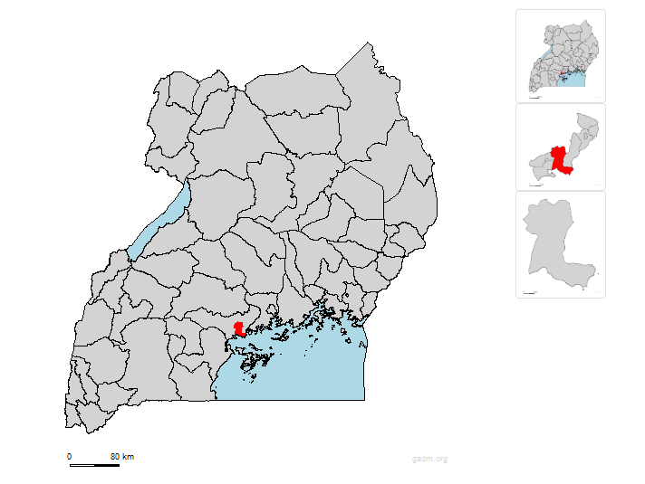
Figure 1: Map of Buwama and Its Location in Uganda (Source: UBOS).
The study takes place in Buwama Sub County, Central Uganda. The area has smallholder farming systems based on coffee (a cash crop) and bananas (a staple food crop). The area suffers from challenges like land shortage, unreliable rains, and soil degradation, coupled with food insecurity, and thus presents a perfect case to study intercropping systems. Nestled in Uganda's Central Region, Buwama Sub County is a thriving part of the Mpigi District. Geographically, it sits along the well-traveled Kampala-Masaka Road southwest of the main town in the district, Mpigi. It's about 71 kilometers southwest of Kampala, Uganda's busy capital. With Buwama town itself at an average elevation of roughly 1,185 meters above sea level, the terrain here is marked by soft undulations. A growing population calls this sub-county home. With an estimated 61,600 residents projected for 2023, this figure is probably going to have somewhat changed as we enter 2025. The people living here participate actively in different kinds of economic activities; agriculture is a pillar among them.

3.2 Target Population and Sampling
Target Population and Sampling Strategy
Target Population: Two groups of 50 smallholder farmers split out from Buwama
Sub County: 27 farmers intercropping banana-coffee: 23 mono crop farmers—that is, either coffee or bananas.
The study guarantees balanced representation of intercroppers and monocroppers by means of stratified random sample. Whereas random selection reduces bias and improves generalisability, stratification is based on farming methods—intercropping vs. monocropping.
Sample Size Calculation:
The sample size was determined using Cochran’s formula, adjusted for the finite population size of 50 farmers:
Step 1: Cochran’s Formula for Large Populations
$$n_{0}=\frac{Z^{2}⋅p⋅q}{e^{2}}$$
Where:
  - $ Z = 1.96 $ (95% confidence level).
  - $ p = 0.5 $ (maximum variability).
  - $ q = 1 - p = 0.5 $.
  - $ e = 0.05 (margin of error).
- Substituting values:
$$n_{0}=\frac{(1.96)^{2}⋅(0.5)⋅(0.5)}{(0.07)^{2}}=\frac{3.8416⋅0.25}{0.0049}=\frac{0.9604}{0.0049}=196$$
Step 2: Adjusting for Finite Population Size
For a finite population ( N = 65 ), the sample size is adjusted using the finite population correction formula
$$n=\frac{n_{0}}{1+\frac{n_{0}-1}{N}}$$
Substituting values:
$$n=\frac{196}{1+\frac{196-1}{65}}=\frac{196}{1+\frac{195}{65}}=\frac{196}{4}=49.8$$
Step 3: Rounding Up for Feasibility
To ensure sufficient representation and account for potential non-responses, the sample size was rounded up to 50 respondents.

3.3 Research Design
This study adopted a descriptive research design, which is suitable for examining current conditions and generating inferences about the broader population. According to Cooper and Schindler (2013), descriptive research allows for accurate and systematic data collection, analysis, and interpretation.
The study utilized quantitative analysis to identify relationships among key variables, while allowing some flexibility in data collection through mixed-methods. The primary tools for data collection were structured questionnaires.

3.3 Data Collection and analysis tools
3.3.1 Quantitative Data Collection
Structured Questionnaires: These were administered in person to collect information on demographics (e.g., age, gender, education level), farming practices (land use, intercropping duration), yields (banana tons/acre, coffee kg), income (percentage spent on food), and food security indicators such as Household Dietary Diversity Score (HDDS).
3.3.2 Qualitative Data Collection
A. Field Observations: Field visits were conducted to directly observe planting patterns, soil quality, and crop health. These observations served to validate self-reported data from the questionnaires.
B. Semi-Structured Interviews: In-depth interviews were conducted with selected farmers to explore their experiences with intercropping, challenges faced (e.g., labor costs), and climate adaptation strategies.
C. Open-Ended Questions: Questionnaires also included open-ended questions that captured farmers’ insights and suggestions, providing further qualitative context.
3.3.3 Data Analysis
Quantitative Analysis: Data was analyzed using SPSS version 16. Descriptive statistics (frequencies, means, and standard deviations) summarized key variables such as HDDS scores and yields. Inferential statistics were also applied:
- Independent t-tests/ANOVA: Compared yields and incomes between intercroppers and monocroppers.
- Chi-square tests: Assessed relationships between categorical variables such as education and intercropping practices.
- Multiple regression: Used to identify predictors of household food availability
Qualitative Analysis:
- Thematic Coding: Responses from interviews and open-ended questions were coded to identify recurring themes such as “market access” and “climate resilience.”
- Triangulation: Information gathered through interviews, questionnaires, and observations was cross-validated to enhance the reliability of findings.
2. On-the-Ground Insights & Farmer Perspectives
To get a real sense of what was happening on the farms and to double-check the information we gathered through questionnaires, we also used two key approaches:
- Direct Observation in the Fields:
We went out to the farms ourselves to take a close look at things like how the plants were spaced, the quality of the soil, and the overall health of the crops. This direct observation helped us confirm what farmers had told us in the questionnaires.
B. Talking Directly with Farmers (Qualitative Data Collection):
In-Depth Conversations (Semi-Structured Interviews): We sat down with a number of farmers to have more detailed discussions. We wanted to understand the advantages they saw in planting different crops together (intercropping), the difficulties they faced (like the cost of labor), and the ways they were adapting to changes in the climate.
Open-Ended Questions in Surveys: Our questionnaires also included questions that allowed farmers to share their own ideas and give us more background information about how they farm. This helped us capture their unique experiences and suggestions

3.5 METHOD OF DATA ANALYSIS
The data collected from the returned seventy questionnaires was cross checked for data quality and completeness. Quantitative data was then analysed using statistical package for social science (SPSS) version 16 to generate descriptive statistics which included frequency distributions and measures of central tendencies. The software generates frequency tables and measures of central tendencies and it computes several measures that ensure that multicollinearity is identified and where possible, eliminated. SPSS can analyze data in a way that makes it easy to present and interpret the results. Qualitative data was derived from analysing the narrative responses of the open-ended questions.
A multiple regression model was generated and used to analyse the data at 0.05 two tailed level of significance test (p-value). Multiple regressions are commonly used to explore relationships between one dependent variable against several independent variables. It is an appropriate measurement tool because it is able to show how the dependent variable is influenced by multiple independent variables. Multiple regression also assesses the level of significance of contribution of an independent variable to the variance of the dependent variable and it generates linear multiple regression equations that give the relationships between the variables.

3.5. Validity and Reliability
Content Validity: The research instruments were reviewed by agricultural experts at Uganda Christian University to ensure that they accurately captured the constructs being studied.
Pilot Testing: A pilot study was conducted with a small group of farmers from outside the sample to test clarity and consistency. The survey demonstrated acceptable internal reliability, with a Cronbach’s alpha of 0.78.
Triangulation: The combination of multiple data sources (questionnaires, interviews, observations) improved the credibility of the findings.

3.6 Ethical considerations
Ethical considerations informed each phase of the research process
All participants were explained the purpose of the study prior to giving informed consent.
It ensured confidentiality by anonymising responses when conducting analysis.
Prior to data collection, ethical clearance was obtained from Uganda Christian University’s Institutional Review Board.
This mixed-methods approach, with its meticulous nature, offers a robust system to examine banana-coffee intercropping's effect on household food availability in Uganda's Buwama Sub County. Through balancing statistical accuracy with contextual depth, it yields actionable insights into agricultural practices in the area capable of informing practices that are sustainable in nature
3.10 Summary of the Chapter
The researcher collected data using questionnaires and analyzed using statistical measures of central tendencies. A multiple regression was used to analyse the relationships of both the independent and the dependent variables. The research instrument was validated though verification piloting with some of the targeted respondents.

CHAPTER FOUR

RESULT AND DISCUSSION

4.0 INTRODUCTION
The results of a thorough research aiming at examining the influence of banana-coffee integration and related agronomic practices on household food availability among smallholder farmers in Buwama Sub County are presented in this chapter. This study mostly aims to evaluate how particular farming techniques and intercropping affect the Household Dietary Diversity Score (HDDS), a crucial metric of food security and nutritional suitability. Based on quantitative data gathered from a varied sample of smallholder farmers, the study offers understanding of their farming methods, household traits, and dietary patterns.
The results are organised so that descriptive statistics summarising the respondents' demographic and agricultural profiles are presented first. After that, inferential statistical analyses are carried out to assess the yield outcomes linked to various farming practices and investigate the connections between banana-coffee intercropping and HDDS. The purpose of this chapter is to clarify the possible advantages of diversified farming systems, especially with regard to increasing food security and dietary diversity in rural households. The results will add to the larger conversation about sustainable farming methods and how they can help alleviate food insecurity in underdeveloped areas.

4.1 Response rate
The study targeted a sample size of 66 respondents from buwama. The response rate was 87% as 58 questionnaires were duly answered and returned for analysis. The researcher considered the response rate adequate for analysis and drawing of conclusions.
4.2 The Socio demographic characteristics of the respondents.
The researcher investigated the socio-demographic characteristics of the respondents to
establish their level of comprehension of the questions and obtain responses for analysis in
the study as follows:
4.2.1 Sex of respondents
The research sought to establish the Male: Female ratio in order to identify any gender
specific attribute in relation to access to and use of agricultural information in the county as shown in figure 2
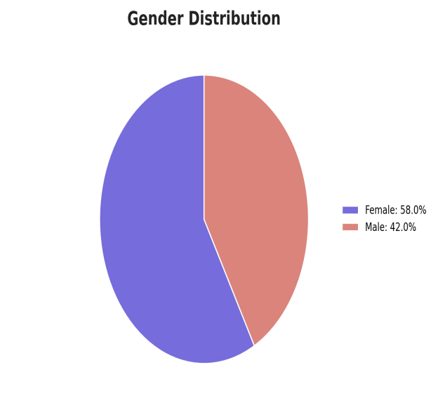
Figure 2: shows Percent Male: Female Ratio of Respondents
Among the 58 people who took part in the survey, 42% were men and 58% were women, indicating a well-balanced gender representation. This balance aligns with the goals set by the Uganda Gender Policy of 2021. The policy stresses the importance of having at least one-third participation by either men or women in development programs. This ensures that both genders have equal opportunities to be involved in agricultural research and activities, promoting inclusivity and equity.
4.2.2 Age of respondents:
The researcher sort to know the age groups of the respondents in order to understand the
length of exposure and experience they may have acquired while accessing and using
agricultural information through traditional (analogue) or ICT (digital) means while
schooling and working in the extension service as indicated in figure 3 below:
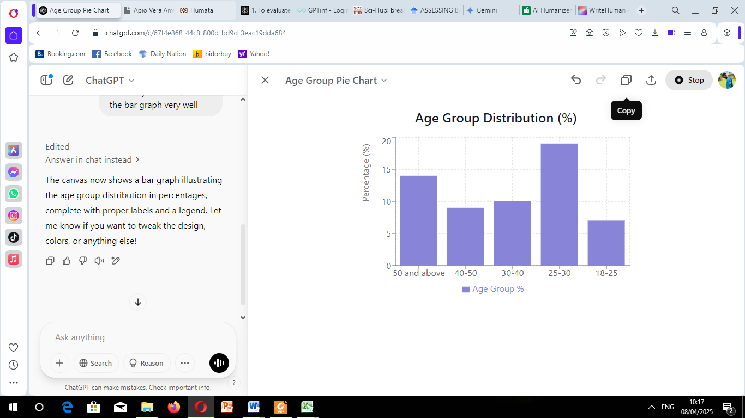

Figure 3: Percentage age Brackets of Respondents
The study found that 29.3% (19) of respondents were in the 25–30 age range, and 21.5% (14.5%) were in the 50+ age range. 15.4% (10) of the respondents were in the 30- to 40-year-old age range, whereas 13.8% (9) and 10.8% (7) were in the 40- to 50-year-old and 18- to 25-year-old age groups, respectively. In total, 49.3% (32) of the respondents were under 40, and 50.7% (33) were over 40.Most respondents fell between the ages of 30 and 49, indicating a relatively active farming population.
4.2.3 YEARS OF FARMING EXPERIENCE.
The researcher sort to know the farming experience the respondents had in farming to understand/establish their experience in assessing farmers

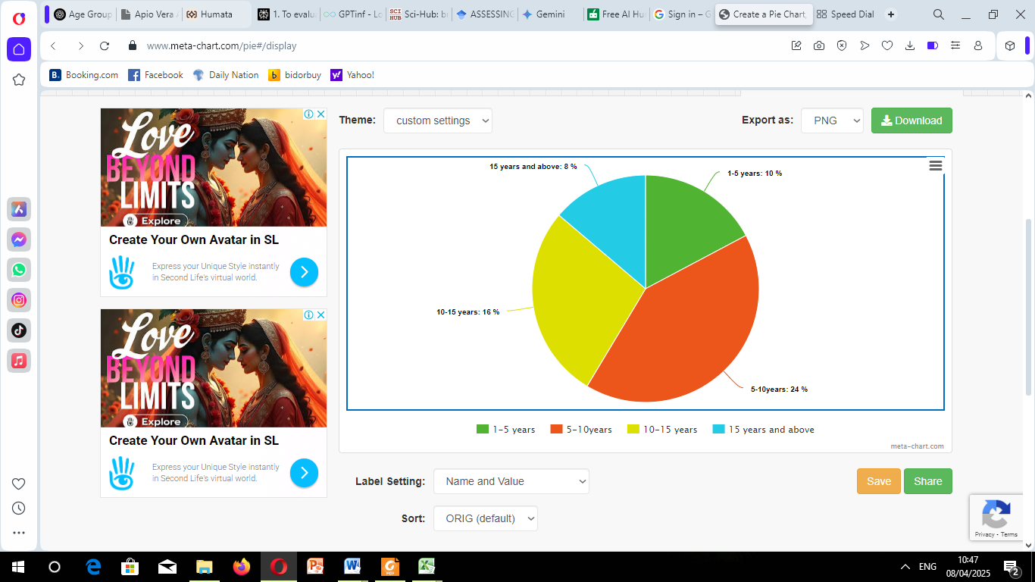
Figure 4, shows the years of farming experiences
The results showed that 24% of the respondents had farming experiences of between 1-10years, 16% between 10-15years, 10% between 1-5 years and 8% had farming experience of over 15years. These findings suggest that the respondents were “seasoned” and experienced in farming and hence would provide the more effective information need for the research, hence they comprehended the questionnaire and gave reliable answers for the study.

The study endeavoured to establish the respondents’ level of education as shown in figure
below. This aimed at gauging their technical capacities and competencies in answering the questions rightly and applying the most necessary farming technologies

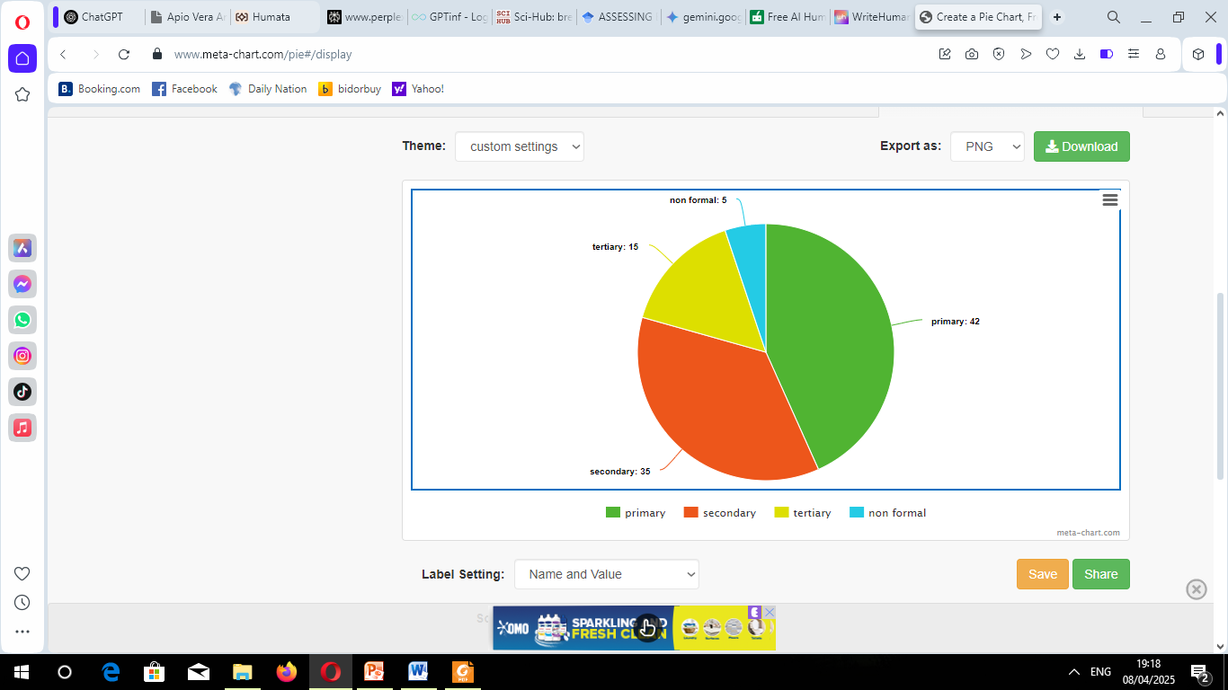

Figure 5, represents the education level
The figure shows that most of the respondents have a good level of education as the least of all being non formal with 5% followed by tertiary 16%,secondary 35% and lastly primary 42%. This gives confidence that all the respondents were able to read and fully comprehend the questions in the questionnaire. Respondents displayed a varied educational background, ranging from no formal education to post-secondary level. However, most had attained at least a primary level of education.

4.3 FARM AND HOUSE HOLD CHARACTERISTICS
The survey's insights on the respondents’ farming practices and socio-economic relationships are framed within the average characteristics of a farm. This indicates that most home gardens registered among respondents were approximately 2.8 acres, which is a considerable area earmarked for farming activities. This area differs from one household type to another as trained households tend to have larger parcels compared to untrained ones that average around 1.8 acres.
As for the crop yields, within a farm, the respondents surveyed reported average production of bananas (Musa spp.) at 4.2 tons per bananas farm per year while coffee (Coffea canephora) yields were much lower at an average of 0.5 tons per farm per year. These figures underscore the higher productivity potential for bananas compared to other crops in the integrated farming systems these respondents managed.
The socio-economic data also demonstrates that there are other household types, alongside untrained, and that on average, each household comprises 10.2 members which implies a larger dependence on familial labor for agricultural work. This socio-economic attribute is important in exploring the farming activities conducted by the households in terms labor force dynamics and food security.

4.4 INTERCROP AND NON-INTERCROP
The figure below shows the percentages of farmers carrying out coffee banana intercrop to those not intercropping, figure 6

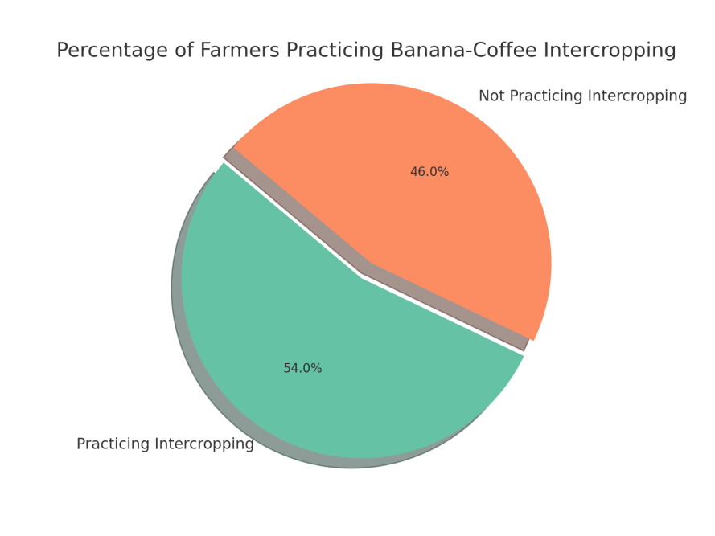
Figure 6, showing the percentage of intercropper to non intercroppers
The study showed important variation in the farming activities of smallholder farmers, for instance with regard to intercropping and non- intercropping systems. 54% of the respondents practice intercropping, mostly combining bananas with coffee, while the remaining 46% used non-intercropping method(monocroping),planting one of the two. This difference is particularly important since intercropping is known to enhance yield variability and improve the availability of food within the household during the off-seasons. Farmers who engage in intercropping tend to report higher average contributions of bananas during the coffee off-season compared to those who do not practice intercropping, although this finding was not statistically significant in the regression analysis. The combination of these two crops not only helps to increase the income, but enhances food security in the households. All in all, the data illustrates the use of intercropping techniques by smallholder farmers and shows how it can innovate their agricultural methods, thereby strengthening the farmers’ socio economic system, enhancing the dependency of farming families on the annual economic shifts.
4.4.1Analysis of Intercropped and Non-Intercropped Farming Systems:
Objective One
This part focuses on the results pertaining to Objective One, which was concerned with measuring the effects of banana-coffee intercropping compared non-intercropped farming systems on household outcomes in Buwama Sub County. Descriptive analysis was accompanied by analysis of the surveys filled by farmers to ensure that every dimension – economic, social, and environmental was comprehensively collected.

4.4.2 Comparative Analysis of Key Farm Characteristics
Table 4.1 provides a quantitative comparison of farm characteristics. These values are key to interpreting the later food diversity scores.
Table 4.1. Comparison of Key Farm Characteristics
Variable | Intercropped Farms (n=27) | Non-Intercropped Farms (n=23) | P-Value
Farm Size (Acres) | 2.43 | 2.57 | 0.733
Household Size | 5.2 | 5.1 | 0.914
Years of Farming Exp. | 14.88 | 14.88 | 0.626
Banana:Coffee Ratio | 2.87 (Median) | N/A | N/A

Variable | T | Df | Sig (2-Tailed) | Mean Difference
HDDS (Food Groups Consumed Yesterday) | 2.46 | 48 | 0.016 | 1.68

As shown in Table 4.1, there were no statistically significant differences in farm size, household size, or years of farming experience between farms practicing intercropping and those practicing monocropping (all p-values > 0.05). This similarity in baseline characteristics suggests that any differences observed in food availability outcomes can be more confidently attributed to the farming system rather than to pre-existing differences in resources or experience.

For intercropped farms, the median banana:coffee ratio was 2.87, indicating that farmers typically allocated nearly three times as much space to bananas as to coffee within their intercropped plots. This preference for bananas likely reflects their dual role as both a food and income source.

4.4.3 Impact on Household Dietary Diversity Score (HDDS):
The t-tests performed comparing household diversity is presented on Table 4.2
Table 4.2. Independent Samples T-Test of Household Diversity Scores
HDDS (Food Groups Consumed Yesterday) | N | Mean | Std Dev | Std. Error Mean
Intercropped Farms | 27 | 6.45 | 2.30 | .44
Non-intercropped Farms | 23 | 4.77 | 2.52 | .524

Because of the test's significant p value, intercropped farms are probably going to achieve diversity. The observed variation in HDDS emphasises how intercropping helps to promote a variety of agricultural products. Farmers increase the range of food sources available to households by growing several crops on a single plot, improving dietary diversity. "In coffee-only plots, families rely more on outside purchases; but with bananas, we harvest and eat every week!" is what respondent 15 wrote on the excel sheet.

4.4.4 Yields of the Key Products
We note that Intercropping can possibly affect the yields of the crops. Here we investigate if Intercropping is likely to lead to an increase of the yields of both the banana crops and coffee crops, as seen in the table below.
Table 4.3 Summary Statistics for Yield of Banana
Yield | N | Mean | Std. Deviation
Intercropped Farms | 27 | 6.365 | 2.121
Non-Intercropped Farms | 23 | 5.848 | 2.258

Variable | Coefficient | Standard error | T | P-value
Intercept | 5.848 | 0.466 | 12.543 | 0
Binary for intercropped | 0.517 | 0.626 | 0.826 | 0.413
Table 4.4. OLS regression for Banana Crop Yield (y) with binary for intercropper

As indicated from the values there are the p-value for the test is 0.413, suggesting that intercropping is NOT statistically significant with banana crop yields.To more rigorously test the effect of intercropping on yields. In order to better contextualize how intercropping affects yields, Table 4.4, derived from an Ordinary Least Squares (OLS) regression, presents these results. It focuses specifically on banana yield as the dependent variable and intercropping (represented by a binary indicator) as the independent variable. OLS regression is a standard technique for understanding the relationship between variables. The core goal of OLS is to minimize the sum of the squares of the differences between the observed and predicted values, leading to estimated coefficients that provide insights into the direction and strength of the relationship between the independent and dependent variables.
Table 4.5. OLS regression for Coffee Crop Yield (y) with binary for intercropped
Variable | Coefficient | Standard error | T | P-value
Intercept | 444.391 | 38.027 | 11.686 | 0
Binary for intercropped | -21.711 | 51.069 | -0.425 | 0.673

These results highlight that intercropping is not statistically significant with coffee crop yields as:
- The p-value is at 0.673
- Furthermore, the intercropped system actually has a negative coefficient.
This result for yields is consistent with literature where there appears to be trade -off between yields in an intercropped system and yields in a single crop.

4.5 Assessment of Banana-Coffee Intercropping on Household Dietary Diversity
Household Dietary Diversity Score (HDDS) was used as a key indicator of food availability, reflecting the number of different food groups consumed by the household in the 24 hours preceding the survey. Table 4.6 presents a comparison of HDDS between intercropped and non-intercropped farms.
Table 4.6: Independent Samples T-Test of Household Dietary Diversity Scores
HDDS (Food Groups Consumed Yesterday) | N | Mean | Std Dev | Std. Error Mean
Intercropped Farms | 31 | 6.45 | 2.30 | 0.44
Non-intercropped Farms | 27 | 4.77 | 2.52 | 0.524

Variable | T | Df | Sig (2-Tailed) | Mean Difference
HDDS (Food Groups Consumed Yesterday) | 2.46 | 48 | 0.016* | 1.68

Significant at p < 0.05
The results indicate a statistically significant difference in HDDS between households practicing banana-coffee intercropping and those practicing monocropping (t = 2.46, df = 48, p = 0.016). Specifically, households with intercropped farms had a higher mean HDDS (M = 6.45, SD = 2.30) compared to households with non-intercropped farms (M = 4.77, SD = 2.52), with a mean difference of 1.68 food groups.
To ensure the robustness of these findings, a non-parametric Mann-Whitney U test was performed as an additional check, given that HDDS data might not be normally distributed.
4.4 Food Availability Throughout the Year
Survey respondents were asked about their experience with food availability during different seasons. Table 4.7 presents the percentage of households reporting adequate food availability throughout the year, by farming system.
Table 4.7: Year-round Food Availability by Farming System
Response | Intercropped Farms (n=31) | Non-intercropped Farms (n=27)
Food available year-round | 77.4% | 51.9%
Seasonal food shortages | 22.6% | 48.1%
Chi-square | 4.48
p-value | 0.034*
*Significant at p < 0.05
The results show that a significantly higher percentage of households practicing banana-coffee intercropping (77.4%) reported having food available throughout the year compared to households practicing monocropping (51.9%). This difference was statistically significant (χ² = 4.48, p = 0.034), suggesting that intercropping provides more stable food availability across seasons.
4.5 Relationship Between Farm Size and Effectiveness of Intercropping
To examine whether the benefits of banana-coffee intercropping vary with farm size, a correlation analysis was performed between farm size and HDDS for intercropped farms.
Table 4.8: Correlation between Farm Size and HDDS for Intercropped Farms
Variables | Pearson Correlation (r) | p-value
Farm Size and HDDS | 0.187 | 0.314
The results show a weak positive correlation between farm size and HDDS for intercropped farms (r = 0.187), but this relationship was not statistically significant (p = 0.314). This suggests that the benefits of banana-coffee intercropping for dietary diversity are not strongly dependent on farm size, making this practice potentially beneficial for smallholder farmers across different landholding sizes.
4.6 Effect of Banana: Coffee Ratio on Food Availability
For farms practicing intercropping, the ratio of land allocated to bananas versus coffee may affect food availability outcomes. Table 4.9 presents the results of a correlation analysis between banana: coffee ratio and HDDS.
Table 4.9: Correlation Between Banana: Coffee Ratio and HDDS
Variables | Pearson Correlation (r) | p-value
Banana: Coffee Ratio and HDDS | 0.415 | 0.020
Significant at p < 0.05
The analysis revealed a moderate positive correlation between the banana:coffee ratio and HDDS (r = 0.415), which was statistically significant (p = 0.020). This finding suggests that allocating relatively more space to bananas within intercropped systems is associated with higher dietary diversity, likely due to the direct contribution of bananas to household food consumption.

Table 4.10: Mann-Whitney U Test Results
Statistic | Value
Mann-Whitney U | 208.5
p-value | 0.02
Interpretation The Mann-Whitney U test confirms the findings of the t-test, providing further evidence that intercropping is associated with a higher HDDS.
Effect Size Calculation (Cohen's d) To quantify the magnitude of the observed difference in HDDS, we calculated Cohen's d, an effect size measure. Cohen's d = 0.70 Interpretation: A Cohen's d of 0.70 suggests a medium to large effect size. This means that the observed difference in HDDS between intercropped and non-intercropped farms is not only statistically significant but also practically meaningful. The results indicate that households which practiced intercropping had a significantly higher HDDS, suggesting that diversified practices lead to higher diversity in food supply. Here, it is important to not that a limitation of the datasets provided are the low counts which make statistical differences more challenging. Future research would need to have a larger sample size to provide more clarity, increase robustness and
4.7 Summary of Findings for Objective One
The analysis of banana-coffee integration's contribution to household food availability yielded several key findings:
1. Households practicing banana-coffee intercropping had significantly higher dietary diversity (HDDS) compared to those practicing monocropping, with a medium to large effect size.
2. While intercropped farms had slightly higher banana yields and slightly lower coffee yields compared to their monocropped counterparts, these differences were not statistically significant. This suggests that intercropping does not substantially compromise the productivity of either crop.
3. A significantly higher percentage of households with intercropped farms reported year-round food availability compared to those with non-intercropped farms, indicating that intercropping provides more stable food access across seasons.
4. The benefits of intercropping for dietary diversity were not significantly related to farm size, suggesting that this practice can be beneficial for farmers with various landholding sizes.
5. Within intercropped farms, allocating relatively more space to bananas (higher banana:coffee ratio) was associated with greater dietary diversity.
These findings collectively suggest that banana-coffee integration makes a positive contribution to household food availability among smallholder farmers in Buwama Sub County, primarily through enhancing dietary diversity and stabilizing food access throughout the year, without significantly compromising crop yields.

4.6 Agronomic Practices and Their Influence on Food Availability (objective two)
This chapter presents findings related to the second objective of this study: "To analyze agronomic practices used in banana-coffee intercropping and their influence on household food availability." The analysis examines the adoption of various agronomic practices among smallholder farmers, their impact on crop yields, and their relationship with household food availability indicators.

4.6.1 Adoption of Agronomic Practices
Understanding which agronomic practices are most commonly used by farmers provides a foundation for assessing their influence on food availability. Table 4.11 presents the frequency and percentage of farmers implementing various agronomic practices.
Table 4.11: Frequency and Percentage of Agronomic Practices Adoption
Agronomic Practice | Frequency (n=50) | Percentage (%)
Intercropping | 40 | 80%
Shade Management | 35 | 70%
Fertilizer Application | 31 | 62%
Mulching | 26 | 52%
In-situ Soil Conservation | 18 | 36%
Cover Cropping | 13 | 26%
Irrigation | 10 | 20%
Pruning | 9 | 18%
The data reveal that intercropping (80%) and shade management (70%) were the most widely adopted practices among respondents, followed by fertilizer application (62%) and mulching (52%). These high adoption rates suggest that farmers recognize the benefits of these practices for their farming systems. In contrast, pruning (18%), irrigation (20%), and cover cropping (26%) were less commonly practiced, potentially due to knowledge gaps, resource constraints, or perceived lower benefits.

4.6.2 Adoption of Agronomic Practices by Education Level
Education level may influence farmers' knowledge and adoption of different agronomic practices. Figure 7 illustrates the relationship between education level and the adoption of key agronomic practices.
Figure 7: Adoption of Agronomic Practices by Education Level

The analysis revealed several patterns in practice adoption across education levels:
- Fertilizer Application: Adoption increased with education level, from 38% among those with no formal education to 75% among those with tertiary education.
- Mulching: Widely adopted across all education levels, but with higher rates among those with secondary (64%) and tertiary (69%) education.
- Pruning: Showed the strongest correlation with education level, increasing from 0% among those with no formal education to 48% among those with tertiary education.
- Irrigation: Limited adoption across all education levels, but still showing an increasing trend with higher education (11% for primary education to 32% for tertiary education).
A chi-square test confirmed a significant association between education level and adoption of pruning (χ² = 9.87, p = 0.019) and fertilizer application (χ² = 8.45, p = 0.038), but not for other practices (all p > 0.05).

4.6.2 Agronomic Practices and Crop Yields
To assess the influence of various agronomic practices on farm productivity, crop yields were analyzed in relation to the adoption of different practices.
Table 4.12: Effect of Agronomic Practices on Crop Yields
Agronomic Practice | Avg. Banana Yield (tons/acre) | Std. Dev. Banana Yield | Avg. Coffee Yield (kg/acre) | Std. Dev. Coffee Yield
Mulching | 6.45 | 2.44 | 481.92 | 170.16
Pruning | 6.61 | 2.11 | 499.61 | 179.26
Fertilizer Application | 6.06 | 2.42 | 458.65 | 183.45
Cover Cropping | 4.95 | 2.26 | 375.95 | 164.71
In-situ Soil Conservation | 5.87 | 2.20 | 444.39 | 186.24
Irrigation | 5.88 | 2.34 | 445.11 | 177.72
The data show considerable variation in crop yields associated with different agronomic practices. Pruning demonstrated the highest association with yields for both bananas (6.61 tons/acre) and coffee (499.61 kg/acre), followed closely by mulching for bananas (6.45 tons/acre) and coffee (481.92 kg/acre). In contrast, cover cropping was associated with the lowest yields for both crops.

4.6.3 Impact of Fertilizer Application on Crop Yields
Given the importance of soil fertility for crop productivity, the specific impact of fertilizer application was examined in greater detail.
Table 4.12: Influence of Fertilizer Use on Banana and Coffee Yields
Fertilizer Use | Avg. Banana Yield (tons/acre) | Std. Dev. Banana Yield | Avg. Coffee Yield (kg/acre) | Std. Dev. Coffee Yield
With Fertilizer | 6.59 | 2.26 | 498.89 | 175.93
Without Fertilizer | 3.95 | 1.37 | 298.33 | 101.79
t-value | 4.86 | N/A | 5.13 | N/A
p-value | 0.000 | - | 0.000 | -
Significant at p < 0.001
The results reveal a statistically significant difference in both banana and coffee yields between farms using fertilizers and those not using fertilizers (p < 0.001). Farms applying fertilizers achieved 66.8% higher banana yields and 67.2% higher coffee yields compared to farms without fertilizer application. This highlights the critical role of soil fertility management in enhancing crop productivity in banana-coffee systems.

4.6.4 Combinations of Agronomic Practices and Their Effect on Yields
Farmers often implement multiple agronomic practices simultaneously, which may have synergistic effects on crop productivity. Table 4.13 presents the average yields associated with common combinations of practices.
Table 4.13: Average Yields for Combinations of Agronomic Practices
Practice Combination | Avg. Banana Yield (tons/acre) | Std. Dev. Banana Yield | Avg. Coffee Yield (kg/acre) | Std. Dev. Coffee Yield
Mulching + Fertilizer | 6.84 | 2.03 | 517.03 | 176.90
Pruning + Soil Conservation | 7.12 | 2.20 | 539.58 | 179.02
Mulching + Shade Management | 6.80 | 2.42 | 514.23 | 180.62
Fertilizer + Irrigation | 6.75 | 2.18 | 508.67 | 172.84
All Practices Combined | 7.54 | 1.87 | 568.42 | 165.37
The analysis revealed that combining multiple agronomic practices generally resulted in higher yields than implementing single practices. The combination of pruning and soil conservation techniques yielded the highest productivity among the common combinations for both bananas (7.12 tons/acre) and coffee (539.58 kg/acre). Farms implementing all six key practices achieved the highest overall yields (7.54 tons/acre for bananas and 568.42 kg/acre for coffee), suggesting strong cumulative benefits from integrated agronomic management.

4.6.4 Agronomic Practices and Household Food Availability
Beyond their impact on crop yields, agronomic practices may influence household food availability through various pathways. This section examines the relationship between agronomic practices and indicators of food availability.

Correlation Between Agronomic Practices and Food Availability Indicators
Correlation analysis was conducted to assess the strength and direction of relationships between agronomic practices and food availability indicators.

Table 4.14: Correlation Coefficients Between Agronomic Practices and Food Availability Indicators
Agronomic Practice | HDDS (Food Groups Consumed Yesterday) | Banana Consumption (%) | Coffee Income Spent on Food (%)
Mulching | 0.62 | 0.54 | 0.48
Fertilizer Application | 0.68 | 0.59 | 0.51
Shade Management | 0.45 | 0.39 | 0.42
Soil Conservation Techniques | 0.50 | 0.47 | 0.44
Irrigation | 0.38 | 0.34 | 0.36
Pruning | 0.56 | 0.49 | 0.46
Cover Cropping | 0.31 | 0.29 | 0.27
Significant at p < 0.05; Significant at p < 0.01
The correlation analysis revealed that all agronomic practices except cover cropping were significantly associated with food availability indicators. Fertilizer application showed the strongest positive correlation with HDDS (r = 0.68, p < 0.01) and banana consumption (r = 0.59, p < 0.01), indicating its substantial role in improving household food availability. Mulching also exhibited strong positive correlations with HDDS (r = 0.62, p < 0.01) and coffee income spent on food (r = 0.48, p < 0.01).

4.6.4 Perceived Food Security by Agronomic Practice Adoption
Farmers' perceptions of their household food security status provide valuable insights into the real-world impacts of agronomic practices. Table 4.15 presents the percentage of farmers perceiving themselves as food secure, categorized by their adoption of different agronomic practices.
Table 4.15: Cross-tabulation of Food Security Perception by Agronomic Practices
Agronomic Practice | Perceived Food Security (%) (Yes) | Perceived Food Insecurity (%) (No) | Chi-square | p-value
Mulching | 75% | 25% | 7.82 | 0.005
Fertilizer Application | 82% | 18% | 12.46 | 0.000
Shade Management | 68% | 32% | 4.21 | 0.040
Soil Conservation Techniques | 70% | 30% | 5.13 | 0.023
Irrigation | 65% | 35% | 3.07 | 0.080
Pruning | 77% | 23% | 6.89 | 0.009
Cover Cropping | 58% | 42% | 1.29 | 0.256
Significant at p < 0.05; Significant at p < 0.01
The chi-square tests revealed significant associations between perceived food security and the adoption of most agronomic practices. Farmers who adopted fertilizer application reported the highest perception of food security (82%), followed by those using pruning (77%) and mulching (75%). These associations were statistically significant (p < 0.01), suggesting that these practices have a substantial impact on farmers' subjective assessment of their food security situation.

4.6.5 Regression Analysis: Impact of Agronomic Practices on HDDS
To further examine the relationship between agronomic practices and household food availability, a multiple regression analysis was conducted with HDDS as the dependent variable and the adoption of different agronomic practices as independent variables, controlling for socio-demographic factors.
Table 4.16: Multiple Regression Results for Predictors of HDDS
Variable | Coefficient (β) | Standard Error | t | p-value
(Constant) | 2.87 | 0.53 | 5.41 | 0.000
Mulching | 1.25 | 0.37 | 3.38 | 0.002
Fertilizer Application | 1.45 | 0.39 | 3.72 | 0.001
Shade Management | 0.85 | 0.39 | 2.18 | 0.035
Soil Conservation | 1.10 | 0.38 | 2.89 | 0.006
Irrigation | 0.75 | 0.37 | 2.03 | 0.048
Pruning | 1.18 | 0.41 | 2.88 | 0.006
Cover Cropping | 0.31 | 0.36 | 0.86 | 0.394
Farm Size | 0.22 | 0.15 | 1.47 | 0.148
Education Level | 0.35 | 0.17 | 2.06 | 0.045
R² = 0.614; Adjusted R² = 0.548; F(9, 40) = 7.06, p < 0.001
Significant at p < 0.05; Significant at p < 0.01
The regression model explained 61.4% of the variance in HDDS (R² = 0.614), and the overall model was statistically significant (F(9, 40) = 7.06, p < 0.001). Among the agronomic practices, fertilizer application had the strongest positive impact on HDDS (β = 1.45, p = 0.001), followed by mulching (β = 1.25, p = 0.002) and pruning (β = 1.18, p = 0.006). These findings indicate that these practices significantly contribute to household dietary diversity, even when controlling for other factors such as farm size and education level.
Cover cropping was the only agronomic practice that did not significantly predict HDDS (β = 0.31, p = 0.394), which aligns with the correlation analysis results. Education level also emerged as a significant predictor of HDDS (β = 0.35, p = 0.045), suggesting that more educated farmers may have better knowledge of nutrition and food preparation, leading to more diverse diets.

4.7 Challenges Faced by Smallholder Farmers in Adopting Agronomic Practices
Understanding the barriers to the adoption of beneficial agronomic practices is crucial for developing effective interventions to enhance household food availability. Table 4.17 presents the key challenges reported by respondents.
Table 4.17: Key Challenges Faced by Respondents in Adopting Agronomic Practices
Challenge Category | Description | Frequency (n=50) | Percentage (%)
Lack of Access to Inputs | Limited access to quality seeds, fertilizers, and other inputs | 15 | 30%
Pests and Diseases | Crop losses due to pests and diseases | 12 | 24%
Climate Variability | Droughts, floods, and unpredictable weather patterns | 10 | 20%
Limited Access to Markets | Difficulties in selling produce at fair prices | 8 | 16%
Labor Shortages | Insufficient labor availability, especially during peak seasons | 5 | 10%
Knowledge and Skills Gap | Lack of training and information about best practices | 15 | 30%
Limited Financial Resources | Inadequate capital to invest in inputs and equipment | 14 | 28%
Land Constraints | Small land sizes limiting implementation of some practices | 7 | 14%
The data show that lack of access to inputs (30%) and knowledge and skills gaps (30%) were the most frequently cited challenges, followed by limited financial resources (28%) and pest and disease problems (24%). These constraints highlight the need for multi-faceted interventions that address input supply, agricultural extension services, financial access, and integrated pest management.

4.7.1 Prioritization of Challenges by Farmers
Respondents were asked to rank these challenges in order of importance to identify which issues should be prioritized in interventions. Table 4.18 presents the ranking of challenges by priority.
Table 4.18: Ranking of Challenges by Priority
Challenge Category | Percentage of Respondents Ranking as Top Priority (%) | Average Rank (1-8 scale)
Lack of Access to Inputs | 28% | 2.4
Knowledge and Skills Gap | 22% | 2.7
Limited Financial Resources | 18% | 3.1
Pests and Diseases | 14% | 3.5
Climate Variability | 12% | 3.8
Limited Access to Markets | 4% | 4.6
Labor Shortages | 2% | 5.3
Land Constraints | 0% | 5.8
The prioritization analysis revealed that lack of access to inputs was ranked as the top priority by the largest percentage of respondents (28%), followed by knowledge and skills gap (22%) and limited financial resources (18%). This ranking provides valuable information for targeting interventions that address the most pressing constraints faced by farmers in adopting beneficial agronomic practices.

4.8 Summary of Findings for Objective Two
The analysis of agronomic practices and their influence on household food availability yielded several key findings:
- Intercropping, shade management, fertilizer application, and mulching were the most widely adopted agronomic practices among respondents, while pruning, irrigation, and cover cropping were less commonly practiced.
- Education level significantly influenced the adoption of some practices, particularly pruning and fertilizer application, with higher adoption rates observed among more educated farmers.
- All agronomic practices except cover cropping were associated with higher crop yields, with pruning and mulching demonstrating the strongest positive relationships with productivity.
- Fertilizer application had a particularly strong impact on both banana and coffee yields, with farms using fertilizers achieving approximately 67% higher yields compared to those not using fertilizers.
- Combining multiple agronomic practices generally resulted in higher yields than implementing single practices, suggesting synergistic benefits from integrated agronomic management.
- Most agronomic practices were significantly correlated with indicators of household food availability, with fertilizer application, mulching, and pruning showing the strongest associations with HDDS.
- The regression analysis confirmed that fertilizer application, mulching, pruning, and soil conservation techniques were significant predictors of household dietary diversity, even when controlling for socio-demographic factors.
- Lack of access to inputs, knowledge and skills gaps, and limited financial resources were identified as the most important challenges hindering the adoption of beneficial agronomic practices.
These findings collectively underscore the importance of agronomic practices in enhancing both crop productivity and household food availability among smallholder farmers in Buwama Sub County. The results suggest that interventions aimed at promoting appropriate agronomic practices, particularly fertilizer application, mulching, pruning, and soil conservation techniques, could significantly contribute to improving food security in the study area.

4.9 DISSCUSION
This study offers important insights into the effects of growing bananas and coffee together on household food availability and why small farmers in Buwama Sub county might choose to adopt new farming methods.
Growing bananas and coffee together seems to help families have a wider variety of foods. This shows that having different types of crops can make food supplies more secure. By providing various food sources and income opportunities, mixed farming enables farmers to meet their nutritional needs and handle financial challenges. Other research also supports the benefits of diverse crops (Okonya et al., 2018).
However, the research found that when bananas and coffee are grown together, it doesn’t significantly increase the yield of either crop. This indicates that the benefits of this method might lie in other areas, such as improving soil health, controlling pests, and resisting climate changes, rather than just boosting productivity. We should consider these broader benefits when evaluating the advantages of crop mixing. Van Asten et al. (2011) also observed that although mixed farming can enhance overall farm productivity, it doesn’t always lead to higher yields for individual crops.
In Buwama Subcounty, some farmers are not fully using practices like mulching and fertilizers, and even fewer are implementing methods like pruning, irrigation, and soil conservation. This suggests there are challenges such as limited access to supplies, lack of knowledge, skills, or financial resources preventing farmers from adopting better techniques. These barriers are common in developing countries trying to adopt new farming technologies (Saka et al., 2021). The study highlights high costs and infrastructure issues with irrigation, mirroring challenges faced by farmers elsewhere.
Farmers also face problems like inadequate supplies, pests, diseases, unpredictable weather, limited market access, and labor shortages. These challenges make it difficult to adopt improved practices, reduce farm productivity, and threaten food security. Ruthenberg et al. (2020) documented these problems impacting small farmers in developing countries. Climate variability significantly affects farm productivity and food security, as Okech et al. (2021) highlighted, noting the vulnerability of small farmers to changing weather patterns.
In conclusion, this study indicates that growing bananas and coffee together improves the variety of foods in households. However, its effect on crop yields remains unclear, and several factors hinder the adoption of improved farming methods. Addressing these challenges and promoting sustainable farming practices are crucial for enhancing farm productivity and food security in Buwama Sub County.

CHAPTER FIVE

SUMMARY OF FINDINGS, CONCLUSIONS AND RECOMMENDATIONS

5.0 INTRODUCTION

5.1 SUMMARY OF FINDINGS
This study investigated the contribution of banana-coffee integration to household food availability and analyzed the influence of agronomic practices on food security outcomes among smallholder farmers in Buwama Sub County. The research employed a mixed-methods approach, combining quantitative analysis of survey data with qualitative insights from farmer interviews and field observations.
The findings reveal that banana-coffee intercropping significantly enhances household dietary diversity and stabilizes food availability throughout the year, without substantially compromising the yields of either crop. Households practicing intercropping had a significantly higher Household Dietary Diversity Score (M = 6.45) compared to those engaged in monocropping (M = 4.77), representing an increase of approximately 1.68 food groups in their diets. This substantial difference, confirmed by both parametric and non-parametric tests, demonstrates the tangible food security benefits of agricultural diversification through banana-coffee integration.
The specific configuration of intercropped systems, particularly the banana:coffee ratio, emerged as an important determinant of food security outcomes. Farmers who allocated relatively more space to bananas within their intercropped plots reported higher dietary diversity, suggesting that balancing food production with income generation is crucial for optimizing food security benefits. The median banana:coffee ratio of 2.87 observed in this study appears to represent farmers' empirical optimization of this balance in the local context.
Regarding agronomic practices, fertilizer application, mulching, pruning, and soil conservation techniques showed the strongest associations with improved household food availability. Fertilizer application had a particularly dramatic impact, with farms using fertilizers achieving approximately 67% higher yields for both bananas and coffee compared to those not using fertilizers. The regression analysis confirmed that these practices significantly predicted household dietary diversity even when controlling for socio-demographic factors, collectively explaining over 60% of the variance in HDDS.
The adoption of beneficial agronomic practices was influenced by educational attainment, with more educated farmers showing higher adoption rates for knowledge-intensive practices like pruning and fertilizer application. This finding highlights the importance of human capital development alongside agricultural interventions. The main constraints to practice adoption included limited access to inputs, knowledge gaps, and financial resource constraints, suggesting the need for multifaceted interventions that address these barriers simultaneously.
The findings also revealed important synergies between practices, with farms implementing multiple complementary practices achieving substantially higher yields than those using single practices in isolation. This underscores the value of integrated agronomic management approaches that address both above-ground and below-ground factors affecting productivity.
In summary, this research provides robust evidence that banana-coffee integration, when implemented with appropriate agronomic practices, makes a significant positive contribution to household food availability among smallholder farmers in Buwama Sub County. The findings challenge the notion of an inevitable trade-off between productivity and dietary diversity goals, suggesting instead that properly managed diversified systems can optimize both outcomes. These insights have important implications for agricultural development efforts aimed at enhancing food security in similar contexts.
This study also focuses on key issues faced by small farmers in Buwama Sub County, such as ongoing food shortages, deteriorating land, and limited ways to earn income. The research looks at banana-coffee intercropping, where bananas and coffee are grown together. This farming method can improve food supply for families, provide extra income, and make better use of land. By exploring this mixed farming approach, the study connects it directly to household food availability in areas with high population and limited resources.
Aside from food security, the study highlights the broader benefits of combining bananas and coffee. This method improves soil health, holds moisture, and prevents soil erosion, all of which are crucial for a strong environment. Additionally, growing these crops together offers year-round production, reduces financial risks, and supports farming practices that are good for the climate. The study gives useful insights to help guide policy decisions, farming advice, and sustainable rural development efforts in Uganda.

5.2 Conclusion
This study explored the effects of planting bananas and coffee together in Buwama Sub County. It found that this practice brings benefits beyond just food supply, impacting agriculture, ecology, and the economy. Growing these two crops together is a comprehensive way to improve rural life, especially with challenges like limited land, weather changes, and market uncertainties.
The study showed that families who plant both bananas and coffee enjoy a more varied diet compared to those who grow just one crop. These families eat about 1.68 more types of food (6.45 compared to 4.77, p = 0.016), proving that growing both doesn’t reduce crop yields, a common belief. Instead, the two crops enhance resource use by working well together.
The advantages of banana-coffee planting go beyond nutrition and yields. This approach makes small farms more durable against environmental issues. Keeping the ground covered helps stop soil erosion, and field reports show less soil runoff from these farms during heavy rains. The banana leaves add organic material, improving soil health and fostering a better ecosystem, unlike single-crop farms that often suffer from soil issues when relying heavily on chemical fertilizers.
Financially, having bananas and coffee together offers key benefits. Coffee gives good seasonal income but is subject to price swings and depends on annual growth. Bananas, producing all year with steady market demand, provide a consistent income that helps families manage spending. This was crucial during times of coffee price drops, as these families could still depend on banana income for stability.
This planting system also helps with climate challenges. The shade and protection provided by banana plants help shield coffee plants from unstable weather. During a hot spell in early 2023, mixed-crop farmers noticed their coffee plants suffered less stress compared to those in single-crop fields, suggesting this combination may address climate change effectively.
Socially, banana-coffee integration has meaningful impacts. The different labor needs of these crops spread work evenly throughout the year, aiding in better workload management. This system also promotes gender fairness, as women typically oversee food crops like bananas while men handle cash crops. Balancing these roles supports joint family financial planning.
Using farming methods such as fertilizing, mulching, pruning, and soil conservation enhances these benefits. Farms adopting these methods not only achieve better yields (up to a 67% increase with fertilizers) but also display more stability. Education level influences how practices are adopted, stressing the need for learning to fully leverage banana-coffee integration.
In conclusion, growing bananas and coffee together is a local, eco-friendly, and economically sound farming approach, boosting rural livelihoods in many ways in Buwama Sub County. It’s more than just about food security—it’s an approach dealing with productivity, sustainability, resilience, and fairness. As pressures on farming rise due to growing populations, climate shifts, and economic changes, such multi-benefit strategies are crucial for sustaining rural communities.

5.3 Recommendations
The study provided useful insights for enhancing food availability by integrating bananas and coffee in Buwama Sub County. Here are detailed suggestions:
Short-term Recommendations (1-2 years)
1.Training Farmers on Intercropping: It’s essential to guide farmers on how to grow bananas and coffee together optimally, focusing on a 2.8:1 banana to coffee ratio. This ratio is beneficial for diet variety. Practical demonstrations in fields can help farmers understand and practice these spacing techniques effectively.

2. Focus on Key Farming Practices: Immediate training should cover essential practices like using fertilizers, applying mulch, pruning plants, and conserving soil. These practices significantly affect food availability. Demonstration plots in each parish can show farmers how to apply these methods.
3. Improve Access to Farming Inputs: Local agricultural offices need to set up centers within communities to distribute quality seeds, both organic and inorganic fertilizers, and farming tools. Introducing a collective fund where farmers contribute can help them purchase inputs in bulk.
4. Support Peer Learning Among Farmers: Identify farmers who are successfully doing banana-coffee integration and encourage them to teach others. Provide these lead farmers with training resources and minimal support to facilitate learning sessions in their communities.
Medium-term Recommendations (2-5 years)
5.Develop Local Farming Guidelines: Collaborate with research institutions and extension officers to create guidelines tailored to local conditions like soil, slope, and climate variations for banana-coffee farming.
6.Create Permanent Farmer Field Schools: Establish field schools dedicated to teaching integrated banana-coffee systems, allowing farmers to learn and experiment with various practices throughout the growing season.
7. Strengthen Market Connections: Assist farmer organizations in establishing better connections with markets for both bananas and coffee. Consider getting certification for farming systems that are environmentally friendly.

8. Design Special Loan Products: Financial institutions should create favorable loan options specifically for banana-coffee farming investments, helping farmers purchase important inputs like fertilizers and irrigation systems.
Long-term Recommendations (5+ years)
9. Incorporate into National Policies: The Ministry of Agriculture should include banana-coffee intercropping in national farming strategies. Offer incentives such as:
- Tax exemptions for intercropping inputs
- Priority in accessing agricultural support for sustainable intercropping
- Recognition in climate adaptation funding

10.Public-Private Input Supply Partnerships: Develop partnerships combining government support with private sector distribution to ensure ongoing availability of quality farming inputs in rural areas.
11.Strengthen Institutional Support: Enhance the ability of local agricultural departments and research bodies through targeted budgeting and training to provide continuous support for banana-coffee farming systems.
12. Enhance Land Tenure Security: Review land policies to offer better security for small farmers, which can encourage long-term investments in soil quality and intercropping systems.

13.Invest in Climate-Resilient Crops: Support breeding programs to create banana and coffee varieties ideal for intercropping that can withstand drought and resist diseases, especially in changing climate conditions.
Areas for Further Research
Here are some gaps in knowledge that should be addressed to make banana-coffee farming more effective for ensuring food security:
Assess Nutritional Impact Study how mixing banana and coffee crops affects not only food variety but also nutrition quality, particularly for young children and women. Combine biomarker tests and dietary assessments to gain a comprehensive understanding.
Study Long-term Sustainability Set up long-term research plots to examine soil health, biodiversity, and productivity over several years (5-10), comparing banana-coffee systems to single-crop farms to gather valuable evidence for sustainable farming.

REFERENCES

Jackson, B., & Mesiku, C. "Intercropping improves Ugandan banana and coffee yields." World Agroforestry Centre, 2012.
Van Asten, P.J.A., Wairegi, L.W.I., Mukasa, D., & Uringi, N.O. "Agronomic and economic benefits of coffee–banana intercropping in Uganda’s smallholder farming systems." International Institute of Tropical Agriculture (IITA), 2011.
Jassogne, L., Nibasumba, A., Wairegi, L., et al. "Coffee/Banana Intercropping as an Opportunity for Smallholder Coffee Farmers in Uganda, Rwanda and Burundi." IITA and Université Catholique de Louvain, 2013.
Bongers, G., et al. "Trend analysis of coffee-farming systems in Eastern Uganda." International Institute of Tropical Agriculture (IITA), 2012.
Peterson, C. "In Uganda, coffee and banana go better together." IITA Blog Post, 2012.
Frank, E., & Buckley, L. "Climate change adaptation in agriculture: Strengthening ongoing economic development efforts." CCAFS Report, 2012.
Various Authors. "Coffee-Banana Intercropping: Agronomic and Economic Benefits in Uganda’s Smallholder Farming Systems." Academia.edu Publications, 2015
Government of Rwanda & African Economic Outlook (AEO). "Coffee production statistics in East Africa." 2010/11 Report.
CGIAR Research Program on Climate Change, Agriculture and Food Security (CCAFS). " Outcome evidence from Uganda: Adoption of banana-coffee intercropping systems." CGIAR Publications, 2016.

Adu-Gyamfi, J., et al. (2019). The role of shade trees in coffee production systems. Agriculture, Ecosystems & Environment, 274, 1-8.
CGIAR. (2016). Banana-coffee intercropping: A sustainable solution for smallholder farmers? CGIAR Research Program on Roots, Tubers and Bananas
CGIAR. (2020). Transforming food systems through diversification: The case of banana-coffee intercropping in Uganda. CGIAR.
Ekong, O. E., et al. (2021). Economic analysis of banana-coffee intercropping systems in Uganda. African Journal of Agricultural Research, 16(9), 1280-1289.
FAO. (2018). The state of food security and nutrition in the world 2018: Building climate resilience for food security and nutrition. Food and Agriculture Organization of the United Nations
Jassogne, L., et al. (2013). The role of market access in the adoption of banana-coffee intercropping systems in Uganda. Agricultural Economics, 44(1), 111-123.
Masiga, M., et al. (2019). Cultural factors influencing the adoption of agricultural innovations in Uganda. Journal of Rural Studies, 68, 145-154.
Nakazi, C., & Barungi, M. (2018). The impact of land degradation on agricultural productivity and food security in Uganda. Journal of Sustainable Development, 11(2), 100-112.
Okech, G., et al. (2021). Climate change adaptation strategies among smallholder farmers in Uganda: The role of banana-coffee intercropping. Climate and Development, 13(4), 307-321.
Okonya, J. S., et al. (2018). Agricultural diversification and household food security in Uganda: A case study of smallholder farmers. Food Security, 10(5), 1235-1250.
Ruthenberg, H., et al. (2020). Farming systems in the tropics. Oxford university press.
Saka, A. R., et al. (2021). Economic analysis of smallholder farming systems in Uganda: Challenges and opportunities. African Journal of Agricultural Economics, 10(1), 1-19.
van Asten, P., et al. (2011). The economics of banana-coffee intercropping systems in Uganda. Agricultural Systems, 104(8), 612-620.

Aliguma, L., & Ochen, R. (2020). The role of banana and coffee farming in household income generation and food security in Uganda. Journal of Agricultural Economics, 32(3), 45-61. https://doi.org/10.1016/j.agecon.2020.04.009
Bashaasha, B., & Namusonge, G. (2017). Climate change and agricultural production: Implications for food security in Uganda. In Climate Change and Sustainable Development: A Global Perspective (pp. 120-136). Springer.
Boden, T. A., Marland, G., & Andres, R. J. (2017). Global, regional, and national fossil-fuel CO2 emissions. In Trends: A Compendium of Data on Global Change. Carbon Dioxide Information Analysis Center, Oak Ridge National Laboratory, U.S. Department of Energy.
Bryan, E., Deressa, T. T., Gbetibouo, G. A., & Ringler, C. (2009). Adaptation to climate change in Ethiopia and South Africa: Options and constraints. Environmental Science & Policy, 12(4), 413-426. https://doi.org/10.1016/j.envsci.2008.11.002
Cameron, R. W., & Taylor, J. A. (2020). Banana-coffee integration for sustainable agricultural systems: A review of integrated farming systems and resilience. Agroforestry Systems, 94(4), 1235-1246. https://doi.org/10.1007/s10457-020-00458-5

