CLIMATE CHANGE AND THE RIGHT TO SAFE AND CLEAN WATER IN NAKIVALE REFUGEE SETTLEMENT, INSIGIRO DISTRICT.

BY
FLAVIA MERCY APIYO

REG NO: J21B82/055

A DISSERTATION SUBMITTED TO THE SCHOOL OF SOCIAL SCIENCES, DEPARTMENT OF UNDERGRADUTE STUDIES IN PARTIAL FUFILMENT OF THE REQUIREMENT FOR THE AWARD OF BACHELOR’S DEGREE IN HUMAN RIGHTS, PEACE, AND HUMANITARIAN INTERVENTIONS AT UGANDA CHRISTIAN UNIVERSITY.

AUGUST 2023.

DECLARATION.
I, Flavia Mercy Apiyo, do declare that this dissertation is my own work piece, and has never been submitted for any Award in any discipline in any Institution of Higher Learning or any other University. In case the researcher quoted the works of other Authors or resource persons, such quotations have been highly acknowledged. The researcher deserves the copyright of this research report .

Signature ---------------------------------------------------
Flavia Mercy Apiyo.
Date------------------------------------------------------------

APPROVAL.
This research report has been prepared under my close supervision and guidance as the University Supervisor. It is submitted to the Board of Examinations of Uganda Christian University for the Award of Bachelor’s Degree of Human Rights, Peace, and Humanitarian Interventions of Uganda Christian University with my approval.

Research Supervisor: Ms. Mercy Amaniyo
Signature ---------------------------------------------------------------
Date ----------------------------------------------------------------------

DEDICATION.
I dedicate this research report to my beloved family, mentors and friends for their financial, spiritual, moral and material support towards my Academic Journey. May God Bless your hands.

ACKNOWLEDGEMENT.
I am indebted to the Almighty God for being the source of wisdom and knowledge that has brought me this far. I know very well that without the grace and power of the Lord, I would do nothing. My sincere gratitude goes to my encouraging supervisor Ms. Mercy Amaniyo for her consistent, constructive , timely criticisms, professional guidance and response that helped me to improve on my work and come up with satisfactory research. May the God Lord Bless you so abundantly!!
In a special way I would like to appreciate the Head of Department (HOD), for the timely approval of my research topic and guidance offered to me to carry this research . I wish to acknowledge the support of my mentors most especially Robyn Suttie , Jackie Skinner, Florence Onur, Ronald Ocen and my fellow students for their encouragement and prayers towards this research work. Thank you all.
I want to acknowledge and appreciate all my lecturers for imparting me with both theoretical and practical knowledge which has built confidence in me in facing much more challenging assignments and the world right from joining the University for my course up to the end of my studies. May the Almighty God reward you all abundantly. Lastly but not least, in a special way I would like to appreciate the office of the Prime Minister and all the staff under various of Isingiro District and Nakivale Refugees’ Settlement for allowing me to collect data for this research as well as all the respondents who despite their busy schedule responded to my interviews and questionnaires; without data from them I would not have successfully completed this research. Thank you for supporting the success of my education.

LIST OF ABBREVIATIONS.
DRC: Democratic Republic of Congo.
GHG: Green House Gas.
HOD: Head of Department.
MFPED: Minister of Finance, Planning and Economic Development.
NHS: National Household Survey.
NGO: Non-Governmental Organization.
UN-SDG: United Nation- Sustainable Development Goal.
OECD: Organization for Economic Cooperation and Development.
OPM: Office of the Prime Minister.
UN: United Nations.
NGO: Non-Governmental Organization.
UNDP: United Nation Development Fund.
UNECA: United Nation Economic Commission for Africa.
UNHCR: United Nation High Commission for Refugees.
UNICEF: United Nation International Children Education Fund.
WHO: World Health Organization.

LIST OF TABLES.
Table 1: Showing the Target Population 16
Table 2: Showing Sampling Techniques to be used on the Target Population 17
Table 3: Showing the Distribution and Returns of the Questionnaires 23
Table 4: Showing the Socio-Demographic characteristics of the respondents according to Gender 23
Table 5: Showing the Socio-Demographic characteristics of the respondents according to Age group 24
Table 6: Showing the Marital Status of the Respondents. 25
Table 7: Showing the number of years spent in Nakivale Refugees’ Settlement 26
Table 8: Showing the Education Level of the Respondents. 26
Table 9: Showing the findings whether Implications of climate change towards availability of clean and safe water 27
Table 10: Showing the findings whether Implication of climate change towards accessibility of clean and safe water in Nakivale refugee settlement. 31
Table 11: Showing the findings whether Impact of climate change on water utilization within the settlement. 33

LIST OF FIGURES.
Figure 1: Showing Conceptual Framework. 6
Figure 2: Percentage showing the sex of the Respondents 24

TABLE OF CONTENTS.

DECLARATION. i
APPROVAL. ii
DEDICATION. iii
ACKNOWLEDGEMENT. iv
LIST OF ABBREVIATIONS. v
LIST OF TABLES. vi
LIST OF FIGURES. vii
TABLE OF CONTENTS. vii
ABSTRACT. xi
CHAPTER ONE. 1
INTRODUCTION. 1
1.0 Introduction. 1
1.1 Background. 1
1.2 Statement of the Problem. 3
1.3 General objective. 3
1.3.1 specific objectives. 3
1.4 Research Question. 3
1.5 Justification. 3
1.6 Significance of the study. 4
1.7 Scope of the Study. 4
1.7.1 Content scope. 4
1.7.2 Time scope. 5
1.7.3 Geographical scope. 5
1.8 Conceptual Framework. 6
CHAPTER TWO. 7
LITERATURE REVIEW. 7
2.0 Introduction. 7
2.1 Climate change. 7
2.2 Implications of climate change towards availability of safe and clean water in refugee settlements. 8
2.3 Implications of climate change on access to safe and clean water. 9
2.4 The impacts of climate change on water utilization in Refugee Settlement. 11
2.5 The existing strategies employed by the communities of Nakivale refugee settlement to cope with climate change impacts on water resources sustainability. 13
2.6 Emerging gaps. 14
CHAPTER THREE. 15
RESEARCH METHODOLOGY. 15
3.0 Introduction: 15
3.1 Research Design 15
3.2 Area of Study 15
3.3 Target Population: 16
3.4 Sample size and Data collection. 16
3.6 Sources of data 18
3.6.1 Primary source 18
3.6.2 Secondary source. 18
3.7 Data collection instruments. 18
3.7.1 Questionnaire. 18
3.7.2 Interview guide. 19
3.7.3 Documentary review. 19
3.8 Data collection procedure. 19
3.9 Data analysis. 20
3.9.1 Quantitative data analysis. 20
3.9.2 Analysis of qualitative data. 20
3. 10 Ethical considerations. 20
3.11 Limitations and the solutions. 21
CHAPTER FOUR. 22
DATA PRESENTATION, INTERPRETATION AND ANALYSIS. 22
4.0 Introduction. 22
4.1 Back ground information. 22
SECTION A: The Socio-Demographic Characteristics 22
Number of Questionnaires returned and not returned 22
Findings according to Gender 23
Findings according to Age Group 24
Findings according to Marital Status 25
Findings according to numbers of years spent in Nakivale Refugees’ Settlement 26
Findings according to the level of Education 26
SECTION B: Implications of climate change towards availability of clean and safe water 27
SECTION C: Implication of climate change towards accessibility of clean and safe water in Nakivale refugee settlement. 30
SECTION D: Impact of climate change on water utilization within the settlement. 33
SECTION E: Existing strategies employed by the communities to cope with climate change impacts on water resources. 36
CHAPTER FIVE. 37
SUMMARY, CONCLUSION, AND RECOMMENDATIONS. 37
5.0 Introduction: 37
5.1 Summary of the findings. 37
5.1.1 Implications of climate change towards availability of clean and safe water. 37
5.1.2: Implication of climate change towards accessibility of clean and safe water in Nakivale refugee settlement. 38
5.1.3: Impact of climate change on water utilization within the settlement. 39
5.1.4: Existing strategies employed by the communities to cope with climate change impacts on water resources. 41
5.2 Conclusion 42
5.2.1 Implications of climate change towards availability of clean and safe water 42
5.2.2: Implication of climate change towards accessibility of clean and safe water in Nakivale refugee settlement. 42
5.2.3: Impact of climate change on water utilization within the settlement. 42
5.2.4: Existing strategies employed by the communities to cope with climate change impacts on water resources. 43
5.3 Recommendations 43
5.4 Areas for further research 44
REFERENCES. 45
APPENDICES. 47
APPENDIX 1: QUESTIONNAIRE 47
APPENDIX TWO: INTERVIEW GUIDE. 51
(Settlement Health Officials and Community Leaders). 51
APPENDIX THREE: INTRODUCTORY LETTER FROM THE UNIVERSITY 53
APPENDIX FOUR: PERMISSION LETTER FROM THE OPM TO COLLECT DATA. 54
APPENDIX FIVE: PERMISSION LETTER FROM THE OPM TO COLLECT DATA 55
APPENDIX SIX: ACTIVITY PHOTOS DURING DATA COLLECTION 56

ABSTRACT.
This study was about Climate Change and the Right to Safe and Clean Water in Nakivale Refugee Settlement, Isingiro District. The study was prompted by the desire to assess climate change and its implications towards the availability, accessibility, right to access clean and safe water and as well as to find out the existing copying strategies established by refugees Nakivaale settlement
The study was undertaken using a mixed methods approach and that is to say; descriptive qualitative and analytical quantitative designs. The sample population comprised of 60 respondents and this included the sample size of 30 Refugees, 10 humanitarian workers, 7 Community Leaders, 6settlement Health Workers, 4 NGO Representatives, and 3 Government Officials. The selection strategy was through, simple random sampling and purposive sampling. The researcher employed basically two tools for data collection. That is; questionnaires and interview guide to collect data. After collection of the data, the results were analyzed in form of statistical tables, percentages as well as pie charts to give good visual impression.
The research findings indicate that, Clean and safe water is still a challenge in Nakivale Refugees’ Settlement as clean and safe water is not readily available for the people in the settlement and there are no clear access routes to fetch clean and safe water. This is further worsened by the situation of Clean and safe water that cannot easily be gotten by even women and children within the settlement. The utilization of polluted water enhanced by climate change has led to water borne disease in Nakivale Refugees’ Settlement because due to scarcity of water, the majority of people within the settlement have resorted to not only sharing water sources like lakes, dams and swamps with animals but consuming polluted water in the settlement.
Finally, the study recommends that, the government, NGOs and all other stakeholders supporting refugees in Nakivale settlement should increase budget allocation for clean and safe water, Encourage and support refugees to build local cemented tanks for the preservation of rain water during drought, creation of small dams where animals can drink water from , provision of water-guard tablets to treat water before utilization and extent more taps in villages to reduce on the long queues which are causing conflicts and fights due to frustrations while at the water sources

CHAPTER ONE.

INTRODUCTION.

1.0 Introduction.
This chapter presents the background of the study, statement of the problem, objectives, research questions and the scope of the study. It further highlights the significance and conceptual framework of the study as per the study topic. This study is about Climate change and the right to access to clean and safe water in drought affected community in Nakivale Refugee Settlement, Isingiro District.

  - Background.
Water and the global climate change dilemma are inextricably intertwined. Climate change is causing the water cycle to be more variable, which is causing extreme weather events, reducing the predictability of water availability, decreasing water quality, and endangering sustainable development, biodiversity, and the enjoyment of the human right to access to safe drinking water and sanitary facilities around the world. More than 90% of significant natural catastrophes during the past ten years have been triggered by weather-related occurrences, according to Misran A, 2014. Because of climate change, these occurrences are anticipated to become more frequent and intense.
Many of the effects of the climate crisis are felt by society through the medium of water, for example, through various threats to the energy, agricultural, health, and transportation sectors. These are influenced by interactions with non-climatic drivers of change like population growth, migration, economic development, urbanization, environmental and land-use changes, or natural geomorphic changes that put the sustainability of resources at risk by reducing water supplies or raising demand for water (Alcayna, T, 2021).
The specifics of a sustainable, safe, and clean water future in Africa might have been manageable. Access to clean and safe water is, however, impacted by a number of global climate change drivers and difficulties. Climate change, population growth, food and energy crises, financial crises, water scarcity, extreme weather events, dietary changes, urbanization, deforestation (which causes erosion and exhaustion), collapsing biodiversity, e-commerce, and technological advancements are some of the main drivers (Phnom P, 2021). On the one hand, these factors present problems and dangers, but on the other, they also present some chances for quicker growth, development, and advancements (Phnom P, 2021).

A major threat to Africa's availability to clean water is posed by climate change in combination with other global drivers of change. Only 3.8% of the world's total greenhouse gas (GHG) emissions come from the continent, with only 1.59% coming from Sub-Saharan Africa (Spore, 2008). This is despite the fact that it is home to 14% of the world's population. The continent is home to the vast majority of the world's poorest nations and communities, and as a result, it will suffer earlier and more severely than other continents due to its lower capacity for adaptation and resiliency as well as its greater reliance on climate-sensitive industries such sustainable safe and clean water supply.
According to the UBOS report 2020, the Nakivale refugee community is vulnerable to droughts brought on by climate change, which makes water scarce and has an impact on people' quality of life. Access to basic resources like clean and safe water is one of the many facets of human life that are impacted by the growing global problem of climate change. One of the most obvious effects of climate change is drought, which has a negative influence on people's rights to access clean water worldwide, especially for vulnerable groups like refugees. A striking example of a community coping with the effects of climate change and its influence on the fundamental human right to obtain clean and safe water is the Nakivale Refugee Settlement in western Uganda's Isingiro district. The Isingiro Refugee Settlement is used as a case study in this study to examine the intricate interactions between climate change, water shortage, and the right to use water in communities afflicted by drought. It looks at the problems encountered, the effects on human rights, proposed fixes, and wider policy ramifications of this important topic. By undertaking a case study in these communities, our investigation aims to close the knowledge gap by illuminating the relationship between climate change, water shortages, and the right to access clean, safe water and raising awareness of these issues.

1.2 Statement of the Problem.
The threat of climate change to vulnerable populations around the world affects their access to clean water and eventually jeopardizes their right to health (Brown, D. 2012). Assuring these people have access to clean water and protecting their wellbeing should be the ultimate goals of climate change mitigation initiatives. (United Nations resolution, 2010) declares that "the right to safe and clean drinking water and sanitation as a human right is essential for the full enjoyment of life and all human rights."
Vulnerable households in the Nakivaale refugee settlement in Isingiro district struggle with a range of issues, including weakened health propensities, reduced agricultural output, elevated financial burdens, and a lack of access to safe, clean water for domestic use. In addition, as people travel further to reach clean and safe water sources, women and girls—who historically bear the task of fetching water—face greater difficulties and hazards (UBOS, 2020).Waterborne infections, which afflict women, children, and the elderly in particular, are at danger due to a lack of clean water supplies. Recent studies have demonstrated that afforestation and valley dam construction are adaptations adopted in an effort to lessen the adverse effects of climate change and drought in the examined area. Locally, the concept of clean and safe water has remained a pipe dream due to the extreme parallelism between the availability of clean water and the population. It is therefore necessary to conduct research on the effects of climate change and the right to access clean and safe water in drought-affected areas, using the Nakivaale Refugee Settlement as an example.

1.3 General objective.
The purpose of the study was to examine the impact of climate change and the right to access clean water in Nakivale refugee settlement, Isingiro district.

1.3.1 specific objectives.
- To assess the implications of climate change towards the availability of clean and safe water in Nakivaale refugee settlement.
- To examine the implications of climate change for access to clean and safe water in Nakivaale refugee settlement?
- To find out the impact of climate change on water utilization in Nakivaale refugee settlement.
- To examine the existing strategies employed by the communities of Nakivaale refugee settlement to cope with climate change impacts on water resources sustainability.

1.4 Research Question.
- What are the implications of climate change towards the availability of clean and safe water in Nakivale refugee settlement.?
- What are the implications of climate change and accessibility to clean and safe water in Nakivale refugee settlement?
- What are the impacts of climate change on water utilization in Nakivale refugee settlement.?
- What are the existing strategies employed by the communities of Nakivale refugee settlement to cope with climate change impacts on water resources sustainability.?

1.5 Justification.
With the increase in scarcity of the access to clean and safe water due to climate change, Climate change and the right to access to clean and safe water in drought affected communities: A case study of Nakivale refugee settlement in Isingiro district is such an eminent study that was to be examined and influence the policy makers and other stakeholders to give closer attention in addressing this untold situation.

1.6 Significance of the study.
As a researcher this study aimed at widening my understanding about adverse effects of climate change towards access to safe and clean water but also to evaluate how these problems are human rights violation. Challenges include limited access to clean and safe water, diseases, and famine and how these vices could be solved was understood by the researcher.
To the community of Nakivale refugee settlement and its nearby places, this study was to create awareness about the immediate causes of climate change and how they could be curbed in future.
To the faculty of social sciences in particular the in the field of human Right Peace and humanitarian interventions, Uganda Christian University, this study was aimed at contributing to the existing literature of potential effective interventions in addressing issues of climate change as well as guide research students or lectures that would be interested in this field of study.
To the government of the republic of Uganda, in particular the office of the prime minister, under the pretext of ministry of disaster preparedness and other social stakeholders, there was a need to formulate or implement and strengthen existing social policies to combat escalation of climate changes that have been induced by humans especially dealing with the escalation of limited access to safe and clean water. Hence through this study the government would be in position to be aware and promulgate more practices in the communities in order to find solutions for the issue at hand.

1.7 Scope of the Study.

1.7.1 Content scope.
The study mainly focused to find out the effects of climate change on the right to access safe and clean in Nakivale refugee settlement. The study was specifically intended to address the following objectives: to assess the implication of climate change towards the availability of safe and clean water: to examine the implications of climate change to access of safe and clean water :to find out the impact of climate change on water utilization: and to examine the existing strategies employed by the communities of Nakivaale refugee settlement to cope with climate change impacts on water resources sustainability.

1.7.2 Time scope.
This study reviewed literature previously collected within the last 10 year, a period between 2012 and 2023, because these periods had witnessed an escalation in the effects of climate change towards the availability and accessibility of safe and clean water drastically brought about by human activities.

1.7.3 Geographical scope.
The study was carried out at Nakivale refugee settlement in Isingiro district in western Uganda. Nakivale Refugee Settlement in Isingiro is approximately 200 Km away from Kampala city, 6 hour’s drive away from Kampala. (Turyamureba, Robert 2017). Nakivale refugee settlement is situated in the western part of Uganda, where Uganda borders Congo and its predominantly occupied by Congolese, Rwandese, Somalis, South Sudanese, Eritrea, Egyptian, Burundian, Ethiopian, some nationals that have run away from political instability and crisis in their various countries. The role of fetching water for home consumption within the settlement household is restricted to women and children (Ronald, 2023).

1.8 Conceptual Framework.

Climate change . Water availability, access, and utilization.
Independent variables
Dependent variables

-Drought
-Farming season change
-Weather change
-Depletion of Water sources
-Fluctuation of Natural resources available

-Number safe water sources
-Health risks
-Competition for clean water
-Human activities
-

5

Intervening variables
-NGO activities
-Government policy
-Social culture

Figure 1: Showing Conceptual Framework.

CHAPTER TWO.

LITERATURE REVIEW.

2.0 Introduction.
This chapter addresses the many complicated aspects of how climate change may affect people's access to, availability of, and use of safe and clean water. It does so by doing a thorough analysis of the material that has already been published. This assessment seeks to provide a thorough understanding of viable tactics for defending the fundamental right to access safe and clean water in drought-affected areas by examining the points of view from many writers contained in their books, journals, articles, and reports from organizations. Within the Nakivale refugee communities in the Isingiro, this topic is especially pertinent.

2.1 Climate change.
The term “climate change” refers to significant changes in temperature, precipitation, snowfall or wind lasting decades or longer (IPCC, 2007). The term “climate change” as used in the United Nations Framework Convention on Climate Change (UNFCCC) only refers to changes caused by human activities. Scientists discuss in detail past climate changes and the difficult task of distinguishing between natural and human causes of currently observable changes (Houghton,
1990). Globally, climate change is already impacting people and the environment and is a real and urgent problem (Braman et al., 2010).
The Earth is experiencing significant changes, including rising sea and air temperatures, widespread melting of ice and snow, and rising sea levels (EPA, 2010). We must combat climate change, which is a serious problem today. This has added to the burden of pre-existing water scarcity issues, such as changes in water retention. Climate change is already affecting people's access to water and causing even worse floods and droughts. One of the main causes of this problem is the increase in global temperature. By changing the location, timing and amount of precipitation, climate change influences the water cycle. Additionally, weather events become more extreme over time.
Increasing water evaporation as a result of rising global temperatures will lead to higher water vapor concentrations in the atmosphere and more frequent, stronger and more severe storms in the coming years.

2.2 Implications of climate change towards availability of safe and clean water in refugee settlements.
The spatiotemporal distribution of precipitation and evaporation is a crucial factor in the availability of clean and safe water resources for human consumption and for ecosystems (Milly.P ,2015). Human-induced climate change in the 21st century could alter precipitation and evaporation patterns, which could affect water availability (WA) and have implications for both humans and the biosphere. Human and natural activities in Africa influence almost every phase of the water cycle, often cumulatively. The water cycle, which includes evapotranspiration, transpiration, flow regimes, groundwater and sea level, is disrupted by human activities including reforestation, agriculture and deforestation. In addition, human activity releases aerosols and their gaseous precursors, which influence cloud formation (Krüger and Grabi, 2022).
Water pollution (the contamination of surface water and groundwater reservoirs with chemicals and microorganisms), water scarcity (the change in run-off regimes and the change, primarily lowering of the groundwater table), and most importantly, global climate change with effects such as redistribution of precipitation, rising sea levels, change in the ocean's ability to absorb CO2, and increases in extroversion are the main threats to the availability of water resources for humans. (WBGU, 2004; Stolberg et al., 2003; Palmer and Räisänen, 2002).
As global average temperatures rise in the second half of the century, the number of people at risk of water scarcity is increasing rapidly (IPCC, 2001; Parry et al., 2001). The consequences for arid and semi-arid countries are expected to be much more severe than the global average suggests. Climate change will therefore worsen the situation in regions where there is already water scarcity, such as Africa. It is known that an increase in global average temperature above 1.5°C leads to losses in water supply and quality in many water-stressed regions (IPCC, 2001). According to Bates et al.(2008), global warming is associated with widespread changes in the water cycle, including: an increase in water vapor in the atmosphere; changes in precipitation patterns, intensity and extremes; reduced snow cover; and widespread ice melting. In other words, water resources pose three problems: too much, too little and resources that cannot be used (for example due to pollution or stagnation). Climate change could worsen each of these problems.
Sometimes human-induced changes in land cover lead to more frequent droughts. Excessive water withdrawal can increase the risks and impacts of drought. Drought directly and indirectly affects people's livelihoods (Pavel, 2003). Crop failure is a direct result and can lead to famine due to a lack of other food sources. Because people lack water for basic hygiene, water scarcity indirectly contributes to the spread of disease.
Given that many water bodies are depleted due to changes as well as the increase in thermal temperature due to intrusion into the atmospheric ozone zone, the availability of clean and safe water, especially in underwater areas, is low in the Sahara region due to the effects of the significantly affected by climate change (Walter, 2015).

2.3 Implications of climate change on access to safe and clean water.
For the first time in history, UNHCR anticipated that there will be over 35.3 million refugees worldwide between 2000 and 2022, totaling 108.4 million refugees or people who had been forcibly displaced. 18,000 refugees and another 22,500 refugees now have access to fundamental sanitation facilities. The population's access to basic drinking water and sanitation services has increased, according to a report from the WHO/UNICEF Joint Monitoring Programme for Water Supply, Sanitation and Hygiene (JMP), which was introduced during a session of the World Water Forum hosted by the African Ministers' Council on Water (AMCOW) and UNICEF.
Not just for refugee groups, equitable access to drinking water, sanitation, and hygiene is crucial for health and development. Water is essential to life, development, and tranquility. (Marie-Pierre Poirier, 2018). There are calls for immediate action to gain access to clean and safe water in a time when water scarcity feeds conflicts and water points are targeted, according to UNICEF Regional Director for West and Central Africa. For household use, women and children need to have secure access to clean water. For such vulnerable populations, there is a need for climate risk-sensitive and climate-resilient water, sanitation, and hygiene services as climate change places additional strain on resources.
Significant disparities in access to clean and safe water across urban and rural areas, sub-national regions, and the richest and poorest people still exist within countries, according to Climate Action Network-Kenya, 2020. In metropolitan areas, water shortage prevents half of the population from having access to basic hygienic services, 2 out of 3 people from having access to safe and clean water, and 3 out of 5 people from having it managed safely. 7 out of 10 rural residents lack access to basic water supplies, 4 out of 5 lack access to safely managed drinking water, 3 out of 4 lack access to safely managed sanitation, and there is a higher prevalence of water-borne diseases in rural regions than in urban areas (Climate Action Network-Kenya, 2020).
The lack of access to safe and clean water particularly affects vulnerable and disadvantaged people as well as people living in extreme poverty (COHRE 2008). These people are mainly people living in slums, unstable housing estates, poor urban areas, rural areas or poor urban peripheries. In sub-Saharan Africa, the proportion of the urban population living in slums is expected to reach 55% in 2014. No West African country has achieved Millennium Development Goal (MDG) 7c Target
, which aims to halve the proportion of people without access to reliable sources of drinking water and sanitation by 2015 (United N 2015). In 2015, 32% of the population in sub-Saharan Africa still had poor water resources and 70% of the population still had poor sanitation. Goals 6.1 and 6.2 of the Sustainable Development Goals (SDGs), which aim to achieve universal and equitable access to safely managed water and sanitation and mitigate the negative impacts of climate change, now serve as a pathway to further develop the WASH sector.
Due to terrible poverty, many rural populations migrate to cities in search of better economic opportunities. daily living conditions, access to infrastructure and availability of safe and clean water. These two categories of migrants have settled mainly in deprived peri-urban areas due to terrible conditions related to climate change. (WHO 2014). In and around Abidjan, around 500,000 people live in precarious communities. Numerous studies conducted in Yopougon, Abidjan's largest municipality, in disadvantaged urban areas have shown that water management systems are inadequate due to climate change and the population is exposed to diseases such as malaria, typhoid, cholera and diarrhea
(Gate K 2016).
The matter is being investigated; However, it takes time. In order to find global and sustainable solutions to reduce the risks associated with access to safe and clean water, it is necessary to understand the social, economic and demographic aspects that influence it.In order to identify the most vulnerable groups in terms of access to safe and clean water, it is necessary to better identify the inequalities associated with these factors at the household or individual level. In short, the Nakivale refugee community continues to struggle to access better quality water. To make faster progress in this area and respond to the UN Sustainable Development Goals (SDG) recommendation of access to clean water and basic sanitation by 2030, innovative planning approaches adapted to the conditions of refugees and based on the social are needed based on the context of each individual. special responsibilities are required. necessary. In addition to local actors and administrative units, these strategies should also take religious communities into account. For example, through their strong presence in WASH communication, women play an important role in providing access to clean water to people in these specific regions.

2.4 The impacts of climate change on water utilization in Refugee Settlement.
Climate change has significantly altered all aspects of the global water cycle in recent decades, providing a high level of confidence in this assessment (Douville et al., 2021). This means that millions of people are regularly confronted with previously unknown hydrological conditions. In Africa, 64% of the potentially available water has already been used. However, due to the impacts of climate change, many countries are expected to transition from water surplus to water scarcity by 2025.The intensification of the water cycle due to human-induced climate change has serious and far-reaching consequences for the cultural, economic, social and political aspects of society. Climate-related changes impact environmental quality, economic development and social well-being, as many aspects of the economy, environment and society are heavily dependent on water resources (World Bank, 2017).
Using unsafe water contaminated with germs, parasites or toxic chemicals poses serious health risks. These pollutants can enter the water from a variety of sources, including human or animal waste, pesticides and other chemicals. Contaminated water and poor sanitation are directly linked to the spread of diseases such as cholera, typhoid and polio.

According to Tilly Alcayna (2021), senior climate advisor for the Red Cross and Red Crescent, the most immediate threats to human health from climate change include the increase in vector-borne and virus-borne diseases from water, as well as nutritional impacts from food shortages due to long-term droughts. Limited access to clean, safe water contributes to poor hygiene and creates an environment that encourages the rapid growth and spread of deadly germs and bacteria, leading to increased mortality. Additionally, lack of access to clean, safe water for handwashing and sanitation can lead to various health problems, particularly affecting children and vulnerable populations in places such as Nakivale refugee camp.
According to the World Health Organization (WHO) in 2015, the use of improved water sources that are protected from external pollutants, especially feces, is essential for maintaining health (Wright J, 2014). The WHO reported that about 91% of the global burden of disease and 6.3% of all deaths are due to the use of unsafe water, inadequate sanitation and poor hygiene. Microbial contamination is widespread and affects all types of water sources, including pipes, in many developing countries due to climate change activities resulting from both natural processes and human activities such as siltation and plastic pollution of water bodies. In 2012, the WHO estimated that around 780 million people worldwide did not have access to clean drinking water.

As the world population grows rapidly, the availability of water resources is expected to continue to decline. It is estimated that countries like India will face water shortages by 2020. According to the 2008 Millennium Development Goals, 1.6 billion people worldwide live in areas characterized by water scarcity and limited access to water. Water scarcity can increase competition between communities and lead to conflicts over access to water. Water scarcity can increase competition between communities and lead to conflicts over access to water. In addition, water shortages could prompt people to migrate in search of better living conditions, increasing tensions in already overcrowded refugee camps.
Water security risks arise from a complex interplay of factors, including human and natural vulnerabilities, climate change, sector-specific exposures and climate risks. Water insecurity is influenced by a range of human and natural activities, and climate change is just one factor contributing to water insecurity in the face of global change. While this chapter focuses on the impacts of climate change on water security, it is important to remember that socioeconomic conditions play an important role in many sectors and regions.

To address water use challenges, issues such as inadequate water storage, poor maintenance of water networks and water supply systems that are vulnerable to drought and floods need to be addressed. Improving water supply and use is possible through more financing, stronger public-private partnerships, empowering women and targeted support for rural populations.

2.5 The existing strategies employed by the communities of Nakivale refugee settlement to cope with climate change impacts on water resources sustainability.
Due to the challenges posed by climate change, particularly in regions prone to drought, communities dealing with the consequences of shifting climate conditions, especially drought, have come up with creative solutions to reduce the negative impacts on water resources. The following outlines the existing strategies utilized by communities affected by climate change in drought-prone areas.
Various initiatives have been undertaken to counteract the effects of drought. These initiatives focus on improving irrigation systems, restoring pumping stations and water pumps, enhancing water supply and sanitation, and forming committees of farmers known as Farmer Water User Committees (FWUC) (Phnom Penh, 2012).
In regions like Africa, where water scarcity and droughts are common, communities have developed a range of coping strategies. They have tapped into indigenous knowledge and traditional water management practices to increase water availability and resilience (Munyati et al., 2017). Furthermore, the creation of community-based water management committees has facilitated collective decision-making and sustainable utilization of water resources (Nhamo et al., 2019).
Beyond Africa, communities worldwide have adopted various approaches to address the impacts of climate change on water resources. Integrated water resource management (IWRM) frameworks have gained recognition for their holistic approach to water management, taking into account social, economic, and environmental aspects (UNESCO, 2012). Water conservation measures, such as collecting rainwater and reusing greywater, have been put into practice to supplement water supplies (Savenije, 2002).
In response to the effects of climate change on water resources in drought-prone areas, communities in Africa and globally have devised innovative strategies. Drawing on indigenous knowledge, community-based methods, and international frameworks like IWRM, these strategies provide insights into building resilience against water scarcity. Nonetheless, as the impacts of climate change continue to unfold, ongoing research and collaboration will be crucial for refining and adapting these strategies for long-term sustainability.

2.6 Emerging gaps.
The majority of the literature discussed focuses on the broader geographical scope of the globe and particularly Africa. This study focuses on refugee camps, particularly Nakivale.
In terms of content, most of the documents examined mainly dealt with climate change in general and water availability. In contrast, this study focuses on climate change and the right to safe and clean water, particularly the availability, availability and use of water in refugee camps.
Finally, the gap identified in the investigation also relates to the amount of time. Basically, the literature examined goes back a long way. This study focuses on the last 10 years, that is to say , the period between 2012 and 2023.

CHAPTER THREE.

RESEARCH METHODOLOGY.

3.0 Introduction:
In this section, an overview of the methodology employed to investigate the impact of climate change on the right to safe and clean water in Nakivale refugee settlement, Isingiro district is provided. The following aspects of the methodology are discussed: research design, study area, sources of information, target population, sampling techniques, data collection procedures, instruments used for data collection, quality control measures, data processing and analysis, ethical considerations, and methodological constraints

3.1 Research Design
The study design serves as an overall strategy and plan for conducting the study. It describes how the research objectives were achieved and how data collection and analysis were carried out. This study adopted a mixed methods approach that integrates quantitative and qualitative methods. This approach provides a holistic understanding of the complex interaction between climate change, water availability and community experiences in the Nakivale refugee camp.
While quantitative data provides statistical information, qualitative data enables a deeper understanding of community perceptions, experiences and coping strategies.

3.2 Area of Study
The research was conducted at the Nakivale refugee center in Isingiro district, western Uganda. The Nakivale refugee camp is located approximately 200 kilometers from the city of Kampala, a six-hour drive from the capital (Turyamureba, Robert, 2017). The area in western Uganda on the border with Congo is inhabited primarily by refugees of around eight different nationalities who have fled political instability and insecurity in their countries of origin. The Study focused on the impact of climate change on the right to access to clean and safe water in Nakivale refugee camp in Isingiro District. Data were collected from sub-camps of the Nakivale refugee camp as these areas were critical to understanding the challenges related to water availability, access and use that impact the entire settlement

3.3 Target Population:
Muganda (1999) defined the target population as the group of individuals or events to which study findings are generalized. In this study, the target population comprised refugees residing in Nakivale refugee settlement. This included households within the settlement, particularly women and children responsible for collecting water. Additionally, the researcher included humanitarian workers, such as representatives from non-governmental organizations (NGOs), government officials, health workers, and community leaders. These individuals were selected due to their knowledge of the study problem and their involvement in devising means to mitigate the identified challenges.
Table 1: Showing the Target Population
Department | Population
Refugees in refugee households | 40
Humanitarian workers | 15
Community leaders | 10
Settlement health official | 10
NGOs representatives | 6
Government officials | 5
Total | 86
Source: Primary Source (2023)

3.4 Sample size and Data collection.
A sample is a section of the target or accessible population that has been arbitrarily chosen to represent it as a whole. A sample is a subset of the population that is examined in order to draw conclusions about the entire population, according to (Oso and Onen 2009). Multiple departments provided samples for the investigation.
Data was collected from a sizeable population in detailed form and for a brief period of two weeks. The sample size was 60 respondents that were selected from a target population of 86 respondents as shown in the table below.
Table 2: Showing Sampling Techniques to be used on the Target Population
S/N | Departments | Target Population | Sample Size | Sample Technique
1 | Refugees in refugee households | 40 | 30 | Simple random
2 | Humanitarian workers | 15 | 10 | Purposive
3 | Community leaders | 10 | 7 | Purposive
4 | Settlement health official | 10 | 6 | Purposive
5 | NGO representatives | 6 | 4 | Purposive
6 | Government officials | 5 | 3 | Purposive
 | Total | 86 | 60
Source: Primary Source (2023)
3.5 Sampling techniques.
The research gathered data from the respondent using the following methods. A non-probability sampling method called "purposeful sampling" entails choosing the best study units based on the researcher's expertise (Campbell, 2020). Choosing units with specific traits or features that are pertinent to the research question or purpose is the main idea. These strategies were used by the researcher with individuals who were thought to be knowledgeable about the topic, such as government officials, medical professionals, humanitarian aid workers, community leaders, and NGO representatives.
For the purpose of choosing a random sample from a population, simple random sampling is a sort of probability sampling in which each person in the population has an equal chance of being chosen (Black et al., 2009). This indicates that each member of the population has an equal chance of being chosen as any other member, and that each potential sample of a given size has an equal chance of being chosen. The Refugees in the Settlement were polled using this method to learn their opinions.

3.6 Sources of data
While conducting the research study, both primary and secondary data was employed by the researcher.

3.6.1 Primary source
Since primary data contains unadulterated information regarding the findings of an experiment or observation, it is crucial for all fields of research. A primary source offers first-hand knowledge or concrete proof about the subject being researched. However, primary sources also included autobiographies, memoirs, and histories recorded later (Yale Collections Collaborative Project, 2008 Yale University). This source was created by witnesses or recorders who frequently experienced the events or conditions being documented. In order to learn more about the subject and research area from the participants, this source was employed.

3.6.2 Secondary source.
Secondary data is collecting and processing data by people other than the researcher in question. For the purposes of a historical research project, secondary sources are scholarly books and articles. Also included were reference sources like encyclopedias. This source was used to collect data from the already written literature, for example textbooks, journals, newspapers, and periodicals.

3.7 Data collection instruments.
The researcher collected data from respondents by use of a questionnaire guide which was used as a tool or instrument of data collection.

3.7.1 Questionnaire.
According to Ahuja (2009), a questionnaire is a systematic set of questions that are usually sent by mail, although they are sometimes delivered by hand. Most questions were closed, that is to say; according to Ahuja (2009), fixed-choice questions where the respondent had to select answers from those suggested by the researcher. The researcher used a limited number of open-ended questions. These questions were good in that they provided greater consistency in answers. Secondly, they save reaction time because the answers were provided and the respondents only had to evaluate them. The respondents who had to fill out the questionnaire were refugees in refugee families. The respondents were mainly women and children, government officials and humanitarian workers. This was justified because these respondents gave a detailed answer on the topic of the study.

3.7.2 Interview guide.
The interview guide on the other hand was used to obtain data from the key informants comprising members of the refugees since they are affected immediately. The interview guide comprised of semi structured questions which are meant to get an in-depth analysis from the respondents about the study. The use of the interview guide provides room for in-depth analysis of the actual situation prevailing in the settlement. The information obtained from this source was used for validation of that obtained from other primary sources. The key informants comprising members of the community leaders and health official who filled the interview guide. This was because they are greatly responsible to take care of the immediate measure to solve problems that arise from in availability of safe and clean water.

3.7.3 Documentary review.
This is another method which was used for the purpose of collecting the secondary data to supplement the primary data. This is information collected by other researchers and it may not necessarily be analyzed or published. The researcher consulted various documents like the annual reports of the university which contain the relevant information about the study. Other sources included files, circulars, journals, manuals, website, and pamphlets which contain relevant information for the study.

3.8 Data collection procedure.
The researcher got an introductory letter from the school of social sciences after the research supervisor’s approval of proposal. This letter introduced the researcher to responding groups, and these in turn introduced the Researcher to the study population. Informed consent was obtained from all respondents before including them in the study. Confidentiality was also promised and kept. The respondents were informed about the nature and purpose of the study and their right to participate or not to participate. Upon agreeing to participate, the respondents were notified of the time and date when questionnaires were issued.

3.9 Data analysis.

3.9.1 Quantitative data analysis.
Data analysis was done with the aid of the package excel which besides being user friendly, is appropriate for managing the correlations between the variables plus relationship in the study. All variables were assigned with names and coded for computer entry. Secondly all the responses were coded to facilitate computer data in-put. Thirdly, after data entry is completed, negatively worded scales were recorded and assigned with new values. Fourthly, to get composite scores for items on a scale, target variables was computed. Fifthly, data was screened to minimize data entry errors. Quantitative data was analyzed using descriptive statistics to examine the relationship between the independent and the dependent variable in the study.

3.9.2 Analysis of qualitative data.
This involved a content analysis. As a result, the qualitative data was edited and reorganized into meaningful sentences. In other words, a thematic approach was used to analyze the qualitative data, identifying themes, categories and patterns. Recurring themes that emerged in relation to each key interview question were presented in the results, with selected direct quotes from participants as illustrations.

3. 10 Ethical considerations.
According to Nsubuga & Katamba (2013), ethical issues include setting clearances from the ethical body and consent of the respondent. It refers to the moral justification of the investigation or intervention; as regards the minimal about disregard, safety, and psychological wellbeing of the person and or community. Therefore, the researcher sought permission and the University letter after the supervisor’s approval of research proposal before going to the field for collect data.
As another part of ethical consideration, the researcher the sought a letter of permission to carry out research in Nakivale refugee settlement from the Office of the Prime minister (OPM), that was presented in the area of the study.
The researchers exhibited a high level of ethical behavior in the course of implementing the study; confidentiality where the information got from the field was only used for academic purposes. There was also anonymity of the respondents exhibited so that they get the freedom to express themselves. More so, informed consent was obtained from all respondents before including them in the study.

3.11 Limitations and the solutions.
The cost of carrying out the study was so high considering that the researcher had limited resources like transport, accommodation while in the field from Mukono to Isingiro district and stationery that was used in typesetting, printing, photocopying the proposal and dissertation. This challenge was however solved by appealing to relatives, friends, and well-wishers for support of the study with a hope of being beneficial to them.
Time to conduct research study was not enough; however, this was solved by formulating appointments with the supervisor in addition to the researcher being committed.
Language barrier was also another limitation since the Nakivale refugee settlement has got different Nationalities speaking different languages. However, this problem was solved by the researcher using an interpreter to help translate the questions and information for those who could not understand English and Luganda.
The research also encountered lack of enough data and information from the respondent for the study as some respondents were reluctant and fear to give out information about the study case. This, however, was solved by assuring such respondent that the information collected would be for academic purposes only and that it would be treated with utmost confidentiality.

CHAPTER FOUR.

DATA PRESENTATION, INTERPRETATION AND ANALYSIS.

4.0 Introduction.
This chapter basically deals with the data presentation; interpretation and analysis of the different findings that were got purely from primary and secondary sources. The findings were obtained from different respondents and their different views, ideas, suggestions and way forward was coded, tabulated and mathematically analyzed and the findings were then presented by the use of tables, graphs and charts.
The study objectives were to assess, examine and find out the implications of climate change towards the availability, accessibility, utilization and existing strategies employed by community of refugees to cope up with its impacts on water resources sustainability.

4.1 Back ground information.
A total of 60 questionnaires were produced and distributed to the targeted population in the area of the study for data collection. Out of the total number of questionnaires distributed 56 questionnaires were returned while four (4) questionnaires were not returned to the researcher by the respective respondents due to unexplained circumstances by some of the respondents, while other respondents explained that, the questionnaires got lost and others failed to trace the questionnaires and said that, they misplaced the questionnaires.

SECTION A: The Socio-Demographic Characteristics

Number of Questionnaires returned and not returned

Table 3: Showing the Distribution and Returns of the Questionnaires
Questionnaires | Frequency (f) | Percentage (%)
Questionnaires retuned | 56 | 93
Questionnaires not retuned | 04 | 07
Total | 60 | 100
Source: Primary source (September, 2023)
Table 3 above shows that out of the 60 questionnaires distributed 93% of the questionnaires were returned to the researcher and 07% of the questionnaires were not returned because some of the respondents reported that, they lost the questionnaires while other respondents were difficult to be traced and others deliberately refused to return the questionnaires due to reasons best known to them (respondents). This implies that the questionnaires were not all returned and of course the percentage (07%) of the unreturned questionnaires was minimal. The 07% of the questionnaires not returned does not affect the outcome of the research.

Findings according to Gender

Table 4: Showing the Socio-Demographic characteristics of the respondents according to Gender
Gender classifications | Number of Respondents | Percentage (%)
Male | 24 | 43
Female | 32 | 57
Total | 56 | 100
Source: Primary source September 2023.

Figure 2: Percentage showing the sex of the Respondents
Source: Primary Data September 2023
The table 4 above represents the respondents according to sex who participated during the data collection process, 43% of the respondents were males who mainly boys while 57% of them were females. The biggest percentage of the respondents goes to the female population because women and girls are group of people who are most engaged with fetching water in Nakivale refugee settlement, Isingiro district.

Findings according to Age Group

Table 5: Showing the Socio-Demographic characteristics of the respondents according to Age group
Age Group | Frequency (f) | Percentage (%)
15-25 | 18 | 32
26-35 | 15 | 27
36-45 | 12 | 21
46 and above | 11 | 20
Total | 56 | 100
Source: Primary source September 2023.
From the table above, the age group of the respondents with the highest percentage was between the age brackets of 15-25 representing 32%. This was followed by the age bracket of 26-35 representing 27%, followed by the age bracket of 36-45 representing 21%, then the least to follow was the age bracket of people of 46 years and above representing 20%. This clearly demonstrates that, most of the respondents are females who understand the challenges due to their everyday engagement in collecting water hence, gave their proper views concerning the impact of climate change on the right to access safe and clean water in Nakivale refugee settlement, Isingiro district.

Findings according to Marital Status
Table 6: Showing the Marital Status of the Respondents.
Marital Status | Frequency(f) | Percentage (%)
Single | 18 | 32
Married | 14 | 25
Divorced | 12 | 21
Widow | 07 | 12
Widower | 05 | 10
Total | 56 | 100
Source: Primary data September 2023.
Of the 56 respondents, the largest percentage of the respondents are the single people. This represents 32% as illustrated in table 4 above. This percentage was so good for the topic under study because most of the respondents are youths who are still single and are actively engaged in fetching water. Closely followed are the married persons representing 25%. The percentage of the respondents who have divorced in their marriages are 21% and the widows represents 12%. The widowers represent 10%. These categories of respondents also form a good base for the study since they have experience in one way or the other on the topic under study. The categories with the least percentage are the divorced persons and the widowers. These categories of respondents too couldn’t be neglected for the study since they have the experience in one way or the other on the topic under investigation by the researcher.

Findings according to numbers of years spent in Nakivale Refugees’ Settlement

Table 7: Showing the number of years spent in Nakivale Refugees’ Settlement
No. of Years Spent in Settlement | Frequency (f) | Percentage (%)
1-5 | 6 | 11
6-10 | 32 | 57
11 and above | 18 | 32
Total | 56 | 100
Source: Primary source September 2023.
When the respondents were asked about the number of years spent in the Refugee Settlement, 57% of the respondents mentioned that, they have spent about 6-10 years in the Refugee Settlement hence giving the highest percentage of the years spent in the Settlement. Only 32% of the respondents spent 11 and above years in settlement while 11% between 1-5 years in the Settlement. This clearly indicate that, many of the respondents have stayed for so long in the refugee settlement and hence have knowledge and occurrence of issues in the settlement.

Findings according to the level of Education

Table 8: Showing the Education Level of the Respondents.
Education Level Attained | Frequency (f) | Percentage (%)
Degree and above | 07 | 12
Diploma | 06 | 11
Secondary Education | 14 | 25
Primary Education | 14 | 25
Never been to school | 15 | 27
Total | 56 | 100
Source: Primary source September 2023.
The table 8 above illustrates the educational level attained by the various respondents. A number of the respondents never went to school representing 27% of the total data collected. Most the respondents are primary and secondary certificate holders representing 25% each respectively of the total questionnaires returned. The respondents who completed Tertiary level are 13 in number for both Diploma and Degree representing 12% and 11% each respectively. The above table clearly demonstrates that the majority of the respondents did not go to school hence explaining the high level of illiteracy in the refugee settlement of Nakivale.

SECTION B: Implications of climate change towards availability of clean and safe water
Using a Likert scale with the options SA (Strongly Agree), A (Agree), NS (Not Sure), D (Disagree), and SD (Strongly Disagree), Table 9 highlights respondents' responses to the Implications of climate change towards availability of clean and safe water
Table 9: Showing the findings whether Implications of climate change towards availability of clean and safe water
 |  | Extent of Agreement and Disagreement
 |  | SA | A | NS | D | SD
S/N | Statements | Freq.  (%) | Freq.  (%) | Freq.  (%) | Freq.  (%) | Freq.  (%)
1 | Clean and safe water is readily available within the settlement | 11  20% | 10  18% | 4  07% | 12  21% | 19  34%
2 | Clean and safe is always provided in the Settlement | 10  18% | 12  21% | 0  0% | 15  27% | 19  34%
3 | Climate changes implications to clean water has been greatly determined by cutting of trees for charcoal burning within the area | 12  21% | 18  32% | 3  05% | 15  28% | 8  14%
4 | Water availability is hindered by dumping of wastes within the area | 7  12% | 11  20% | 0  0% | 17  30% | 21  38%
5 | Drought as a result of climate change has reduced water levels, therefore affecting the availability of clean and safe water. | 24  43% | 13  23% | 5  9% | 8  14% | 6  11%
Source: Primary data September 2023.A
The table 9 above shows that, majority of the respondents disagreed that people in Nakivale Refugees Settlement can readily get clean and safe water within the Settlement. According to the statistics, 34% of the respondents strongly disagreeing. Similarly, 21% of the respondents still disagreed to the opinion that, clean and safe water is readily available within the settlement. However, 20% of the respondents strongly agreed to the view point of clean and safe water readily being available within the settlement. On the same note, 18% of the respondents also agreed to the view point. Only four of the respondents were not sure to the view point.
Similar to the above, responses from the interviews revealed the pains households have to go through due to the unavailability of clean and safe water. One respondent had this to say during the interview,
“Water taps points are controlled and only two jerricans are strictly given to every household within the settlement irrespective of the family members we have. so safe and clean water is always not available here” …. (respondent 1, 10/09/2023)
From the data collected, 34% of respondents strongly disagreed that, Clean and safe water is always provided in the Settlement. Similarly, 27% of the respondents also disagreed to the view point of Clean and safe water is always provided in the Settlement. On the opposing view point, 22% of the responses agreed to the view point while 17% strongly agreed to the view that, Clean and safe water is always provided in the Settlement. From the above data collected, it can be concluded that, Clean and safe water is not always provided in the Settlement. It means, people in the settlement have to look for clean and safe water elsewhere.
we are only allowed to collect water from 12:00 midday up to 01:00pm at the water taps provide …so we if missed out on that , we have no choose but to go long distance like about 5km and collect dirty water from lakes ,dams, swamps which are not clean and safe for drinking or cooking ” (respondent 2, 10/ 09/2023)
The data collected as demonstrated in table 11 above clearly indicated that, the respondents agreed that, Climate changes implications to clean water has been greatly determined by cutting of trees for charcoal burning within the area. However, 28% of the respondents disagreed with the view. Meanwhile 21% of the respondents strongly agreed to the view that, Climate changes implications to clean water has been greatly determined by cutting of trees for charcoal burning within the area are. Only eight of respondents representing 14% strongly disagreed to the view and only 3 respondents were not sure of the statement. From the above data collected, it can be concluded that, Climate changes implications to clean and safe water has been greatly determined by cutting of trees for charcoal burning within the area. Another respondent asserted that,
“When you left Mbarara town coming here to Nakivale refugee settlement, have you seen any trees? Almost everywhere is empty except rocky mountain around, trees have been cut down for firewood, charcoal and constructing houses too….” (respondent 8, 10/09/2023)
The table above shows the data collected on the view of whether Water availability is hindered by dumping of wastes within the area. The findings indicate that, 38% of the respondents strongly disagreed on the view. This was followed by 30% of the responses who still disagreed with the view. Only 11 of the respondents agreed to the view and the 11 respondents were backed by 7 other respondents who strongly agreed to the view. Conclusively from the data obtained, it can be concluded that, Water availability is not hindered by dumping of wastes within the area of Nakivale Refugees Settlement. Among a few who agreed to the view, one of the respondents commented that,
“……sometime fishermen dump wastes on dams and lake Nakivale and yet some of us sometimes go there to go collect water during dry season. This makes water dirtier and not safe”. (respondent 6/ 10/09/2023.)
When asked whether Drought as a result of climate change has reduced water levels, therefore affecting the availability of clean and safe water, 43% of the respondents strongly agreed on the view point. Similarly, 23% of the respondents still agreed with the view of Drought as a result of climate change has reduced water levels, therefore affecting the availability of clean and safe water. Only 14% of the respondents disagreed to the view and 11% strongly disagreed. Meanwhile, 9% of the respondents were not sure. From the above finding, it can be concluded that, Drought as a result of climate change has reduced water levels, therefore affecting the availability of clean and safe water.
“Prolonged drought that extended from 1st of may September this made all the natural water sources near us all dried up …….”. respondent 8, 11, 10/09/2023, “Due to dry season, lake has dried up which has reduced on water production supply within the settlement “(respondent 15, 11/09/2023.)
According to literature, the number of people at risk due to water scarcity increases rapidly with rising temperatures towards the second half of the century, with impacts in arid and semi-arid regions expected to be much larger than the global averages suggest (IPCC, 2001; Parry et al., 2001). In nakivale Refugee settlement, the study found out that drought has greatly affected the availability of right to access clean and safe water. It was found out the Nakivale refugee settlement has been experiencing dry spell of drought since 1st May to September 2023 which dried up all water sources hence affecting the right to access clean and safe water by refuges.

SECTION C: Implication of climate change towards accessibility of clean and safe water in Nakivale refugee settlement.
Using a Likert scale with the options SA (Strongly Agree), A (Agree), NS (Not Sure), D (Disagree), and SD (Strongly Disagree), Table 10 highlights respondents' responses to the Implication of climate change towards accessibility of clean and safe water in Nakivale refugee settlement.

Table 10: Showing the findings whether Implication of climate change towards accessibility of clean and safe water in Nakivale refugee settlement.
 |  | Extent of Agreement and Disagreement
 |  | SA | A | NS | D | SD
S/N | Statements | Freq.  (%) | Freq.  (%) | Freq.  (%) | Freq.  (%) | Freq.  (%)
1 | There are clear access routes to fetch clean and safe water within the settlement | 09  16% | 12  21% | 07  13% | 13  23% | 15  27%
2 | Clean and safe water can easily be gotten by even women and children within the settlement | 4  07% | 6  11% | 0  0% | 20  36% | 26  46%
3 | There are usually few people at water points hence long queues are avoided at water sources | 10  18% | 8  14% | 6  11% | 14  25% | 18  32%
4 | In times of water scarcity there is rationing of the available safe and clean water to the refugee community. | 19  34% | 14  25% | 0  0% | 8  14% | 15  27%
5 | The water fees are relatively high within the settlement due to water scarcity | 14  25% | 09  17% | 12  21% | 8  14% | 13  23%
Source: Primary data September 2023.
From the above table, it can be seen that, 27% of the respondents strongly disagreed that, there are clear access routes to fetch clean and safe water within the settlement. This view was supported further by 23% of the respondents who still disagree to the view of clear access routes to fetch clean and safe water within the settlement. Only 21% of the respondents agreed to the view of clear access routes to fetch clean and safe water within the settlement and 16% of the respondents also strongly agreed to the view. Meanwhile, 7 of the respondents were not sure. From the above data collected, it is a clear indication that, there are no clear access routes to fetch clean and safe water within the settlement.

When the respondents were asked to comment whether Clean and safe water can easily be gotten by even women and children within the settlement, overwhelmingly, 46% of the respondents strongly disagreed and furthermore, the responses were backed up by 36% of the respondents who still disagreed to the view. Only 11% of the responses agreed with the statement. Meanwhile 7% strongly agreed to the statement. From the above data obtained, it is clear indication that, Clean and safe water cannot easily be gotten by even women and children within the settlement. Similar in regards to the above findings, another key informant during the interview stated that,
“The distance for water sources is too long for children and pregnant women, they get tired, sometime children are attacked by crocodiles in lakes and swamps while they go to bath and collect water and also Our girls are being raped on their way to search for water from far distance.” (Respondent 10, 13/09/2023)
The Table above shows the data collected on the statement whether there are usually few people at water points hence long queues are avoided at water sources and the data collected reveals that, 32% of the respondents strongly disagreed on the statement. This finding was so interesting meaning that, there are usually many people at water points hence long queues are never avoided at water sources. However, only 18% of the respondents strongly agreed with the statement. Furthermore, 25% of the respondents disagreed to the statement and 14% agreed with the view point. Only 11% of the respondents were not sure to the view. “
When asked to comment whether in times of water scarcity there is rationing of the available safe and clean water to the refugee community, 34% of the respondents strongly agreed to the statement that, in times of water scarcity there is rationing of the available safe and clean water to the refugee community. However, 27% of the respondents strongly disagreed to the statement. Similarly, 25% of the respondents also agreed that in times of water scarcity there is rationing of the available safe and clean water to the refugee community. From the data collected, it can be concluded that, indeed, in times of water scarcity there is rationing of the available safe and clean water to the refugee community. From the literature, it has been stated that Inadequate water supply management systems caused by climate change have been revealed in numerous studies conducted in Yopougon, the largest municipality of Abidjan, in disadvantaged urban areas, exposing people to diseases like malaria, typhoid, cholera, and diarrhea (Brama K 2016). Nakivale refugee settlement is not excluded from this challenges,according to the finding during data collection .
The above Table shows the data collected on the statement whether, the water fees are relatively high within the settlement due to water scarcity and 25% of the respondents strongly agreed against 23% of the respondents who strongly disagreed. Meanwhile, 21% of the respondents were not sure meaning that, they could neither support the statement nor disagree with the statement. From the above date collected, it seems to be true that, the respondents support the view that, the water fees are relatively high within the settlement due to water scarcity.

SECTION D: Impact of climate change on water utilization within the settlement.
Using a Likert scale with the options SA (Strongly Agree), A (Agree), NS (Not Sure), D (Disagree), and SD (Strongly Disagree), Table 11 highlights respondents' responses to the Impact of climate change on water utilization within the settlement.
Table 11: Showing the findings whether Impact of climate change on water utilization within the settlement.
 |  | Extent of Agreement and Disagreement
 |  | SA | A | NS | D | SD
S/N | Statements | Freq.  (%) | Freq.  (%) | Freq.  (%) | Freq.  (%) | Freq.  (%)
1 | Utilization of polluted water enhanced by climate change has led to water borne disease | 14  25% | 09  17% | 12  21% | 08  14% | 13  23%
2 | Due to scarcity of water, people within the settlement have resorted to consuming polluted water in the settlement and Utilization of water has led to livelihood disruption | 14  25% | 9  17% | 12  21% | 08  14% | 13  23%
3 | Many people within the settlement usually eat raw food due to scarcity of water | 21  37% | 10  18% | 6  11% | 8  14% | 11  20%
4 | People in the settlement in most cases go hungry due to lack of clean and safe water | 24  43% | 13  23% | 0  0% | 8  14% | 11  20%
5 | Due to scarcity of clean and safe water, people usually share same water sources with animals | 30  54% | 19  34% | 0  0% | 3  5% | 4  7%
Source: Primary data September 2023.
When asked to comment whether utilization of polluted water enhanced by climate change has led to water borne disease, 25% of the respondents strongly agreed to the statement that, utilization of polluted water enhanced by climate change has led to water borne disease. However, 23% of the respondents strongly disagreed to the statement. Similarly, 17% of the respondents also agreed that utilization of polluted water enhanced by climate change has led to water borne disease. From the data collected, it can be concluded that, utilization of polluted water enhanced by climate change has led to water borne disease in Nakivale Refugees’ Settlement.
When asked to comment whether due to scarcity of water, people within the settlement have resorted to consuming polluted water in the settlement and Utilization of water has led to livelihood disruption, 25% of the respondents strongly agreed to the statement that, due to scarcity of water, people within the settlement have resorted to consuming polluted water in the settlement and Utilization of water has led to livelihood disruption. However, 23% of the respondents strongly disagreed to the statement. Similarly, 17% of the respondents also agreed that due to scarcity of water, people within the settlement have resorted to consuming polluted water in the settlement and Utilization of water has led to livelihood disruption. From the data collected, it can be concluded that, due to scarcity of water, people within the settlement have resorted to consuming polluted water in the settlement and Utilization of water has led to livelihood disruption in Nakivale Refugees’ Settlement.
On the view point of whether many people within the settlement usually eat raw food due to scarcity of water, 37% of the respondents strongly agreed to the statement that, many people within the settlement usually eat raw food due to scarcity of water. However, 20% of the respondents strongly disagreed to the statement. Similarly, 18% of the respondents also agreed that many people within the settlement usually eat raw food due to scarcity of water. Therefore, from the data collected, it can be concluded that, many people within the settlement usually eat raw food due to scarcity of water in Nakivale Refugees’ Settlement.
The respondents were asked to give their view on the statement of whether people in the settlement in most cases go hungry due to lack of clean and safe water and 43% of the respondents strongly agreed to the statement that, People in the settlement in most cases go hungry due to lack of clean and safe water and they further supported by 23% of respondents who also agreed to the statement. However, 20% of the respondents strongly disagreed to the statement. Similarly, 14% of the respondents also disagreed that many people within the settlement usually in most cases go hungry due to lack of clean and safe water. Therefore, from the data collected, it can be concluded that, people in the settlement in most cases go hungry due to lack of clean and safe water in Nakivale Refugees’ Settlement.
On the statement of whether due to scarcity of clean and safe water, people usually share same water sources with animals, overwhelmingly, 54% of the respondents strongly agreed to the statement that, due to scarcity of clean and safe water, people usually share same water sources with animals and the respondents were further supported by 34% of respondents who also agreed to the statement. It was only, 07% of the respondents who strongly disagreed to the statement. Similarly, only 05% of the respondents disagreed that due to scarcity of clean and safe water, people usually share same water sources with animals. From the above data collected, conclusion can be made that, due to scarcity of clean and safe water, people usually share same water sources with animals in Nakivale Refugees’ Settlement.
World bank (2017) reported that, Environmental quality, economic development and social well-being have been affected by climate-induced hydrological changes since many aspects of the economy, environment and society are dependent upon water resources. In Nakivale refugee settlement, the study found out that the impact of climate change on water source level has disrupted the refuge livelihood and other economic activities due to prolong drought that resulted into water scarcity. For examples restaurants, saloons, schools and so many others.

SECTION E: Existing strategies employed by the communities to cope with climate change impacts on water resources.
When the respondents were asked to give their views on the existing strategies that have been employed by the communities of Nakivale Refugees’ Settlement to cope with climate change impacts on water resources sustainability, majority of the respondents gave in their opinions such as; water tracking from long distances although it was not yet operational in the area of study; water harvesting during dry season is done by the community members; planting trees near water sources to reduce evaporation, boiling of dirty water; reusing water, for example, some respondents stated that, they always keep dirty water used for washing plates, to clean toilet and water plants at the same time; provision of some taps though not enough since each village has got only one source and every household is restricted to fetching only 40litres per day irrespective to the number of family members; evaporation of man-made dams; rain water harvesting, that is to say, a few who can afford have built tanks to collect and store rain water during wet seasons for use during dry periods; collaboration with NGOs and Aid Agencies; water is being controlled to avoid wastage; and restricting people from settling in the wetlands.
During the data collection, respondents were asked to suggest some of the best strategies that can be employed by the communities to cope with climate change impacts on water resources and majority of the respondents gave in their views such as; need to provide enough fuel to be used in machines that are used to pump water; provision of water guard to treat water; provision of more tanks to conserve water during drought season; provision of more jerricans or containers to every household; need to plan more trees ( afforestation); advocacy for policy change on environment and climate change; enforcing strict laws on water pollution such as dumping wastes and grazing animals near water sources; strict laws on deforestation; NGOs like UNHCR, Nsamazi and government need to have better plans for increment of water in the Refugees’ Settlement; increasing the budget for water by the NGOs; and girls and women should be provided with pads and soap during water scarcity.

CHAPTER FIVE.

SUMMARY, CONCLUSION, AND RECOMMENDATIONS.

5.0 Introduction:
This chapter basically presents the summary of the findings, discussions, conclusions and recommendations on the topic “Climate Change and the Right to Safe and Clean Water in Nakivale Refugee Settlement, Isingiro District.”

5.1 Summary of the findings.
The researcher dispatched 60 questionnaires to the respondents in the entire Refugees Settlement of Nakivale in Isingiro District. The data collected were based on the four objectives of the study specifically; to assess the implications of climate change towards the availability of clean and safe water in Nakivaale refugee settlement; to examine the implications of climate change for access to clean and safe water in Nakivaale refugee settlement; to find out the impact of climate change on water utilization in Nakivaale refugee settlement; and to examine the existing strategies employed by the communities of Nakivaale refugee settlement to cope with climate change impacts on water resources sustainability.

5.1.1 Implications of climate change towards availability of clean and safe water.
On the statement that, clean and safe water is readily available in Nakivale Refugees’ Settlement, majority of the respondents strongly disagreed that people in Nakivale Refugees Settlement can readily get clean and safe water within the Settlement with 34% of the respondents strongly disagreeing. Similarly, 21% of the respondents still disagreed to the opinion that, clean and safe water is readily available within the settlement.
Meanwhile, 34% of respondents strongly disagreed that, Clean and safe water is always provided in the Settlement. Similarly, 27% of the respondents also disagreed to the view point of Clean and safe water is always provided in the Settlement. On the opposing view point, 22% of the responses agreed to the view point while 17% strongly agreed to the view that, Clean and safe water is always provided in the Settlement. From the data collected, it can be concluded that, Clean and safe water is not always provided in the Settlement. It means, people in the settlement have to look for clean and safe water elsewhere.
The research findings also indicated that, most respondents agreed that, Climate changes implications to clean water has been greatly determined by cutting of trees for charcoal burning within there. However, 28% of the respondents disagreed with the view. Meanwhile 21% of the respondents strongly agreed to the view that, Climate changes implications to clean and safe water has been greatly determined by cutting of trees for charcoal burning within the area. Only eight of respondents representing 14% strongly disagreed to the view and only 3 respondents were not sure of the statement. Therefore, it can be concluded that, Climate changes implications to clean water has been greatly determined by cutting of trees for charcoal burning within the area.
On the view of whether Water availability is hindered by dumping of wastes within the area. The findings indicated that, 38% of the respondents strongly disagreed on the view. This was followed by 30% of the responses who still disagreed with the view. Hence the conclusion that, Water availability is not hindered by dumping of wastes within the area of Nakivale Refugees Settlement.
When asked whether Drought as a result of climate change has reduced water levels, therefore affecting the availability of clean and safe water, 43% of the respondents strongly agreed on the view point. Similarly, 23% of the respondents still agreed with the view of Drought as a result of climate change has reduced water levels, therefore affecting the availability of clean and safe water. Hence drawing the conclusion that, Drought as a result of climate change has reduced water levels, therefore affecting the availability of clean and safe water with nakivale refugee settlement.

5.1.2: Implication of climate change towards accessibility of clean and safe water in Nakivale refugee settlement.
The research findings revealed that, 27% of the respondents strongly disagreed that, there are clear access routes to fetch clean and safe water within the settlement. This view was supported further by 23% of the respondents who still disagree to the view of clear access routes to fetch clean and safe water within the settlement . This makes it clear that, there are no clear access routes to fetch clean and safe water within the settlement.

On the statement whether Clean and safe water can easily be gotten by even women and children within the settlement, the research findings overwhelmingly revealed that, 46% of the respondents strongly disagreed and furthermore, the responses were backed up by 36% of the respondents who still disagreed to the view. Only 11% of the responses agreed with the statement. Meanwhile 7% strongly agreed to the statement. This makes it clear that, Clean and safe water cannot easily be gotten by even women and children within the settlement
The research findings on the statement whether there are usually few people at water points hence long queues are avoided at water sources shows that, 32% of the respondents strongly disagreed on the statement. This finding was so interesting meaning that, there are usually many people at water points hence long queues are never avoided at water sources. However, only 18% of the respondents strongly agreed with the statement.
The revelation on the statement whether in times of water scarcity there is rationing of the available safe and clean water to the refugee community indicated that, 34% of the respondents strongly agreed to the statement that, in times of water scarcity there is rationing of the available safe and clean water to the refugee community. In conclusion therefore, it is indeed true that, in times of water scarcity there is rationing of the available safe and clean water to the refugee community.
The data collected on the statement whether, the water fees are relatively high within the settlement due to water scarcity shows that, 25% of the respondents strongly agreed against 23% of the respondents who strongly disagreed. Meanwhile, 21% of the respondents were not sure meaning that, they could neither support the statement nor disagree with the statement. This in conclusion means that, it is true that, the water fees are relatively high within the settlement due to water scarcity.

5.1.3: Impact of climate change on water utilization within the settlement.
The research findings on whether utilization of polluted water enhanced by climate change has led to water borne disease indicated that, 25% of the respondents strongly agreed to the statement that, utilization of polluted water enhanced by climate change has led to water borne disease. However, 23% of the respondents strongly disagreed to the statement. Similarly, 17% of the respondents also agreed that utilization of polluted water enhanced by climate change has led to water borne disease. Hence the conclusion that, utilization of polluted water enhanced by climate change has led to water borne disease in Nakivale Refugees’ Settlement.
On the statement whether due to scarcity of water, people within the settlement have resorted to consuming polluted water in the settlement and Utilization of water has led to livelihood disruption, the research findings show that, 25% of the respondents strongly agreed to the statement that, due to scarcity of water, people within the settlement have resorted to consuming polluted water in the settlement and Utilization of water has led to livelihood disruption. However, 23% of the respondents strongly disagreed to the statement. Similarly, 17% of the respondents also agreed that due to scarcity of water, people within the settlement have resorted to consuming polluted water in the settlement and Utilization of water has led to livelihood disruption. Therefore, drawing the conclusion that, due to scarcity of water, people within the settlement have resorted to consuming polluted water in the settlement and Utilization of water has led to livelihood disruption in Nakivale Refugees’ Settlement.
On the view point of whether many people within the settlement usually eat raw food due to scarcity of water, 37% of the respondents strongly agreed to the statement that, many people within the settlement usually eat raw food due to scarcity of water. However, 20% of the respondents strongly disagreed to the statement. Similarly, 18% of the respondents also agreed that many people within the settlement usually eat raw food due to scarcity of water. Therefore, from the data collected, it can be concluded that, many people within the settlement usually eat raw food due to scarcity of water in Nakivale Refugees’ Settlement.
The research conducted reveals that, people in the settlement in most cases go hungry due to lack of clean and safe water whereby, 43% of the respondents strongly agreed to the statement that, People in the settlement in most cases go hungry due to lack of clean and safe water and they were further supported by 23% of respondents who also agreed to the statement. However, 20% of the respondents strongly disagreed to the statement. Similarly, 14% of the respondents also disagreed that many people within the settlement usually in most cases go hungry due to lack of clean and safe water.
On the statement of whether due to scarcity of clean and safe water, people usually share same water sources with animals, overwhelmingly, the research findings show that, 54% of the respondents strongly agreed to the statement that, due to scarcity of clean and safe water, people usually share same water sources with animals and the respondents were further supported by 34% of respondents who also agreed to the statement. It was only, 07% of the respondents who strongly disagreed to the statement. This makes it clear that, due to scarcity of clean and safe water, people usually share same water sources with animals in Nakivale Refugees’ Settlement.

5.1.4: Existing strategies employed by the communities to cope with climate change impacts on water resources.
The research findings on the views of respondents on the existing strategies that can be employed by the communities of Nakivale Refugees’ Settlement to cope with climate change impacts on water resources sustainability, mainly indicated that; water tracking from long distances although it was not yet operational in the area of study; water harvesting during dry season is done by the community members; planting trees near water sources to reduce evaporation, boiling of dirty water; reusing water, for example, some respondents stated that, they always keep dirty water used for washing plates, to clean toilet and water plants at the same time; provision of some taps though not enough since each village has got only one source and every household is restricted to fetching only 40litres per day irrespective to the number of family members; evaporation of man-made dams; rain water harvesting, that is to say, a few who can afford have built tanks to collect and store rain water during wet seasons for use during dry periods; collaboration with NGOs and Aid Agencies; water is being controlled to avoid wastage; and restricting people from settling in the wetlands.
Meanwhile the views of the respondents to suggest some of the best strategies that can be employed by the communities to cope with climate change impacts on water resources mainly focus on; need to provide enough fuel to be used in machines that are used to pump water; provision of water guard to treat water; provision of more tanks to conserve water during drought season; provision of more jerricans or containers to every household; need to plan more trees ( afforestation); advocacy for policy change on environment and climate change; enforcing strict laws on water pollution such as dumping wastes and grazing animals near water sources; strict laws on deforestation; NGOs like UNHCR, Nsamazi and government need to have better plans for increment of water in the Refugees’ Settlement; increasing the budget for water by the NGOs; and girls and women should be provided with pads and soap during water scarcity.

5.2 Conclusion

5.2.1 Implications of climate change towards availability of clean and safe water
Clean and safe water is still a challenge in Nakivale Refugees’ Settlement as clean and safe water is not readily available for the people in the settlement. Similarly, Clean and safe water is not always provided in the Settlement. It means, people in the settlement have to look for clean. On the other hand, Climate changes implications to clean water has been greatly determined by cutting of trees for charcoal burning within the refugee’s settlement. Meanwhile, Water availability is not hindered by dumping of wastes within the area of Nakivale Refugees Settlement and Drought as a result of climate change has reduced water levels, therefore affecting the availability of clean and safe water in Nakivale Refugees’ Settlement.

5.2.2: Implication of climate change towards accessibility of clean and safe water in Nakivale refugee settlement.
In Nakivale Refugees’ Settlement, there are no clear access routes to fetch clean and safe water. This is further worsened by the situation of Clean and safe water that cannot easily be gotten by even women and children within the settlement. The situation in the Settlement is even made worse by many people at the few water points hence long queues are never avoided at water sources. However, in times of water scarcity there is rationing of the available safe and clean water to the refugee community and the water fees are relatively high within the settlement due to water scarcity.

5.2.3: Impact of climate change on water utilization within the settlement.
The utilization of polluted water enhanced by climate change has led to water borne disease in Nakivale Refugees’ Settlement because due to scarcity of water, people within the settlement have resorted to consuming polluted water in the settlement and Utilization of water has led to livelihood disruption in Nakivale Refugees’ Settlement. Equally, many people within the settlement usually eat raw food due to scarcity of water in Nakivale Refugees’ Settlement and scarcity of water has made people in the settlement in most cases to go hungry due to lack of clean and safe water and due to scarcity of clean and safe water, people usually share same water sources with animals.

5.2.4: Existing strategies employed by the communities to cope with climate change impacts on water resources.
The existing strategies that can be employed by the communities of Nakivale Refugees’ Settlement to cope with climate change impacts on water resources sustainability include; water tracking from long distances although it was not yet operational in the area of study; water harvesting during dry season is done by the community members; planting trees near water sources to reduce evaporation, boiling of dirty water; reusing water, for example, some respondents stated that, they always keep dirty water used for washing plates, to clean toilet and water plants at the same time; provision of some taps though not enough since each village has got only one source and every household is restricted to fetching only 40litres per day irrespective to the number of family members; evaporation of man-made dams; rain water harvesting, that is to say, a few who can afford have built tanks to collect and store rain water during wet seasons for use during dry periods; collaboration with NGOs and Aid Agencies; water is being controlled to avoid wastage; and restricting people from settling in the wetlands.
Meanwhile the best strategies that can be employed by the communities to cope with climate change impacts on water resources are; need to provide enough fuel to be used in machines that are used to pump water; provision of water guard to treat water; provision of more tanks to conserve water during drought season; provision of more jerrycans or containers to every household; need to plan more trees ( afforestation); advocacy for policy change on environment and climate change; enforcing strict laws on water pollution such as dumping wastes and grazing animals near water sources; strict laws on deforestation; NGOs like UNHCR, Nsamazi and government need to have better plans for increment of water in the Refugees’ Settlement; increasing the budget for water by the NGOs; and girls and women should be provided with pads and soap during water scarcity.

5.3 Recommendations
The research on the topic “Climate Change and the Right to Safe and Clean Water in Nakivale Refugee Settlement, Isingiro District” reveals several findings ranging from laxity within the local leaders and poor policies in regard to availability, accessibility and utilization of clean and safe water. From the Research findings, the Researcher wish to recommend the following;
The government through the Office of the Prime Minister and Refugees’ Desk office should carry out routine maintenance of the Community Access Roads to enable timely accessibility of water sources.
The government should encourage the Refugees to consider water harvesting during rainy season which can be safely stored in harvest tanks and then used during time of scarcity especially during dry spell when there is scarcity of water.
The Local leaders should encourage planting trees near water sources to reduce evaporation and also to safe guard the water sources from animals and other human activities such as farming and dumping of wastes in the water sources.
The Refugees should be sensitized on proper usage of the scarce water by encouraging them to boil dirty water and also reusing of water, for example, they can always keep dirty water used for washing plates, to clean toilet and water plants at the same time.
The line ministries that are concerned with environment and water should make policies that are relevant on environment protection and climate change and the enforcement of strict laws on water pollution such as dumping wastes and grazing animals near water sources.
Since water is life, the government and NGOs working in the Refugees’ settlement should increase budget allocation for necessary logistics of water supply in the settlement.

5.4 Areas for further research
The researcher wishes to recommend that similar studies should be undertaken on the topics such as:
An Assessment of Hygiene and Sanitation on the Livelihood of Refugees
The Factors for Early Pregnancy and Marriages among refugees
An Assessment of Poor Enrollment of Children in Schools in Refugee Settlement

REFERENCES.
Adejuwon, James (2009) Adapting to Climate Change in Africa. Nairobi; Joto Africa.
Africa Action (2007) Africa Policy Outlook. Available at www.africaaction.
Org.
African Water Development Report, AWDR (2006) Freshwater Resources in Africa: http://www.uneca.org/awich/AWDR%202006/Freshwater% 20Resources%20in%20Africa.pdf (viewed 14 November 2009).
Anyadike, R.N.C. (2009) Climate change and sustainable development in Nigeria: Conceptual and empirical issues. Debating Policy Options for National Development; Enugu Forum Policy Paper 10; African Institute for Applied Economics (AIAE); Enugu, Nigeria: 13-18. Available at: http://www.aiaenigeria.org/Publications/ Policypaper10.pdf

Associated Press (2006) Shrinking of Lake Chad. Global Policy Forum. Available at: http://www.globalpolicy.org/component/content/article/198/40377.html.
Ayonghe S.N. (2001) A quantitative evaluation of global warming and precipitation in Cameroon from 1930 to 1995 and projections to 2060: Effects on environment and water resources. In Lambi, C.M. (ed.), Environmental Issues: Problems and Prospects. Bamenda: Unique Printers: 142-155.
Azim, R.A. (2008) Water Resource Inventories 2006- 2007. LIFE Integrated Water Resources Management Task Order No. 802,EPIQ II: Contract No. EPP-T-802-03- 00013-00 USAID
Bates, B.C., Kundzewicz, Z.W., Wu, S., and Palutikof, J.P. (eds) (2008) Climate Change and Water. Technical Paper of the Intergovernmental Panel on Climate Change. IPCC Secretariat, Geneva: 210pp.
Brown D,(2012)“Climate change impacts, vulnerability and adaptation in Zimbabwe, IIED Climate Change Working Paper No. 3,
Zhu, T. (2010).Climate Change Implications for Water Resources in the Limpopo River Basin. International Food Policy Research Institute (IFPRI) Discussion Paper 00961.
Misran A,( 2014 ). Climate change and challenges of water and food security. International Journal of Sustainable Built Environment
Rosen, J.(2021) “Burnt by the scorching sun”: climate-induced livelihood transformations, reproductive health, and fertility trajectories in drought-affected communities of Zambia. BMC Public Health 21, 1501
Alcayna, T( 2021).climate change impacts on health: Kenya assessment. Red Cross Red Crescent Climate(RCRCC
Brillault A,(2018) How Climate Change Threatens Girls’ Education
Dodman,D.(2010). Blaming cities for climate change? An analysis of urban greenhouse gas emissions inventories. Environment and Urbanization, 22(1), 91-113
United Nation(2010). human right to water and sanitation : resolution adopted by the General Assembly https://digitallibrary.un.org/record/687002 accessed on July 2023
United Nations Office for the Coordination of Humanitarian Affairs (OCHA) 2018 . Annualreport.https://www.unocha.org/sites/unocha/files/OCHA2018AnnualReport.pdf. Accessed in March 2023.
EPA(2022). The United States environmental protection policy . climate change . retirved from, https://www.epa.gov/climate-indicators/greenhouse-gases. Accessed by June 2023

WHO(2023) climatehealth https://climahealth.info/resource-library/climate-change-impact- map/. Accessed on June 2023Royal Government of Cambodia (RGC). 2010. Law on Water Resources Management of theKingdom of Cambodia.
Phnom P(2021) Ministry of Water Resources and Meteorology.Climate Change Strategic Plan for Water Resources and Meteorology (2013-2017).
Delpla, I(200). Impacts of climate change on surface water quality in relation to drinking water production. Environ. Int. 35, 1225−1233.
Bond, T (2011). Occurrence and control of nitrogenous disinfection by-products in drinking water- A review. Water Res. 2011, 45, 4341−4354.
Smeets, P.(2008). The Dutch secret: how to provide safe drinking water without chlorine in the Netherlands.Drink Water Eng. Sci. 2009, 2, 1−14.

APPENDICES.

APPENDIX 1: QUESTIONNAIRE
(Refugees, Humanitarian Workers, Government Officials and Other Local Authorities in the Refugee Settlement)
Dear respondent,
I am FLAVIA MERCY APIYO a student of Uganda Christian University Mukono pursuing a bachelor’s degree in Human Rights, Peace and Humanitarian Intervention. I am carrying out research on the impact of climate change on the right to access safe and clean water in Nakivale refugee settlement, Isingiro district. My humble appeal is that you kindly and honestly fill in this questionnaire without hesitations to enable me to acquire vital information for the study. That information will be considered purely academic and will be treated as confidential as possible. Please feel free to withdraw whenever you do not feel comfortable with answering the question.
Your assistance and cooperation are highly appreciated. Thank you.
BIODATA
A: Background of respondents
1. Gender
a) Female ( )
b) Male ( )
2. Age
a) 15– 25 ( )
b) 26 – 35 ( )
c) 36 – 45 ( )
d) 46 and above
3. Marital status
a) Single ( )
b) Married ( )
c) Divorced ( )
d)widow ( )
e)widower()
4. How many years have you spent in Nakivale refugee camp?
………………………………………………………………………………………………
5. Educational level: ……………………………………………………………………...
Note: In these subsequent sections, use the scale provided to tick in the box of the relevant answer that describes your opinion. NB: 5=Strongly Agree, 4=Agree, 3= Not Sure, 2= Disagree and 1=strongly disagree.
Section B: Implications of climate change towards availability of clean and safe water
 | Questions | Responses
NO. | statements | 5 | 4 | 3 | 2 | 1
1 | Clean and safe water is readily available within the settlement
2 | Clean and safe is always provided in the Settlement
3 | Climate changes implications to clean water has been greatly determined by cutting of trees for charcoal burning within the area
4 | Water availability is hindered by dumping of wastes within the area
5 | Drought as a result of climate change has reduced water levels, therefore affecting the availability of clean and safe water.

Section C: Implication of climate change towards accessibility of clean and safe water in Nakivale refugee settlement.
 | Questions | Responses
NO. | statements | 5 | 4 | 3 | 2 | 1
1 | There are clear access routes to fetch clean and safe water within the settlement
2 | Clean and safe water can easily be gotten by even women and children within the settlement
3 | There are usually few people at water points hence long queues are avoided at water sources
4 | In times of water scarcity there is rationing of the available safe and clean water to the refugee community.
5 | The water fees are relatively high within the settlement due to water scarcity

Section D: Impact of climate change on water utilization within the settlement.
 | Questions | Responses
NO. | statements | 5 | 4 | 3 | 2 | 1
1 | Utilization of polluted water enhanced by climate change has led to water borne disease
2 | Due to scarcity of water, people within the settlement have resorted to consuming polluted water in the settlement and Utilization of water has led to livelihood disruption
3 | Many people within the settlement usually eat raw food due to scarcity of water
4 | People in the settlement in most cases go hungry due to lack of clean and safe water
5 | Due to scarcity of clean and safe water, people usually share same water sources with animals
SECTION E: Existing strategies employed by the communities to cope with climate change impacts on water resources.
In your own observation, Mention some of the existing strategies that have been employed by the communities to cope with climate change impacts on water resources
….…………………………………………………………………………………………………………………………………………………………………………………………………………………………………………………………………………………………………………………
In your own view, suggest some of the best strategies that can be employed by the communities to cope with climate change impacts on water resources
….…………………………………………………………………………………………………………………………………………………………………………………………………………………………………………………………………………………………………………………

Thank you for your response.

APPENDIX TWO: INTERVIEW GUIDE.

(Settlement Health Officials and Community Leaders).
I FLAVIA MERCY APIYO a third-year student pursuing a Bachelor’s Degree in Human rights, peace and humanitarian intervention at Uganda Christian University. This guide is designed to investigate. THE CLIMATE CHANGE AND THE RIGHT TO ACCESS SAFE AND CLEAN WATER IN NAKIVALE REFUGEE SETTLEMENT,ISINGIRO DISTRICT.
I very much appreciate your participation in this study, be assured that your responses will be completely anonymous and therefore any information you provide in here will be treated with strict confidentiality.
Good afternoon, sir/madam,
- HOW LONG HAVE YOU STAYED IN THIS REFUGEE SETTLEMENT CAMP?
………………………………………………………………………………………………….
………………………………………………………………………………………………….
- WHAT ARE SOME OF THE IMPLICATIONS OF CLIMATE CHANGE ON THE ACCESSIBILITY OF SAFE AND CLEAN WATER.
………………………………………………………………………………………………………………………………………………………………………………………………………………
- WHAT ARE SOME OF THE IMPLICATIONS OF CLIMATE CHANGE ON THE AVAILABLITY OF SAFE AND CLEAN WATER.
……………………………………………………………………………………………………………………………………………………………………………………………………………
- WHAT ARE SOME OF THE IMPLICATIONS OF CLIMATE CHANGE ON THE UTILIZATION OF SAFE AND CLEAN WATER.
……………………………………………………………………………………………………………………………………………………………………………………………………………
- HOW HAS LIMITED ACCESS TO SAFE AND CLEAN WATER BROUGHT ABOUT BY CLIMATE CHANGE AFFECTED YOUR HEALTH AND SOCIAL LIFE?
………………………………………………………………………………………………………
……………………………………………………………………………………………………
- WHAT ARE SOME OF THE EXISTING STRATEGIES EMPLOYED BY THE COMMUNITIES TO COPE WITH CLIMATE CHANGE IMPACTS ON WATER RESOURCES?
………………………………………………………………………………………………………
………………………………………………………………………………………………………
Thanks for your participation

APPENDIX THREE: INTRODUCTORY LETTER FROM THE UNIVERSITY
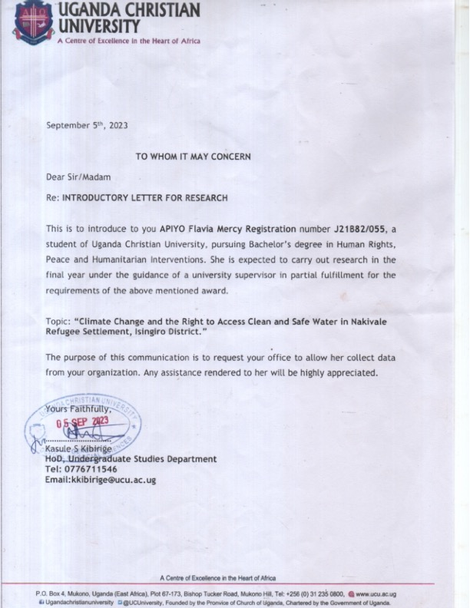

APPENDIX FOUR: PERMISSION LETTER FROM THE OPM TO COLLECT DATA.
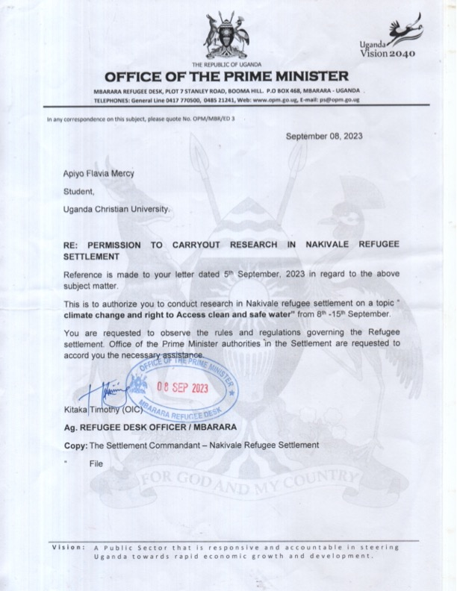

APPENDIX FIVE: PERMISSION LETTER FROM THE OPM TO COLLECT DATA
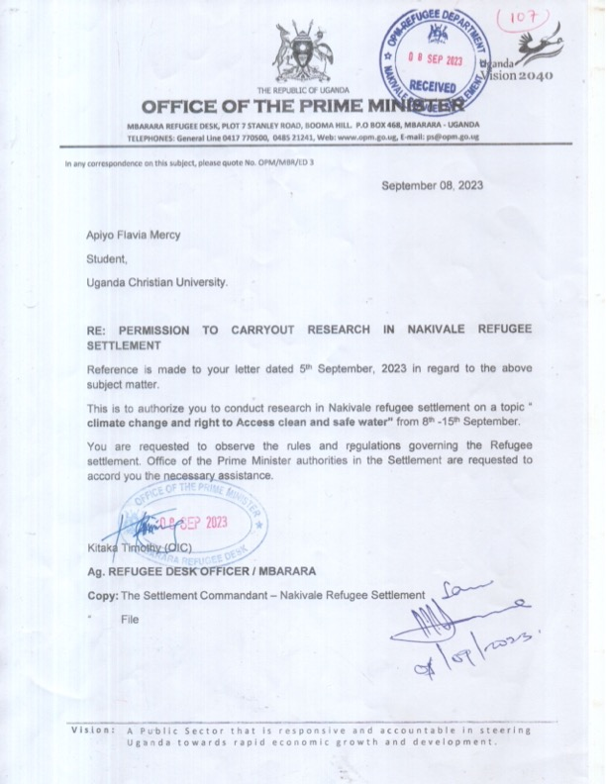

APPENDIX SIX: ACTIVITY PHOTOS DURING DATA COLLECTION
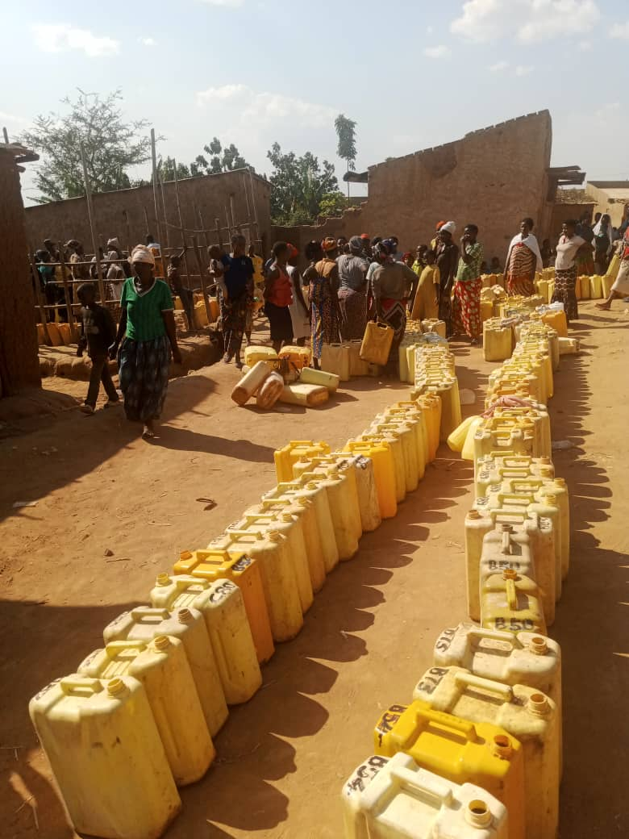

One of the long queues for water while collecting data in Nakivale refugee settlement .
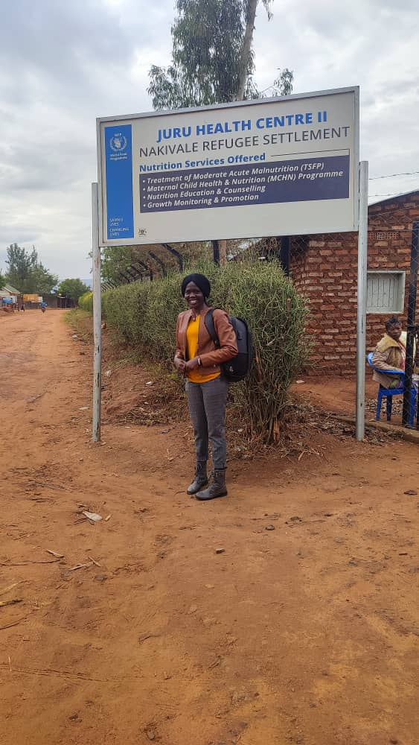

A researcher at one of the health facilities during data collection in Nakivale refugee settlement.

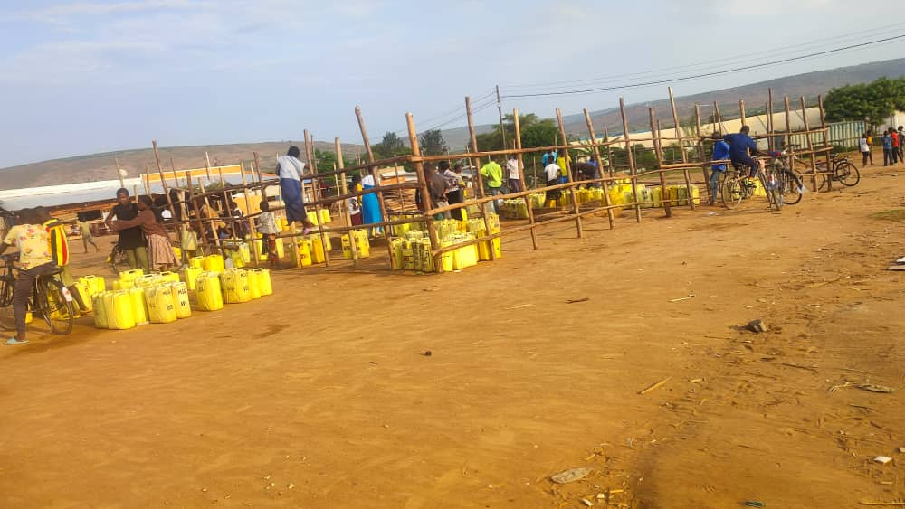

A researcher interacting with some of the women and girls at one of the water points in Nakivale refugee settlement.
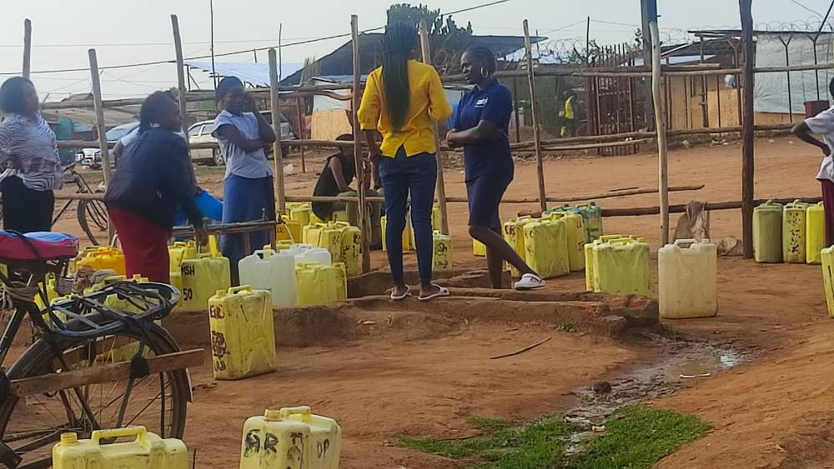
A researcher with some of the community leaders during data collection . 