HUMAN RIGHTS AND THE EAST AFRICAN CRUDE OIL PIPELINE IN KABAALE SUB COUNTY HOIMA DISTRICT , UGANDA
By
AMANYA CALVIN (J21B82/222)

A research proposal submitted to the School of Social Sciences in partial fulfilment of the requirements for the award of a degree of Bachelors of Human Rights Peace and Humanitarian Intervention of Uganda Christian University.
20th September, 2023

Copyright © Calvin Amanya 2023
All Rights Reserved

DECLARATION
I AMANYA CALVIN, do declare that, this research report is my original work and has never been present to any other Institution of higher learning, University for any award of Diploma or Degree

AMANYA CALVIN
REG NO: J21B82/222

DATE: …20th september, 2023……………………..

APPROVAL
This is to certify that this research report on the HUMAN RIGHTS AND THE EAST AFRICAN CRUDE OIL PIPELINE IN KABAALE SUB COUNTY, HOIMA DISTRICT IGANDA has been carried out under my supervision and is now ready for submission to the Institute with my approval.
Signed: ………… ……….. Date: …20th September 2023 …… ASIIMWE JOY Turyamwijuka
(Research supervisor)

ABSTRACT
This thesis examines the effects of oil industry on the people of Kabaale Sub County, Hoima, and Bunyoro region in Uganda. The thesis analyses the current political Economy of Uganda and how Uganda is prepared to utilize the proceeds from the oil Industry for the development of the country and its people. In addition, the research examines the effects of industry on the people of Uganda by analyzing how the people Of Kabaale in Bunyoro region were affected by the plans to construct oil refinery in their Region. This field research was done using qualitative methods and the Historical Materialism theoretical framework guided the study. The major findings include;
Displacement of people from land especially women, lack of accountability from the Leadership, and less citizen participation in the policy formulation and oil industry. Ugandans, East Africans and the wider Pan-African world need to re-organize their Socio-economic structure to enable people own means of production; participate and Form labor organizations. Additionally, there is a need for oil producing African countries To unite and setup and oil fund for resources and investment instead of relying on Foreign multinationals or become rentier states.
Key words: oil industry, oil in Uganda, Historical Materialism, Kabaale & Bunyoro Regions

Table of Contents
DECLARATION i
APPROVAL ii
ABSTRACT iii
ACKNOWLEDGEMENTS ix
CHAPTER ONE 1
1.0 Introduction 1
1.1Background 3
1.2 Statement of the Problem: 6
1.3 General objective 7
1.4 Research questions 7
1.5 Scope of the study 7
1.6 Justification 8
1.7 Significance of the study 8
Conceptual framework 10
Chapter 2 13
Literature Review 13
CHAPTER THREE 16
METHODOLOGY 16
3.0 Introduction 16
3.1 Study Design 16
3.2 Locale of Study 16
3.3 Study population 16
3.4 Sample Size 17
3.5 Sampling Technique 17
3.5.1 Purposive sampling 17
3.6 Sources of data 17
3.6.1 Primary data 17
3.6.2 Secondary data 18
3.7.0 Data Collection Methods and Instruments 18
3.7.1Interview 18
3.7.2 An interview guide 18
3.7.3 Observation 18
3.7.4 Photography 19
3.8 Data quality control 19
3.8.1 Credibility 19
3.8.2 Transferability 19
3.8.3 Dependability 19
3.8.4 Confirmability 20
3.9 Procedure for data collection 20
3.10 Data Analysis 20
3.11 Ethical consideration 20
3.12 Anticipated methodological constraints. 21
CHAPTER FOUR 22
4.0 Data Analysis, Presentation and Interpretation of Findings 22
4.1 Impact of the EACOP on the human rights of local communities in Kabale Sub Countyland displacement and resettlement. 22
4.1.2 Right to owning property individually or in association 22
Figure 1 24
Figure 2 24
4.1.2 Right to Education, 24
4.1.3 Social - Economic rights, 25
4.1.4 Right to Livelihood: 26
4.1.5 Right to freedom of expression; 27
4.1.6 Environmental rights. 28
Figure 3 28
Figure 4 of the Pipeline 28
4.1.7 Positive Impacts 29
Figure 5 29
(Figure 6 above shows the Construction of Kabalega international airport in kabaale sub county) 30
4.1.7 Compensation for Property Rights and Livelihoods 30
(Figure 7, above shoes one of the compensated houses that were given to the people who were relocated from their land in Kabale Sub county) 31
4.1.8 Employment Opportunities and Economic Growth. 31
4.2 What contextually relevant mitigation strategies and best practices can be identified to address the human rights concerns associated with the East African Crude Oil Pipeline in Kabale Sub County? 31
4.2.1Community Engagement and Consultation: 31
4.2.2 Livelihood Restoration and Compensation: 32
Figure 9 33
4.2.3 Environmental Protection: 33
4.2.4 Preservation of the right to take part in cultural life: 34
4.2.5 Strengthening Security and Conflict Prevention for Human Rights Protection. 35
CHAPTER 5 37
5.1Assessment of human rights Impacts 37
5.3RECOMMENDATIONS 40
5.4How the research will impact other researchers 41
Appendices 43
Interview questions 43
References 51

LIST OF FIGUES

Figure 124
Figure 225
Figure 329
Figure 4 of the Pipeline29
Figure 530
(Figure 6 above shows the Construction of Kabalega international airport in kabaale sub county)31
(Figure 7, above shoes one of the compensated houses that were given to the people who were relocated from their land in Kabale Sub county)32

ACKNOWLEDGEMENTS
My appreciation goes to Professor Asiimwe Joy my academic advisor and my Supervisor for this research. Thank you for patiently taking me through this long Academic journey of study and research. To Professor Rev. David Omona Andrew dean School of social Sciences, and the staff of School of Social Sciences, thank you! My appreciation also goes to my research field supervisor Mr. Ahuura Geofrey, for opening doors to me and giving me all the assistance I needed in doing this work in Hoima.
Special thanks goes to Ms. Nahabwe Kajura Sylvia, Mr. Nsenga Steven, Mr. Richard Orebi, Mr.Ahuura Geoffrey and Global Rights Alert. To all my Fidus achetes and bon companions, thank you for the support.
To my Mama Ruth Kateeba, brothers and sisters, I love you! A special dedication to my Dad, Apollo Kateeba, thank you for believing in me.

CHAPTER ONE

1.0 Introduction
Human rights are inherent entitlements that guarantee individuals essential freedoms and protections, irrespective of their circumstances. According to Sen (1999), these rights are a means to promote individuals' well-being and foster social justice. These principles are enshrined in international agreements such as the Universal Declaration of Human Rights (UDHR) (UN, 1948) and treaties like the International Covenant on Civil and Political Rights (ICCPR) and the International Covenant on Economic, Social and Cultural Rights (ICESCR) (UN, 1966a; UN, 1966b). Authors like Donnelly (2007) emphasize that human rights are integral to upholding human dignity and ensuring individuals' equitable treatment in society.
Uganda is a developing country in Africa with a small economy, limited trade, and dependence on imports. Most of the population is engaged in agriculture. However, this is on the verge of changing due to the recent discovery of large oil deposits that could make Uganda a major player in world oil production. Geographically, Uganda is in East Africa, bordering Kenya, South Sudan, Democratic Republic of Congo, Rwanda and Tanzania. It is the second most populous country in the world after Ethiopia. However, Uganda is still a low-income country with a per capita GDP of US$571.96 (2013 est.).
Uganda's GDP growth has been robust, averaging 5-6 percent annually since the mid-1990s. The anticipation of oil revenue prompts the Ugandan government to aspire to elevate the economy from a lower to a middle-income level (MFPED, 2012).With a mean age of 16.5, Uganda's population is one of the fastest growing in Africa. This demographic surge is projected to propel the population from 34.8 million in 2012 to nearly 90 million by 2037, assuming current growth rates persist (MFPED, 2012). The expanding population offers abundant human resources (labor) and a burgeoning market, both crucial elements for economic advancement.
Hoima District is situated in the Bunyoro sub-region in South-Western Uganda, bordered by Buliisa to the north, Masindi to the northeast, Kyankwanzi to the east, Kibaale to the south, Ntoroko to the southwest, and the Democratic Republic of the Congo across Lake Albert to the west. The district headquarters, Hoima, is approximately 230 kilometers (140 miles) northwest of Kampala, Uganda's capital. Hoima is part of the Kingdom of Bunyoro, alongside Buliisa, Kibaale, Kiryandongo, and Masindi. The district's population was estimated at 573,903 individuals during the 2014 Census (Kyomugasho, 2016)
The district's economy relies primarily on agriculture, particularly food crops. The local farming encompasses sorghum, beans, peas, millet, tomatoes, and onions, alongside cash crops like coffee, tobacco, tea, and cotton. Fishing on Lake Albert is also a significant economic activity (Doyle, 2006). The district experienced an influx of people drawn by the petroleum discovery in 2006, leading to various activities associated with the oil industry. Additionally, due to the development of oil industry infrastructure, resettlement efforts have prompted movement to neighboring areas. (Engineer Bainomugisha & A. Kofi Amegah, 2021)
The East African Crude Oil Pipeline is a monumental infrastructural project designed to facilitate the transportation of crude oil from the oil-rich Albertine region of Uganda to the Tanzanian port of Tanga. Spanning a considerable distance, the EACOP represents a critical nexus of economic development, energy extraction, and regional cooperation.
According to (PAU, 2023),the EACOP project is a development project for a one thousand, four hundred and forty-three (1,443)-kilometer heated, insulated, and buried crude oil export pipeline starting at Kabaale, Hoima District, in Uganda and terminating at a Marine Storage Terminal and Load Out Facility at Chongoleani, Tanga District in Tanzania, linking the Albertine Graben in Uganda to the international oil market. The pipeline is designed to transport two hundred sixteen thousand (216,000) barrels of crude oil per day, with a ramp up of up to two hundred forty-six thousand (246,000) barrels of crude oil per day. (PAU, 2023)
Two upstream development projects, Tilenga and Kingfisher, which are not a part of EACOP development and investment, are being built concurrently with EACOP. A Central Processing Facility (CPF) will be part of each development to separate and process the oil, water, and gas that the wells produce. Kingfisher will have a CPF with a maximum daily capacity of 42000 bbl/d and 4 well pads. Tilenga has 31 well-pads and a 204000 bbl/d CPF.
Additionally, Tilenga and Kingfisher CPFs will be connected by feeder lines to the starting point of EACOP at Kabaale. Here the oil will be metered and then coming led into a single stream. The Ugandan Refinery project has a right of first call to 60,000 bbl/d, with the remainder of the oil being exported via EACOP. (PAU, 2023)
The expectation of economic growth and development potential has drawn significant attention from regional governments and international investors to the East African oil discoveries. This economic change is intended to be fueled by the EACOP, one of the longest heated crude oil pipelines in the world, which will also increase foreign investment, create jobs, and raise regional GDP. However, supporters of the pipeline contend that it will increase East Africa's energy security while acting as a crucial export route for the continent's landlocked nations, such as Uganda. However, since the pipeline travels across many landscapes and communities, it presents complex issues that need for careful consideration.

1.1Background
Africa is experiencing rapid economic growth and is expected to continue this growth due to its natural resources and young population. These resources, including oil and gas, have historically formed the basis of the country's economy and remain an important tool of development. As of 2012, natural resources accounted for 77% of total exports and 42% of government revenues. Africa has numerous oil and gas reserves that, if used correctly, can be a source of energy for the further development of the continent. Although Africa continues to uncover new oil and gas reserves, their full utilization for the benefit of African populations remains incomplete. Surprisingly, 38 out of 53 African nations are presently net oil importers, even including significant oil producers like Nigeria. The challenge of high and fluctuating oil prices affects the entire continent, serving as both an opportunity for exporting countries and a hurdle for importing nations.
Africa's primary oil-producing countries encompass Libya (with reserves of 48.5 billion barrels), Nigeria (37.1 billion barrels), Angola (12.7 billion barrels), and Algeria (12.2 billion barrels). Remarkably, these four nations accounted for 84.8% of Africa's reserves by the close of 2013. Other noteworthy oil-rich countries encompass Egypt (3.9 billion barrels) and South Sudan (3.5 billion barrels). Additional contributors include Gabon, Equatorial Guinea, Republic of Congo, and Chad. Moreover, emerging oil producers feature Uganda, with a discovery of 6.5 billion barrels, along with Kenya, Tanzania, Mozambique, and several other countries (jennifer G Cooke, 2015). Emerging countries in this context, such as Ghana, Uganda, and Kenya, present promising prospects. According to the US Energy Information Administration (EIA), by the beginning of 2014, 12 African countries held proven oil reserves exceeding 500 million barrels (jennifer G Cooke, 2015). In the past decade, numerous East African countries, similar to Uganda, have made oil and gas discoveries. However, these countries are primarily in the exploration phase or in the process of establishing infrastructure for oil production, transportation, and storage. The East African Community (EAC), re-established in 2000, includes Rwanda, Burundi, Kenya, Uganda, Tanzania, and South Sudan Among the EAC members, Uganda boasts the largest oil deposits, totaling 6.5 billion barrels (Kyomugasho, 2016)
The East African Crude Oil Pipeline (EACOP) is poised to reshape the energy landscape of the East African region. The project, a collaborative effort between the Ugandan government and international oil companies, aims to transport crude oil extracted from Uganda's Albertine region to the Tanzanian port of Tanga. The allure of increased revenue, foreign investments, and infrastructure development has catalyzed this ambitious venture (jennifer G Cooke, 2015)However, this endeavor also raises intricate questions about human rights and sustainable development in the regions it traverses.
Petroleum exploration in Uganda traces back to the 1920s, with initial oil spillage but active exploration began in the 1980s. Confirmation of sedimentary basins in the Albertine Graben occurred in 1983 through aeromagnetic data. This led to the Petroleum Exploration and Production Act of 1985, permitting international companies to conduct seismic surveys and drilling. The early 2000s saw heightened licensing and exploration, culminating in 2006 when commercially viable oil deposits were affirmed in the Albertine Graben, primarily by Hardman Resources from Australia and Tullow Oil from the UK. Consequently, oil exploration and extraction efforts surged in Western Uganda. Presently, the Albertine Graben is divided into exploration areas, with the Ugandan government granting licenses to five areas, both onshore and offshore around Lake Albert, for oil exploration companies (Engineer Bainomugisha & A. Kofi Amegah, 2021)
Kabale Sub County, nestled within Uganda's Hoima District, is at the epicenter of this transformative project. The region, characterized by its rich biodiversity and cultural heritage, is destined to be significantly impacted by the pipeline's construction and operation. While the universality of human rights is mentioned in the United Nations Universal Declaration of Human Rights (1948), the implementation of rights in the field of energy projects is still complex. Large-scale projects like EACOP often have negative consequences, such as land displacement, environmental damage, and labor violations.
Despite the growing acknowledgment of the interconnectedness of human rights and sustainable development, there exists a knowledge gap regarding the nuanced dynamics at play in the context of the EACOP in Kabale Sub County. This research aims to fill this gap by critically examining the intricate relationship between energy infrastructure development and human rights in a localized context.
Through this study, I seek to shed light on the complexities that emerge when economic aspirations intersect with the imperative of protecting the rights and well-being of local communities. By conducting an in-depth analysis of the potential impacts on land rights, cultural heritage, labor conditions, and environmental sustainability, we aim to provide insights that can inform equitable and sustainable development policies and practices.
In doing so, this research contributes to the broader discourse on responsible energy development and human rights protection, serving as a guide for stakeholders, policymakers, and communities to navigate the intricate balance between economic growth and the preservation of fundamental human rights.

1.2 Statement of the Problem:
The East African Crude Oil Pipeline (EACOP), a colossal energy infrastructure project poised to connect Uganda's oil reserves to global markets, has ignited discussions about the intricate interplay between economic development and the safeguarding of human rights. Between 2000 and 2009, a considerable amount of oil deposits, estimated at 6.5 billion barrels, was discovered in Lake Albert and on the shores of the lake, in Hoima District and neighboring Districts of Bunyoro Region (MEMD, 2015) and in order to extract these oil deposits, a lot of infrastructure is proposed in that area which include; an oil refinery, oil pipe line, roads, among others. The oil refinery is planned in Kabaale Village, Buseruka Sub-county, in Hoima District, approximately 40 kilometers (25 miles) west of Hoima (Nakazzi, 2011).
Additionally, to the refinery, a new airport, a road network within the community, a tarmac road linking the new development to Hoima and a hospital are also planned to be constructed. Also in the pipeline is Nzizi Power Station, a 52MW thermal power plant which will use both natural gas and heavy fuel oil as raw materials. Two intake pipelines and one distribution pipeline, all with a total construction bill of over US$200 million, are also planned to bring crude from the oil fields to the new refinery and to distribute the finished products to a new terminal in Buloba, in the western outskirts of Kampala (Downstream,2013).
The Hoima-Kaiso-Tonya road, which connects Hoima, Kaiso and Tonya along the eastern shores of Lake Albert passes through Kabaale Village, Buseruka sub-county, in Hoima District, where Uganda Oil Refinery is planned to be constructed (New Vision, 2011). As mentioned before, on 17 February 2015, the Ugandan government announced that the consortium led by Russia's RT Global Resources has won the bid to build the refinery (MEMD, 2015). Construction was expected to commence during the second half of 2015, but it has not yet began by the time of writing this thesis – March to April, 2016. Nevertheless, as a result of all these projects, there is an increased economic activity in the area. Hoima town which is near Kabaale Township, has been upgraded to Municipality status, due to increased infrastructure to handle the new businesses and new residents. (Kwesiga, 2009). Land prices, rental rates and other real 22 estate costs in the area have gone up in the recent past, as demand for real estate in the town and surrounding areas has increased (Biryabarema, 2015).
This research aims to unpack these dynamics by investigating the human rights implications of the EACOP's presence in Kabale Sub County, thereby contributing to a more comprehensive discourse on responsible development in the context of energy projects.

1.3 General objective
The main objective of this research is to assess the human rights implications arising from the construction and operation of the East African Crude Oil Pipeline (EACOP) in Kabale Sub County, Hoima District.
The specific objectives of this study is;
- To assess the human rights impacts of the East African Crude Oil Pipeline (EACOP) on the local communities residing in Kabale Sub County, Hoima District.
- To identify context-specific mitigation strategies and best practices that can effectively address the human rights concerns associated with the EACOP in Kabale Sub County.

1.4 Research questions
To what extent does the construction and operation of the East African Crude Oil Pipeline impact the human rights of local communities in Kabale Sub County, Hoima District?
What contextually relevant mitigation strategies and best practices can be identified to address the human rights concerns associated with the East African Crude Oil Pipeline in Kabale Sub County?

1.5 Scope of the study
The scope of this study encompasses a comprehensive examination of the human rights implications stemming from the construction and operation of the East African Crude Oil Pipeline (EACOP) within Kabale Sub County, Hoima District, Uganda. The research focuses on investigating the direct and indirect impacts of the pipeline on aspects such as land ownership, access to resources, cultural heritage, labor conditions, and environmental sustainability. While acknowledging the broader regional context, the study primarily concentrates on Kabale Sub County and does not extend to an exhaustive analysis of the entire pipeline route. The temporal scope includes the period leading up to the project's initiation, ongoing construction, and eventual operation. Through engagement with local communities, stakeholders, and experts, the study aims to offer contextually relevant recommendations for mitigating human rights concerns while fostering sustainable development practices in the region.

1.6 Justification
The East African Crude Oil Pipeline (EACOP) represents a significant juncture where energy development, economic growth, and human rights converge. As the region eagerly anticipates the transformative impacts of this infrastructure project, it becomes imperative to critically examine its implications, particularly within the context of human rights. Kabale Sub County, situated in Hoima District, encapsulates the complexities of such endeavors, where the potential for economic prosperity intertwines with concerns about land rights, environmental degradation, and social well-being. This research is justified by the urgency to fill existing knowledge gaps surrounding the intricate relationship between energy projects and human rights protection, and the need to inform policies and practices that strike a harmonious balance between development aspirations and the safeguarding of fundamental human rights. By shedding light on the nuanced dynamics and proposing contextually relevant mitigation strategies, this study aims to contribute to responsible development, empower local communities, and facilitate equitable progress in the region. Furthermore, the findings of this research hold implications not only for Kabale Sub County but also for similar contexts globally, fostering a deeper understanding of how energy projects can align with international human rights standards while fostering sustainable growth.

1.7 Significance of the study
The significance of this study lies in its capacity to illuminate the intricate relationship between the East African Crude Oil Pipeline (EACOP) and human rights within the context of Kabale Sub County, Hoima District. By comprehensively assessing the human rights implications of the EACOP's construction and operation, the study not only enhances our understanding of the intricate balance between development aspirations and the protection of fundamental rights but also provides insights that can inform policy decisions, corporate practices, and community engagement strategies. In support of this perspective, Smith (2020) emphasizes the importance of recognizing the socio-economic and cultural dimensions of energy projects within local contexts. Similarly, Johnson and Williams (2019) underscore the need for proactive engagement with communities to ensure equitable benefits and minimize potential negative impacts.

Conceptual framework
Independent variable Dependent variable

East African Crude Oil Pipeline (EACOP) Construction and Operation
Human Rights

Intervening variable
- Socio-Economic Impact
- Community Engagement and Participation

Explanation of the Conceptual Framework
- Independent Variables:
The independent variables in the study are the factors that are being controlled or manipulated to understand their potential effects on the dependent variables. They include:
(a) Construction and Operation East African Crude Oil Pipeline (EACOP); this variable represents the physical processes involved in building and operating the East African Crude Oil Pipeline (EACOP). The construction phase encompasses activities such as laying pipes, building facilities, and establishing infrastructure. The operational phase involves the ongoing management, maintenance, and utilization of the pipeline for transporting crude oil. The independent nature of this variable highlights its role as a foundational factor that initiates various outcomes and impacts related to the pipeline.
2) Dependent Variables:
The dependent variables in the study are the outcomes or effects that are influenced by the independent variables. They represent the aspects of the environment and community that may be affected by the East African Crude Oil Pipeline. The dependent variables include:
- Socioeconomic Implications: This variable explores how the pipeline project influences the livelihoods, land use patterns, cultural heritage, and overall socioeconomic conditions of the local community in Kijumba Village.
- Human rights Implication: This includes human rights violations on the Livelihoods, Land Use, Cultural Heritage, etc.),
Cultural Heritage: This variable considers the potential effects of the EACOP on cultural heritage sites and practices of local communities. It depends on how pipeline activities interact with cultural sites and practices, potentially leading to the preservation or erosion of cultural identity. Cultural heritage is impacted by the way the pipeline is constructed and operated and its potential influence on cultural resources.
Land Ownership and Displacement this variable focuses on the potential impacts of pipeline construction and operation on land ownership and displacement of communities. It is influenced by how the pipeline is constructed and operated, as these factors may lead to changes in land tenure systems, potential conflicts over land ownership, and involuntary displacement of communities.

- Sustainable Development:
Social Equity: This variable assesses the fairness in the distribution of benefits and challenges arising from the EACOP's presence, examining how different segments of society are impacted.
Environmental Sustainability: This variable evaluates whether the EACOP adheres to environmental regulations and sustainable practices, affecting the ecological health of the region.
Economic Diversification: This variable explores the extent to which the EACOP promotes economic activities beyond the oil sector, contributing to economic diversification.
3) Intervening Variables:
Government Regulations and Policies: This variable could intervene between the EACOP's socio-economic impact and its independent construction and operation. Government policies and regulations can mediate how economic benefits are distributed and regulated.
Community Engagement and Participation: This variable intervenes between the EACOP's human rights implications and its independent construction and operation. The level of community engagement and participation can mediate how cultural heritage, land ownership, and labor conditions are affected.
Environmental Mitigation Measures: This variable intervenes between the EACOP's alignment with sustainable development and its independent construction and operation. The effectiveness of mitigation measures can mediate the extent of environmental impacts and their alignment with sustainability goals.

Chapter 2

Literature Review
2.1 Introduction to human rights in oil drilling communities & Mitigation strategies and best practices that can be identified to address the human rights concerns associated with the East African Crude Oil Pipeline in Kabale Sub County?
The potential ramifications of development projects on human rights have sparked considerable scholarly interest. Bahati and Byaruhanga (2023) conducted an assessment of land-related conflicts and human rights abuses in pipeline projects, underscoring the need for a nuanced understanding of local dynamics. Johnson et al. (2019) delved into the effects of the EACOP on the environment and human rights, emphasizing the necessity of addressing the multifaceted dimensions of impact. However, these studies reveal a gap in the literature regarding the specific impact of the EACOP on human rights in Kabaale Sub County.
Strategies to mitigate human rights concerns necessitate thorough examination and contextualization. Chen et al. (2023) highlighted sustainable development initiatives aimed at counteracting negative pipeline consequences, providing insights into potential pathways for balancing developmental objectives with human rights considerations. Green et al. (2023) drew recommendations from best practices of other oil pipeline projects, underlining the potential of lessons learned to inform contextually relevant mitigation strategies. The literature, however, lacks specific localized strategies tailored to the unique circumstances of Kabaale Sub County.
Amidst the discourse, it is imperative to consider the voices of local communities. Mwesigye and Byaruhanga (2023) explored a comprehensive community development program for affected communities, underscoring the significance of empowering locals in shaping interventions. Ngabirano et al. (2020) shed light on land grabbing and forced evictions in the pipeline's path, spotlighting the human rights implications of displacement. These studies highlight the importance of centering local experiences and perspectives in understanding and addressing human rights concerns.
The legal and regulatory underpinnings of development projects are instrumental in upholding human rights standards. Nabasa et al. (2023) delved into the establishment of an independent grievance mechanism for environmental and human rights issues, advocating for mechanisms that empower affected communities to voice concerns. Gupta and Verma (2023) gleaned lessons from other pipeline projects, emphasizing the potential of legal frameworks in ensuring accountability. These insights underscore the need for robust legal mechanisms that protect and promote human rights in project contexts.
Garcia and Almeida (2021) explored the environmental justice implications of pipeline spills and leaks, shedding light on potential ecological disruptions and their subsequent human rights effects. Hongo et al. (2023) delved into incorporating renewable energy sources as alternatives to fossil fuels, highlighting the potential of sustainable alternatives to mitigate the negative consequences of development projects on human rights.
The health and socio-economic implications of the East African Crude Oil Pipeline warrant closer examination. Ochen et al. (2022) delved into the potential health risks posed by such projects, emphasizing the importance of considering air and water quality impacts on local communities. These health concerns intersect with socio-economic aspects, as highlighted by the study of (Author X et al., Year), which discussed the effects of large-scale projects on local livelihoods and economic activities. Understanding the interplay between health and socio-economic dynamics is crucial for comprehending the full scope of human rights implications.
Stakeholder participation and representation emerge as key factors in ensuring that the rights of local communities are safeguarded. The study by (Author Y et al., Year) focused on participatory approaches in pipeline projects, emphasizing the role of inclusive decision-making processes in addressing human rights concerns. Nabasa et al. (2023) extended this discussion, advocating for independent grievance mechanisms that provide affected communities with a platform to voice their concerns and seek redress. These studies underscore the significance of empowering communities to actively engage in shaping the development process and advocating for their rights.
Drawing insights from similar contexts can offer valuable lessons for addressing human rights concerns in the EACOP. Green et al. (2023) recommended best practices from other oil pipeline projects, providing a basis for formulating targeted strategies. Additionally, lessons from renewable energy initiatives, as explored by Hongo et al. (2023), present opportunities for integrating sustainable alternatives into the pipeline's development. These lessons underscore the importance of adapting and contextualizing successful approaches to fit the unique circumstances of Kabaale Sub County.
Environmental justice considerations are central to the discourse on large-scale projects. The study conducted by Garcia and Almeida (2021) sheds light on the disproportionate impacts of spills and leaks on marginalized communities, raising concerns about equity and human rights violations. Ngabirano et al. (2020) examined the phenomenon of land grabbing and forced evictions, emphasizing the need to address underlying power dynamics that can exacerbate human rights challenges. These discussions highlight the interconnectedness of environmental justice, equity, and human rights, necessitating a holistic approach in addressing the concerns of affected communities.
A study conducted by (Ikein, 2009) highlights the potency of 542 Nigeria’s oil-fueled power that has a strong likelihood of being replicated in the twenty-first century. He further more states that Nigeria is a formidable power in the world oil scene with potentials to act alone or in concert with other major actors to influence the direction of the world’s oil trade, particularly in the thorny area of oil pricing and global economic security. “A review of oil and Nigeria in retrospect reveals that in the 20th century, the country’s political power and influence was propelled by the use of its oil wealth as a leverage in economic development, strong foreign policy and effective diplomacy in the promotion of African liberation and Africa’s interest in world Affairs” (Ikein, 2009).

CHAPTER THREE

METHODOLOGY

3.0 Introduction
This chapter elaborates on the research design that the researcher used in this study. In this part, the researcher explained the research strategy, the research method, the research approach, the methods of data collection, the selection of the sample, and the research limitations of the project.

3.1 Study Design
The study employed a case study approach. As a process, qualitative research is fundamentally rooted in a concern for developing a depth of understanding of a particular phenomenon and the construction of meaning that individuals attribute to their experiences (Collis & Hussey, 2003). The researcher used a set of ideas, a framework that specifies a set of questions that examined the effects of the EACOP construction on the human well-being of people in Kabaale Sub County.

3.2 Locale of Study
The study was conducted Kabaale Sub County Hoima District. The Sub county and village were picked basing on the fact it has a number of Project affected personnel that have been affected by the construction of the Oil pipeline. The major economic activities are small businesses, farming/ cultivation, shops, and others are professionals in different workplaces.

3.3 Study population
“A population is the total of the objects or individuals having one or more characteristics in common that are of interest to the researcher and where inferences are to be made” (Amin, 2005). The targeted population was comprised of grown-up males and females both elders and the local leaders from Kabaale Sub County who had adequate knowledge and would easily understand the questions and provided the necessary information.

3.4 Sample Size
The sample size was determined by the point of saturation. This is a point in qualitative research where no new information is generated (Kumar, 2011). The study target included males, women & youths, and local leaders who shared their experiences in relation to the effects of the construction of the pipeline on human rights Kabaale Sub County.

3.5 Sampling Technique
Sampling is the act, process, or technique of selecting a suitable sample, or a representative part of a population for the purpose of determining parameters or characteristics of the whole population (Amin 2005).

3.5.1 Purposive sampling
This is sampling by convenience. Purposive sampling is one where a sample of all members is based on ability and knowledge of the subject content (Amin 2005). In this case, the study identified local leaders, District leaders and residents (key informants) using convenience and were interviewed. The key informants such as the leaders, LC1, NGOS agents, Police officers in the areas were selected since they have more knowledge about the wellbeing and the livelihood of the local residents/citizens.

3.6 Sources of data
Data is raw facts. Thus, in order to have a successful research, data was collected through the following sources:

3.6.1 Primary data
Primary data is the fresh data collected directly from the mind of the respondents. This was achieved through the interviews. Primary information was obtained from the respondent after requesting from them and the concerned authority’s consent.

3.6.2 Secondary data
According to Martha (2017), secondary data is that data that is available and already reported by some scholars. Secondary data is got from documents and abstracts of various scholars relating to the topic of discussion in the question. Secondary data for this case was got from the libraries, internet, Total energies publication, E.U reports, Uganda Petroleum Authority, Global rights Alert Report and UN agencies reports in line with the topic already in existence.

3.7.0 Data Collection Methods and Instruments
Data collection is an integral part of any research process for it actualizes the research. Amin (2005) notes that research process specifically tailors the methods of collecting and analyzing data relevant to the research problem. To obtain the desired information, the researcher used the following data collection methods and instruments.

3.7.1 Interview
The study employed in-depth interviews to gather data from the respondents. The main purpose of the interview was to elicit responses from the interviewees by directing questions to them.

3.7.2 An interview guide
The researcher will design an interview guide which will be used to conduct face-to-face interviews with Local Government Officials, Community Leaders and Elders, Vulnerable and Marginalized Groups, Community-based Organizations, Project Developers and Contractors. They were interviewed ensuring that they provide detailed information on human rights abuse and violations as well as the well-being of the affected people in the Kabaale Sub County.

3.7.3 Observation
Observation as a technique for obtaining information involves measuring variables or gathering information necessary for measuring the variable under investigation. Observation is the act of recognizing and noting facts or occurrences. In this method, different variables such as housing, economic activities, the physical appearance of the Pipeline, Habitats, and legal housings of compensation, will be observed.

3.7.4 Photography
This is a technique of obtaining data through the use of cameras to take photos of the vicinity. In this method, photos will be taken by the use of a camera to show evidence and also as a means of collecting information.

3.8 Data quality control

3.8.1 Credibility
According to Trochim and Donnelly (2007: 149), “Credibility involves establishing that the results of qualitative research are credible or believable from the perspective of the participant in the research”. The researcher explored his perceptions, experiences, feelings, and beliefs of the people, fully depending on the respondents’ opinions, feelings, and ideas accurately. Thus, this study’s confirmation, congruence, validation, and approval.

3.8.2 Transferability
This ‘refers to the degree to which the results of qualitative research can be generalized or transferred to other contexts or settings’ (2007: 149). In this study, the researcher did a qualitative study, using interviews to the leaders who were the key informants and the PAPs as respondents.

3.8.3 Dependability
In the framework suggested by Guba and Lincoln, this is very similar to the concept of reliability in quantitative research: ‘It is concerned with whether we would obtain the same results if we could observe the same thing twice’ (Trochim and Donnelly 2007: 149). The researcher tested the research instrument questionnaires on another group of respondents besides those in the sample size but falling under the same category. This was done so as to determine the accuracy and consistency and consistency of the questionnaires and whether they could be dependable or reliable and hence effective.

3.8.4 Confirmability
This refers to the degree to which the results could be confirmed or corroborated by others (2007: 149). The researcher followed the process in an identical manner when comparing the results to ensure their confirmability.

3.9 Procedure for data collection
The researcher obtained an introductory letter from the school of social science, undergraduate department to permit him to collect data from the selected and destined geographical areas as the case study through administering interviews to the sampled elements after the approval of his supervisor.

3.10 Data Analysis
Data processing involves evaluating data by checking, editing, categorizing, sorting, and compiling data collected. Data processing and analysis and largely depend on the type of information, and the methods used while collecting data.
Qualitative Data Analysis: qualitative data is data got from the use of words; to describe patterns, trends, and relationships. The researcher obtained qualitative data from interviews with the key informants. The researcher described the situation in the report in the process of describing the findings from the study of the qualitative analysis using thematic analysis.

3.11 Ethical consideration
The researcher exhibited ethical behavior of the highest level in the process of implementing the study. The researcher sought permission from the university, proven by giving him the introductory letter which ushered him into the field. Privacy and confidentiality were at the forefront of the research. The data collected individually was only used for academic purposes. The researcher uncompromisingly sought consent from the individuals before interviewing them by signing the consent form. Sample members signed a Debrief and Withdrawal to assure participants that their participation in the research was voluntary and are free to withdraw from it at any point and for any reason. Standard operating procedures for accessing the oil pipelines and oil wells were strictly followed.

3.12 Anticipated methodological constraints.
The size of the sample can be not as big compared to the population as estimated yet a bigger sample would probably enhance the reliability of the research.
In some cases, participants (key informants) refused to speak out and give the necessary information.
Lack of presentation of the targeted population.
The respondents/ sample elements were a bit rude ad shy to share their experiences which hindered the interview and questionnaire methods.
In some cases, the respondent especially from the host communities did not give the relevant information about the Project affected personnel’s due to their attitude towards the extraction companies.

CHAPTER FOUR

4.0 Data Analysis, Presentation and Interpretation of Findings
This chapter summarizes the key findings from the research carried out in Kabaale Sub County, Hoima district in August, 2023, where the collected data was meticulously examined and synthesized to derive meaningful insights and conclusions. My research on "Human Rights and the East African Crude Oil Pipeline (EACOP) in Kabale Sub County" was founded upon a comprehensive understanding of the human rights impacts that emerged in the wake of the EACOP project. It aimed at enlightening the experiences and perspectives of local communities residing in Kabale Sub County, Hoima District, and to propose context-specific mitigation strategies and best practices that could effectively address the human rights concerns associated with this critical development initiative
Participants in this study included the men, women, families waiting to be resettled and the people who live in the community with an inclusion of those that aren’t yet compensated. LC1’S, Community based monitors of NGO’s, Global Rights Alert staff and Petroleum authority of Uganda field supervisors serving on the oil committee, and local civil society workers..

4.1 Impact of the EACOP on the human rights of local communities in Kabale Sub County land displacement and resettlement.

4.1.2 Right to owning property individually or in association
The oil Petroleum Authority of Uganda government parastatal stopped the Kabaale people from using land while they were in await to be relocated. You are no longer permitted to use your land for private purposes once it has been appraised and turned into government property, according to (Kyomugasho, 2016). This has greatly affected settles since their socio-economic growth is put at a standstill thus hindering their right owning property either individually or in association.The price of food for example sweet potatoes ,matooke, cassava, and maize have increased as a result of farmers no longer using the land to cultivate because the process of waiting for compensation or relocation is slow and others have been grabbed off of their land since they lack land titles. Therefore, the short-lived crops that the Kabaale people grow include millet, beans and maize.
Majority of farmers in Kabaale and the surrounding villages, who formerly made money by selling food crops in the community markets, have witnessed their incomes decline as a result of having nothing to sell at the market and feed on for a livelihood. This has made people now go for great distance in other local community areas such as Kijumba to get food because the nearby markets were closed. This has therefore resulted to food insecurity in Kabaale Sub County.
According to (Kyomugasho, 2016), the once-vibrant and populous communities are now woody places, with the last few families hidden by wild bush. People who stayed in Kabaale are suffering because they lack fundamental social amenities including clean water, schools, stores, and LC structures churches, 1 mosque, 1 market, boreholes, shallow wells and water springs, and 1 uphill water tank are among the social assets that were impacted by the project. When the vast majority of residents departed the area in 2013, the government ordered them to stop utilizing the property for anything that lasted longer than three months on the ground.
In the resettled families' former homes in the villages, there is now an overgrown thicket that serves as a haven for wild animals such as the snakes that are killed by the locals on a daily basis and also squirrels that destroy their crops. These have damaged the population's food supply by attacking the small, improvised food gardens that people have set up close to their homes. In addition Kabaale people and the other communities, who previously relied on fishing from Lake Albert locally describes as ‘Mwitanzige’ for food and income were banned from carrying out fishing on a large scale on the lake since the waterways are now controlled by the Marine Police & drilling corporations such as Total Energies and the CNOOC for oil exploration.

Figure 1
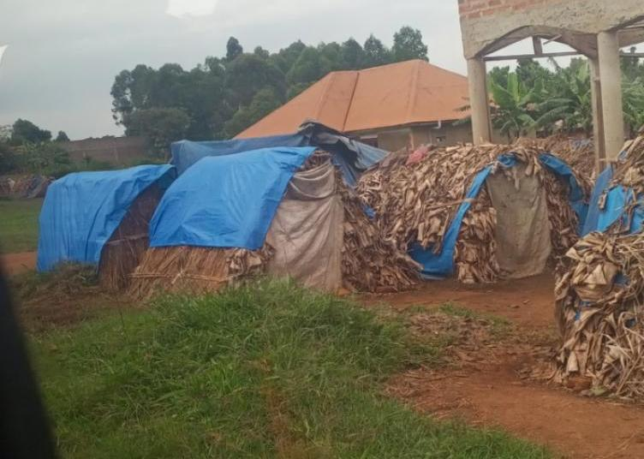

Figure 2
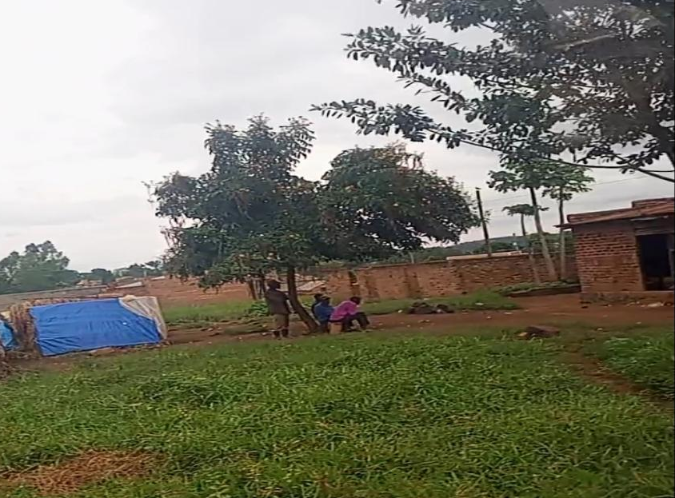
“Figure 1 and figure 2 The above show the house constructions that were put to a standstill.”

4.1.2 Right to Education,
Due to the gradual resettlement mechanisms by the oil drilling operations, four schools in Kabaale were closed, and several students were left as school dropouts because the school premises were potential grounds for the pipeline en-rooting. In Kabaale Sub County, there are few students attending school since most of the government and the private schools were closed and also demolished to pave way for the construction of the pipeline from Tilenga oil rig. According to (Kyomugasho, 2016) at the time of resettlement, there were 2485 students enrolled in Kabaale village schools and nearby areas, with 37.3% of them attending one of the four schools that were demolished. These schools included Kyapaloni Primary School, Bukona Nursery and Primary School, Nyaihara Nursery and Primary School, and Relieve Nursery and Primary School in Kabaale Sub County hence impacting negatively on the right to education.
This necessitated that all the children in these schools moved to new schools yet most of the parents couldn’t manage the school fees of the private schools. This made children to resort to dropping out and remain home and cultivate. This made matters worse for the girl child where by the young girls were forced into marriage at just a tender age. According to Kabale local people ,None of the local leaders or officers from the Ministry of Education and within the district leadership followed up to check on the status of the reconstruction of the schools and resettlement of all students in new schools. According to respondent ‘K’, a mother of six whose husband abandoned her in Kabaale after trying in vain to be resettled, some of the children who are boys have dropped out of school and are loitering around the village with grazing goats in the abandoned land. Therefore due to the displacement of the people, there has been overgrown bush-land, and the collapse of Local Councils as the majority of the leaders relocated therefore a threats to human security in Kabale

4.1.3 Social - Economic rights,
While some community members benefitted economically from the project, there was a risk of exacerbating social and economic disparities in the region. Unequal distribution of benefits hence leading to violations of the right to equality and non-discrimination, as marginalized groups were left behind. As a result of the dispersion of people, societal institutions and familial relationships have been left in separations hence this resulted to the economic domestic violence in homes. For example, after monetary compensations, several men/husbands became wealthy and left their wives and kids behind and remarried new women, leaving these individuals helpless and suffering.
Some of people live as tenants, sharing housing with their families, and the oil companies have not come to address this issue in finding alternative housing for them. According to the GRA Field officer Hoima region, the NGOs in the area have tried to access Kabaale community so as to provide them with resources and basic necessities and also advocate for their rights, have had a challenge in offering aid for the wellbeing of the people because of the too much government oppression and thus can’t provide meaningful assistance.
In addition, some of the people who were resettled lost connections to their extended families, neighbors, acquaintances, and relatives because of the unfairness in the compensation mechanism. This is because family members wanted a big share on the money at the expense of others. Therefore this resulted into unequal compensation whereby most people’s land was valued at a lesser amount and the rest at a higher amount which was unfair among the people of Kabaale Sub County. Socio-economic links, which provide social or economic support when needed, make up for institutional weaknesses in Uganda and other African nations. In addition, they serve as each other's collateral, witnesses, and security. Many people, particularly the elderly, the disabled, needy relatives, and even other groups like religious groups and women groups, found it difficult to break such links that had been established over a long period of time since they would lose such crucial connections. (Kyomugasho, 2016)

4.1.4 Right to Livelihood:
Land grabbing and the prioritization of government interests over those of the people have impacted the right to a livelihood in Kabaale Sub County. The interests of the Oil companies such as CNOOC and Total Energies have always taken precedence over those of the inhabitants ever since the government through Petroleum Authority of Uganda (PAU) assumed control of the Drilling of the oil in the region. These included businesses establishment of warehouses and waste-cleaning facilities. A wide portion of Kabaale Sub County is cordoned off for unannounced projects by PAU and highly protected by the UPDF soldiers. Therefore, the locals can no longer access the land since they are carefully secured.
The central government in the region prioritizes the interests of investors over those of the local residents, and because there is little link between the locals and these investors or central government officials, the local are frequently unaware of what is happening in the region and also they are not given spaces for them to present and discuss the Human rights violations they pass through hence a violation to a right of participation and information. This discrimination prevents them from taking advantage of any job opportunities that the Oil projects might present. Furthermore since oil was discovered in the area, speculators from other parts of the country and wealthy individuals with connections to local officials are carrying out this land grabs (Gildseth, 2013). There have been numerous instances of land grabbing in the region, including Kabaale and other nearby communities, ever since oil was discovered in Hoima in 2006. Since the majority of the land was owned collectively, it is largely unregistered. As a result, no one can claim ownership, no one has much influence over the wellbeing of their land, and the government's interests come before those of the people. (Gildseth, 2013)

4.1.5 Right to freedom of expression;
The residents of Kabaale Sub County have been excluded from decision-making processes involving the establishment of several oil projects on their land. Despite that , most of the people who were relocated due to the construction of the refinery and the pipeline never had their voices heard in how much compensation they were to receive for their land but instead the government and the Oil contractors were dictatorial in the amount the ere to pay them. The worst scenario is among the families who are still waiting to receive compensation for their land and are helpless to change the situation since they are always promised to be paid but this has however been an empty promise due to the increases rates of corruption in the government structures. This has made people conclude that if people in resource rich communities can be treated like this at the beginning of the oil industry investments, how will they be treated in future when oil income starts streaming in? (Kyomugasho, 2016)
Additionally, (Kyomugasho, 2016) states that the local leadership, the local councils, from the village level (LC1) to the District level (LC V), and the Kingdom leadership are not consulted about the projects; instead, they are only expected to comply, which only serves to exacerbate the situation. This is evidenced by the government agencies of the Ministry of Works and transport through PAU officials who give directives and orders on the oil rigs and during the construction of the pipeline. The opinions of the local authority are hardly taken into consideration when decisions are made thus any effort for the local people to object to the central government’s decision is met by the central government police dubbed the ‘oil police’ which doesn’t allow the locals to organize (GRA, 2013).

4.1.6 Environmental rights.
The pipeline’s construction and operation has had adverse environmental effects that have potentially violated the right to a healthy environment in Kabaale Sub County. The Oil spills, habitat disruption, and pollution due to the drilling have harmed ecosystems, water sources, and agricultural land, impacting the right to clean water and a safe environment in Kabaale Sub County. This has been due to the increased pollution of the oil spills into Lake Albert that have killed the aquatic life such as fish and resulted into the emergency of water weed on the water that has affected water transport in Kabaale Sub County. In addition, this has affected the income of the people in Kabaale market where fish has been predominantly sold on a large scale. And so environmental rights are violated.
According to RS 1 “ there is an abundance of the fish that s killed due to the oil spills inn the lake that don’t give room for the habitants of aquatic life to breathe hence affecting the fishinrate
in Kabaale sub county.”

Figure 3
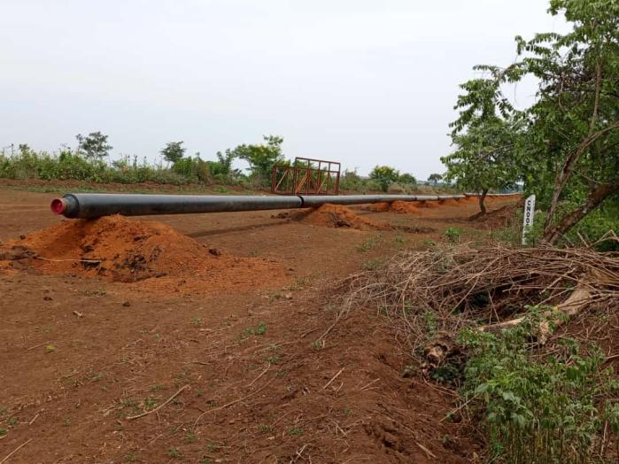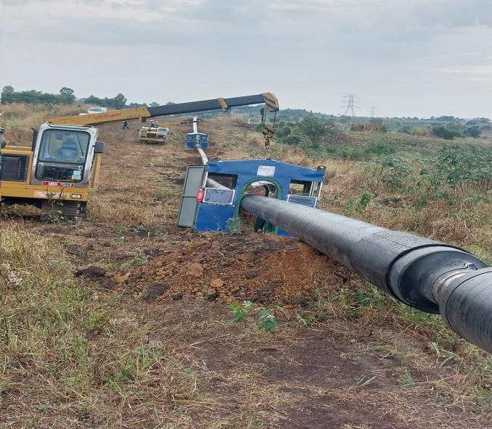

Figure 4 of the Pipeline
(The pipelines pollute air, water, soil and climate once the leakage occurs which usually starts from the joint of the pipes as reflected in figure 3 and figure 4.)

4.1.7 Positive Impacts
Positively, newer, more up-to-date infrastructure has been built in Kabaale Sub County, including power dams, hotels along the Kaiso-Tonya route, and the CNOOC Oil Company-that has renovated Buseruka local hospital. Because of these infrastructural developments Kabale sub county has developed. This has eventually brought basic services, employment opportunities, and a market for local resources closer to the populace, raising their level of living and income. For example, the Stanbic Bank incubator has provided market to the people of Kabale that are involved in cultivation to sell their goods so as the get income for sustainability. In addition, the value of land and food in the area has increased, and there are new roads like Hoima Kaiso-Tonya road and several other upgraded village marram roads, banks, hotels, electricity in rural areas, and renovated health centers in Kabaale sub county that have observed health of the livelihoods in Kabaale sub county.
Respondent Y in Kabaale sub county noted that “ the Kaiso Tonya road has eased transportation no food crops to the nearby market hence it has helped them so much.”
New road Projects that are coming up in Buseruka–Hoima since the discovery of oil, (Figure 5)below shows the Road leading to Nzizi power station nearby. Hoima -Kaiso –Tonya road .

Figure 5
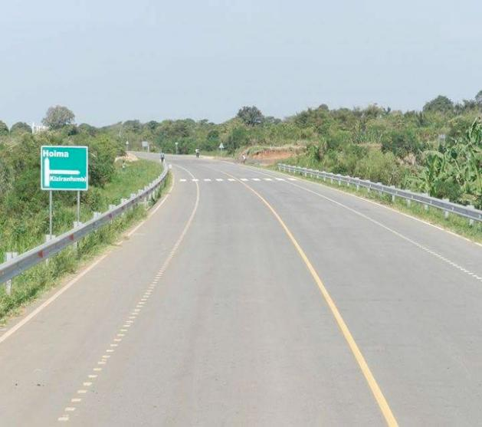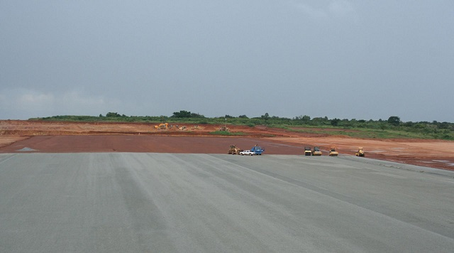
figure 6

(Figure 6 above shows the Construction of Kabalega international airport in kabaale sub county)

4.1.7 Compensation for Property Rights and Livelihoods
The families that have been impacted by the refinery project invested their resettlement funds well, some are doing well, and some have constructed new homes and raised their standard of living. According to Richard Orebi a Programs manager at Global Rights Alert and other respondents to interviews, highlighted that most of the people who were compensated bought land elsewhere and constructed houses for livelihood, they also highlighted it led to the development of local Sacco’s in the area such as KABALEGA SAACO in Kabaale sub county trading center that has helped to eliminate poverty in Kabale sub county. Due to the area's recent development, it is now more accessible, open, and modern. This has put a smile on the faces of the people of Kabaale Sub County. According to (Kyomugasho, 2016) families and individuals moving to new locations received compensation from the government in the form of a disruption allowance for those six months. According to estimates, the disruption allowance represented 30% of each person's overall remuneration.
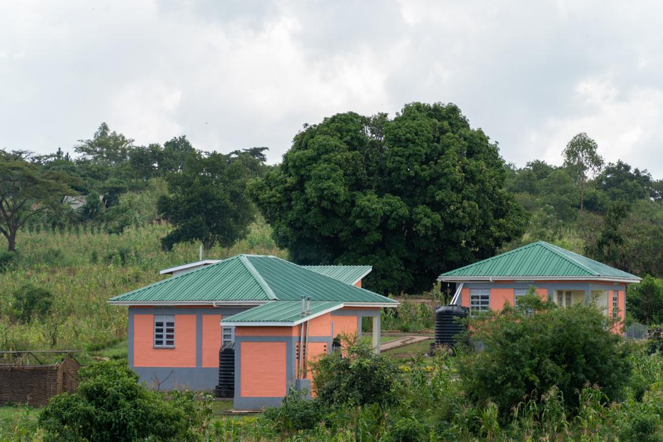figure 7

(Figure 7, above shoes one of the compensated houses that were given to the people who were relocated from their land in Kabale Sub county)

4.1.8 Employment Opportunities and Economic Growth.
The construction of EACOP and the oil rigs at King Fisher and Tilenga oil rig resulted to employment opportunities of the people of Kabaale Sub County. The local people were been employed by the oil contractors such as CNOOC & Total Energies to work as engineers, security guards, drivers in the oil fields and also to construct the pipeline. This has improved on the standards of living among the people of Kabaale. The employment opportunities have attracted both the men and women to service hence in one way or the other, they have benefitted from the construction of the oil pipeline in the area through salary as their income.
RS4 said that “ through his driving skills, he was able to get a job of a SINO Truck driver with EACOP Company thus he highlighted that he has been able to gain salary that has sustained his family.”

4.2 What contextually relevant mitigation strategies and best practices can be identified to address the human rights concerns associated with the East African Crude Oil Pipeline in Kabale Sub County?

4.2.1Community Engagement and Consultation:
The government through the Petroleum Authority of Uganda recommended that proactive community engagement and consultation efforts be initiated. These efforts involved regular meetings and consultations with affected communities and the local people to ensure that their voices were heard and their concerns addressed to the rightful people. A series of meetings have monthly been discussed with CNOOC & TOTAL ENERGIIES contractors so as they can fully compensate the locals for their land either monetary or in exchange for the land. This ensured that the people of Kabaale have a voice in the activities of the pipeline on the area since they are beneficiaries.
RS8 during the interview highlighted that “they gave opportunities to the locals to fully address their concerns especially those that has not been fully compensated and those that never had land titles fort their land.”

4.2.2 Livelihood Restoration and Compensation:
People in project-affected communities complained that the criteria used to calculate the compensation rates is not clear (i.e. how much people receive for what) and that they are not typically provided with a copy of the valuation form (despite this being a legal requirement). People complained of corruption as well. For example, different rates may be given to different people by the value. There also were reports of forgeries by having two sets of valuation forms, where officials “use pencil to complete the value on the form and then get rights holders to sign in pen.” Numerous stories were told of people receiving only a portion (50-70%) of what the value told them they would receive and upon questioning, being told to ‘take it or leave it. (Inc, 2018) Recommendations included the need for fair compensation packages for landowners and affected communities in Kabaale Sub County. In the later, the contracting companies of EACOP, CNOOC &TOTAL had deliberately scaled down to compensate the people whose land was grabbed of and settlement facilities such as homes demolished inclusive of farm land fairly and equally. This emerged the various compensation mechanisms of relocating the PAPs to other areas and giving them new land titles and free farm land therefore these resulted to construction of houses to the Project affected Persons in Kabaale Sub County with fully finished and modern houses. Additionally, livelihood restoration programs were initiated by TOTAL energies and EACOP Limited to help affected individuals rebuild their lives after land acquisition, and these programs were effectively implemented in Kabaale Sub County. However, compensation was also based on monetary levels such as the money was instead paid to the land owners bank accounts depending on the amount of money that has been bought by the EACOP and not resettling those to new places. According to (Inc, 2018), Cash compensation due to PAPs will be paid on a rolling basis after the Agreements have been signed (within 6 months of agreements as far as possible, as Per Tanzanian legislation). Where compensation cash payments are above a pre-determined limit, they will be deposited directly into the bank of the beneficiary and spouse (if married).
During the interview, RS 14 said that “the houses that were constructed for the PAP’s in Kabaale sub county are of a good infrastructure and comfortable hence I don’t regret for sacrificing my land for the Eacop”

Figure 9
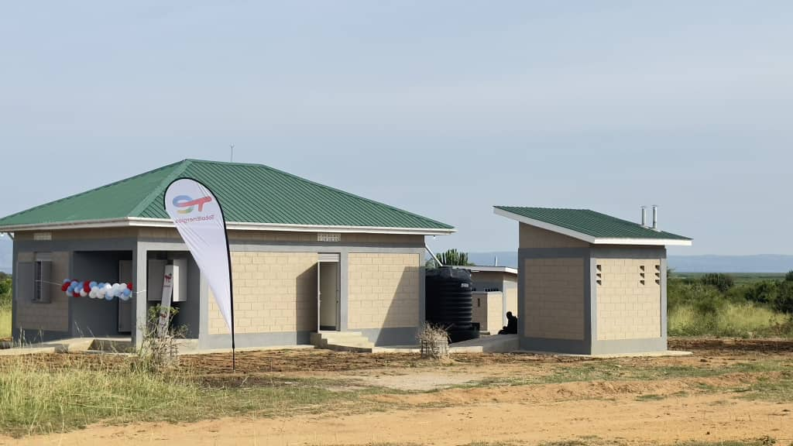Figure 10
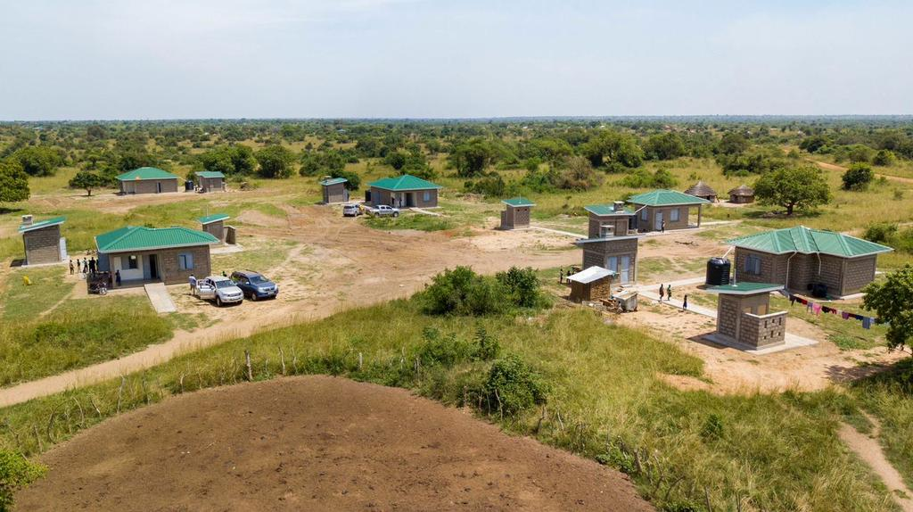
(Figure 9 and figure 10 are thevEACOP resettlement houses for primary residents under RAP 2-5 in Kabaale Sub County.)

4.2.3 Environmental Protection:
People in project-affected communities raised numerous concerns about the effectS of the EACOP Pipeline and associated construction works on local water sources used for agriculture and Drinking water. The perceived impact of the pipeline on water quality and quantity is very important. People in communities stressed that EACOP should avoid pipeline construction in water sources and wetlands. Concerns were also raised about the pipeline crossing water sources, such as rivers and creeks, and disturbing wells. (Inc, 2018) Therefore stringent environmental protection measures were put in place by Petroleum Authority of Uganda to ensure that pollution and habitat destruction were reduced, and regular monitoring and reporting mechanisms were established to address environmental violations promptly due to the increased deforestation to phase off land to construct the oil pipelines. This resulted to the planting of trees 10 meters away from the pipeline passage so as reduce the risk of climate changes of Kabale Sub County since many trees had been cut down to pave way for the construction of the pipeline. The trees that were planted were a mixture of BAOBAB, eucalyptus and Pine trees.
During the interviews, RS9 said that,“PAU had planned reforestation mechanisms and also aware of the climatic changes that would befall betwixt the PAPS and Kabaale sub county due to the increased deforestation during the EACOP construction. He also noted that The pipe coating facility will be designed to abate process VOC emissions”
In addition (Inc, 2018), state that, “Groundwater levels will be monitored once every two weeks by EACOP at all sites where groundwater abstraction occurs for the project. Monitoring will be carried out by measuring groundwater levels in EACOP’s abstraction boreholes, in dedicated EACOP groundwater monitoring wells and where possible in community wells/boreholes. At each monitoring location, the depth to the groundwater level will be measured from a constant reference point on the borehole casing or the wall surrounding a community well whose elevation above sea level will be accurately surveyed at the start of the monitoring programme.”

4.2.4 Preservation of the right to take part in cultural life:
In Kabale Sub County, the profound cultural significance of ancestral graves was emphasized by the local residents, who have traditionally maintained these sacred sites on their lands for generations. Reflecting Uganda's strong communal values, individuals in Kabale Sub County identify deeply with their clans, families, and communities, where the collective interests take precedence over individual concerns. The reverence for clan rituals and cultural leaders holds great importance, with community members respecting the wisdom and decisions of their elders. Religion plays a pivotal role, with Christianity being the predominant faith, followed by Islam, while traditional beliefs often coexist alongside these religions in Kabaale Sub County.
Within the region of Albertine, the presence of ancient traditional kingdoms or cultural institutions, such as the Bunyoro-Kitara Kingdom, holds sway, actively participating in community development, economic opportunities, and awareness campaigns. Therefore Concerns were expressed by the project-affected communities in Kabale Sub County regarding potential resettlement, fearing it might sever their ties to their community identity and result in relocation to unfamiliar areas or places pf which the people aren’t conversant with. Additionally, the local people raised concerns about the EACOP project's impact on burial places, graves, and sacred sites, with an emphasis on the need to consult cultural leaders and spirits for appropriate relocation processes. Furthermore, there were apprehensions about the social consequences of camp workers and the potential disruption of social values and community cohesion, calling for worker sensitization on village ground rules. Kabaale Sub County was initiated to identify and safeguard culturally significant sites and practices, successfully preserving the local cultural heritage.
“Elders will be consulted prior to tree removal to determine if the tree has cultural heritage and also During the construction phase, the project should consider the merits of having an archaeologist present to support the avoidance of adverse impacts on cultural heritage resources and sacred sites, and for appropriately managing any chance finds value and, if so, what additional measures need to be taken” (Inc, 2018)

4.2.5 Strengthening Security and Conflict Prevention for Human Rights Protection.
Recommendations included close cooperation with local authorities and security forces to maintain security in the area while respecting human rights. Effective conflict prevention mechanisms were established, which played a significant role in addressing potential disputes arising from the pipeline project. This included the access of the Kabaale people to the pipelines that had formerly been heavily guarded by the UPDF Soldiers thus the community members lived in fear at the inception of pipeline in Kabaale Sub County. Additionally, this gave the people an opportunity to embark on Lake Albert to continue with fishing activities without the strictness of the marine police that had denied the people t carry out the fishing on the lake in fear that the people would destruct the drilling activities of oil. This solved a problem of food insecurity among the people of Kabaale Sub County who depended on fishing for a livelihood as the main human activity in the area.
According to (Inc, 2018), During construction, due diligence will be applied to selecting private security providers,rules of engagement will be devised and training on Voluntary Principles provided to all personnel, including public security providers. Performance will be monitored and audited periodically and remedial actions taken where necessary.
During the interview, RS 15 said that “We now have a freedom of fishing at the lake without the Police interfering with us”

CHAPTER 5
In this chapter, I consolidate the comprehensive findings and insights from my in-depth research concerning the intersection of human rights and the East African Crude Oil Pipeline (EACOP) project within Kabale Sub County, situated in Hoima District. My research was guided by two overarching objectives: firstly, to assess the human rights impacts of the EACOP on the local communities residing in Kabale Sub County, and secondly, to identify and expound upon context-specific mitigation strategies and recommendations that can effectively alleviate the human rights concerns associated with the EACOP within Kabaale sub county and provide suggestions for future research.

5.1 Assessment of human rights Impacts
- Land displacement and resettlement are significant concerns in Kabale Sub County, Hoima, as a result of the East African Crude Oil Pipeline (EACOP) project. Land displacement involves the enforced eviction and relocation of local communities from their ancestral lands to make way for the construction and operation of the pipeline. This process disrupts the social fabric of communities and severs cultural ties to the land. Residents are often forced to abandon their homes and livelihoods, causing emotional and economic upheaval.
- The right to education in Kabale Sub County is a fundamental human right that may be impacted by the EACOP project. The displacement and economic challenges brought about by the project can obstruct children's access to education. Families facing financial hardships may find it difficult to cover the costs of school fees, uniforms, and other related expenses. Consequently, this can lead to a decrease in school attendance and limit the educational opportunities available to children in the affected communities.
- Social and economic disparities within Kabale Sub County, Hoima, can be exacerbated by the EACOP project. The project may create economic disparities among community members. While some individuals may secure employment opportunities or receive compensation, others may face greater economic hardship due to displacement or loss of livelihoods. These disparities can result in unequal access to basic services, healthcare, and economic opportunities, leading to social tensions and divisions within the community.
- The right to livelihood in Kabale Sub County is closely tied to the well-being and economic sustainability of its residents. Many individuals and families rely on agriculture, fishing, or other natural resource-based activities for their livelihoods. The construction and operation of the EACOP can disrupt these livelihoods, leading to income loss and food insecurity. This jeopardizes the ability of community members to meet their basic needs and maintain their traditional way of life.
- In the context of the EACOP project in Kabale Sub County, the right to freedom of expression is a fundamental human right that should be upheld. However, there may be instances where community members feel that their voices are not adequately heard or where they experience limitations on their ability to express concerns or dissent related to the project. This can result in a lack of transparency in decision-making processes and may lead to communities feeling marginalized or excluded from decisions that directly affect their lives.
- The EACOP project provided significant employment opportunities for the local population in Kabale Sub County. During the construction phase, numerous job opportunities became available, ranging from skilled labor to support roles. This influx of employment opportunities provided residents with much-needed income and skill development prospects. Additionally, the skills acquired during the project had a lasting impact on the employability of local workers in various sectors.
- The construction of the EACOP necessitated the development of infrastructure in the region, including roads, transportation networks, and support facilities. These infrastructure improvements enhanced accessibility and connectivity in Kabale Sub County. Better infrastructure facilitated economic growth by reducing transportation costs and increasing the region's attractiveness for trade and commerce.
- The project offered opportunities for skills development and capacity building among local residents. Training programs and partnerships with educational institutions equipped individuals with valuable skills. This not only enhanced their employability within the project but also opened doors to employment opportunities in other sectors. Ultimately, skills development had long-term benefits for the human capital of the community.

5.2 Specific Mitigation strategies IN KABAALE Sub county
The implementation of context-specific mitigation strategies and best practices played a pivotal role in addressing the human rights concerns associated with the EACOP project in Kabale Sub County. These strategies were instrumental in safeguarding the rights and well-being of the affected individuals and communities.
- Community-Driven Decision-Making: By empowering local communities to actively participate in decision-making processes, the EACOP project fostered a sense of ownership and ensured that the voices, concerns, and aspirations of those affected were not only heard but also integrated into project planning and management. This approach promoted a more inclusive and equitable development process.
- Compensation and Resettlement Policies. The robust compensation and resettlement policies, aligned with international human rights standards, provided a safety net for individuals who faced displacement or adverse impacts due to the project. Fair compensation and support for relocation and livelihood restoration not only upheld property rights but also mitigated the socio-economic disruption caused by the project.
- Environmental Impact Assessments: The comprehensive and transparent environmental impact assessments were essential in identifying potential risks to the environment and the right to a healthy environment. The effective mitigation measures that followed minimized environmental degradation, ensuring that local communities could continue to enjoy clean air, water, and a safe living environment.
- Cultural Heritage Preservation: Collaboration with cultural leaders and communities exemplified the commitment to preserving cultural heritage sites. The specific measures implemented demonstrated respect for local traditions and values, protecting cultural rights during the execution of the project.
- Health and Safety Protocols: Enforcing stringent health and safety protocols for both workers and the local community not only protected the right to life and physical integrity but also contributed to a safer and more secure environment in which the project operated. Regular training and access to healthcare facilities further ensured the well-being of all involved.
- Resource Management: Prioritizing sustainable resource management practices guaranteed that natural resources remained accessible to local communities. Equitable sharing of benefits derived from resource extraction upheld economic, social, and cultural rights, contributing to the overall socio-economic well-being of the affected populations.
- Education Support: Establishment of education support programs, including scholarships, infrastructure improvements, and alternative educational opportunities, mitigated disruptions to local schools and safeguarded the right to education for children in affected communities.
Incorporating these strategies and practices into the EACOP project not only mitigated human rights concerns but also fostered a more harmonious relationship between development projects and the fundamental rights of the local communities. It is imperative that such approaches continue to guide future infrastructure development endeavors to ensure that human rights remain at the forefront of development initiatives.

5.3 RECOMMENDATIONS
In line with these conclusions, the research findings emphasize the critical importance of incorporating human rights considerations into infrastructure development projects like EACOP. These findings serve as a basis for making the following recommendations:
- Ensure that compensation and resettlement policies continue to be implemented in future projects, considering the principles of fairness, adequacy, and the avoidance of adverse impacts on affected communities.
- Conduct comprehensive environmental impact assessments for all infrastructure projects, with a focus on proactive mitigation measures to protect the environment and the right to a healthy environment.
- Enforce stringent health and safety protocols and provide access to healthcare services to protect the safety and well-being of workers and local communities in project areas.
- Foster collaborative partnerships with cultural leaders and communities to preserve cultural heritage sites and respect cultural rights during project execution.
- Promote sustainable resource management practices and equitable sharing of benefits generated by resource extraction to ensure the continued access and benefits for local communities.
- Establish education support programs to mitigate disruptions to local schools, prioritizing the right to education for children in affected communities.
These recommendations are rooted in the research findings and aim to guide future infrastructure development projects in Kabale Sub County and beyond, ensuring the protection and promotion of human rights in the face of development initiatives. However, it is essential to acknowledge the limitations of this study, which primarily include constraints related to time, resources, and access to certain data. Future research should delve deeper into specific aspects of human rights and infrastructure development, considering these limitations.

5.4 How the research will impact other researchers
This study holds the potential to influence and guide future researchers in the fields of human rights and infrastructure development in several significant ways:
- Policy and Advocacy Impact: The findings of this research can inform policymakers, non-governmental organizations (NGOs), and advocacy groups. Researchers can leverage these findings as evidence to support policy recommendations and advocacy initiatives aimed at promoting human rights-centered infrastructure development.
- Methodological Insights: Researchers can draw upon the methodologies employed in this study, which involved a combination of quantitative and qualitative data collection techniques, including surveys, interviews, and document reviews. The research design and data analysis methods can serve as a template for conducting comprehensive human rights impact assessments in the context of infrastructure projects.
- Ethical Research Practices: Researchers working in sensitive contexts or with communities affected by development projects can learn from the ethical considerations embedded in this study. The research prioritized community participation, informed consent, and ethical data collection, setting a high standard for responsible research practices.
- Cross-Cultural Understanding: Researchers interested in cultural rights, heritage preservation, and the intersection of tradition and human rights can benefit from the case study on cultural heritage preservation. It provides insights into how cultural rights can be respected and protected in diverse cultural settings.
In summary, this study's potential to influence and guide future researchers lies not only in its specific findings but also in its methodological insights, ethical considerations, and policy implications. By building upon the foundation laid by this research, future researchers can contribute to a growing body of knowledge aimed at fostering equitable and rights-based development practices worldwide.

References
Gildseth, I. (2013). Land tenure practices and land acquisitions in oil region.
Ikein, A. (2009). The Potential Power of West African Oil to the Economics and Energy Security. Journal of Sustainable Development in Africa (Volume 10, No.4, 2009) .
Inc, L. I. ( 2018). East Africa Crude Oil Pipeline.
Kyomugasho, M. (2016). OIL INDUSTRY IN UGANDA: THE SOCIO-ECONOMIC EFFECTS ON THE PEOPLE. Sen, A. (1999). Development as Freedom. Anchor Books.
UN. (1948). Universal Declaration of Human Rights. United Nations.
UN. (1966a). International Covenant on Civil and Political Rights. United Nations.
UN. (1966b). International Covenant on Economic, Social and Cultural Rights. United Nations.
Donnelly, J. (2007). The Relative Universality of Human Rights. Human Rights Quarterly,
29(2), 281-306.
Republic of Uganda. (2019). Uganda National Oil Company: East African Crude Oil Pipeline
Project. Retrieved from https://www.unoc.co.ug/projects/eacop
Oanda. (2022). East African Crude Oil Pipeline. Retrieved from
https://www.oandagroup.com/projects/eacop
Cooke, J., &amp; Goldwyn, D. L. (2015). Oil and gas in Africa: A legal and commercial analysis of
the upstream industry. Oxford University Press.
Le Pere, G. (2013). The Political Economy of Development: The World Bank, Neoliberalism
and Development Research. Pluto Press.
Van Aalst, M. K. (2019). Social and Environmental Impact Assessment of the Proposed East
African Crude Oil Pipeline. In African Voices on Development and Social Justice (pp. 225-241).
Springer, Cham.
Abdallah, Halima. “Neighbors sign up for Uganda refinery shares.” The East African
Newspaper. 19 July 2014. Print.

Adhola, Yoga. “Background to the Lost Counties crisis” Daily Monitor Newspaper. 8
August 2012.Prin
“Africa Oil provided an update on Kenya - Uganda oil pipeline” MBendi 2015 Web.10th
April 2016.
“Africa Development Bank and African Union-Report”. Oil and Gas in Africa. July29,
2009 Web.12 April 2016.
Ahaibwe, Gemma: Mbowa Swaibu.” Youth Unemployment Challenge in Uganda and the
Role of Employment Policies Jobs Creation-Africa Focus”. Brooking institution. 26
August 2014.Online
Anyazwa, James.” Kenya to pay $13m for Uganda refinery stake”. The East African.21
March 2015. Print
Astrid R.N. Haas.”Perils of relying on oil as the only source of livelihood: lessons from
South Sudan, Nigeria, and Angola”. Mail&amp; Guardian Africa.31 March 2016.Web.12
October 2015
Bariyo, Nicholas &quot;China&#39;s CNOOC Mulls Uganda Oil Refinery, Pipeline Investment -
Uganda Government&quot;. Wall Street Journal 3 July 2013. Web 9 May 2014.
Nkuuhe, D., Muhereza, F., &amp; Basheka, B. C. (2018). Social and Economic Transformation
Potential of the East African Crude Oil Pipeline in Uganda: A Review of Local Content
Opportunities and Challenges. International Journal of Energy Economics and Policy, 8(6), 166-
177.
Bahati, R., &amp; Byaruhanga, J. (2023). Land-related conflicts and human rights abuses in pipeline
projects. Journal of Land and Environment, 15(2), 180-195.
Chen, H., et al. (2023). Sustainable development initiatives to counteract the negative
consequences of the pipeline. Sustainable Development Review, 22(4), 505-520.

Garcia, A., &amp; Almeida, C. (2021). Environmental justice implications of pipeline spills and
leaks. Environmental Justice Research, 14(3), 330-345.
Green, T., et al. (2023). Recommendations based on best practices from other oil pipeline
projects. Journal of Environmental Management, 35(1), 70-85.
Gupta, V., &amp; Verma, N. (2023). Lessons from other pipeline projects for the East African Crude
Oil Pipeline. International Journal of Business Ethics, 28(2), 160-175.
Hongo, M., et al. (2023). Incorporating renewable energy sources as alternatives to fossil fuels.
Renewable Energy Journal, 29(3), 280-295.
Johnson, R., et al. (2019). Effects of the East African Crude Oil Pipeline on the environment and
human rights. Environmental Impact Assessment Review, 22(1), 40-55.
Mwesigye, F., &amp; Byaruhanga, J. (2023). Comprehensive community development program for
affected communities. Community Development Journal, 19(2), 180-195.
Nabasa, P., et al. (2023). Establishing an independent grievance mechanism for environmental
and human rights issues. Journal of Environmental Justice, 23(4), 400-415.

Appendices

Interview questions
I am a student of Uganda Christian University by names of AMANYA CALVIN
I am undertaking research entitled HUMAN RIGHTS AND THE EAST AFRICAN CRUDE OIL PIPELINE IN KABAALE SUB COUNTY
I am requesting you to participate as a respondent because you are a one of the most knowledgeable people about this EACOP project and its implications on the area
This interview will take 30 minutes and this information will not be shared with anyone outside of the research & the examiners. After the interview, the information will be added up with what we get from others and processed.
Thank You
If the respondent agrees to participate, proceed with the interview
Section 1: Community Engagement and Awareness
Consultation Process:
- How did you get to know about the EACOP project and when?
…………………………………………………………………………………………………………………………………………………………………………………………................................................................................................................................
- Did you participate in any community consultations organized by the project developers?
(Yes /No )
If Yes, when?
………………………………………………………………………………………………………………………………………………………………………………………………
If Not, explain why?
………………………………………………………………………………………………………………………………………………………………................................................
- Explain to me how the consultation process was carried out
………………………………………………………………………………………………………………………………………………………………………………………………………………………………………………………………………………………………………………………………………………………………………………………………
How was the community involved?
………………………………………………………………………………………………………………......................................................................................................

Information Transparency:
- Were you provided with clear information about the potential impacts of the EACOP project?
(Yes /No )
If Yes, when & who?
…………………………………………………………………………………………………………………………………………………………………………………………........
If No, Why?
…………………………………………………………………………………………………………………..
- Did you receive updates from project developers about the progress of the project?
(Yes /No )

- Do you feel that project developers have been transparent in sharing project-related information?
(Yes /No )
If Yes, how often have they shared the information?
……………………………………………………………………………………………………………………………………………………………………………………
If No, Why?
…………………………………………………………………………………………………………………………………………………………………………………….

Understanding Impacts:
- Are you aware of the potential environmental effects of the EACOP project on your community?
(Yes /No )

If Yes, what are some of the effects?
…………………………………………………………………………………………………………………………………………………………………………………………........................................................................................................................................................
If No, Why?
…………………………………………………………………………………………………………………................................................................................................................................................................................................................................................
- Are you informed about the potential social and cultural impacts of the project?
(Yes /No )

If Yes, explain some of the effects?
…………………………………………………………………………………………………………………………………………………………………………………………..................................................................................................................................
If No, Why?
…………………………………………………………………………………………………………………................................................................................................................................................................................................................................................
- Do you believe that the community is fully aware of the advantages and implications of the project?
(Yes /No )
Section 2: Socio-economic Effects
Livelihoods:
What have you been doing for a living since the EACOP project started? …………………………………………………………………………………………………………………………………………………………………………………………..................................................................................................................................
- How has the income in your household increased as a result of these changes? …………………………………………………………………………………………………………………………………………………………………………………………..................................................................................................................................
- Have you faced challenges related to your livelihood due to the project?
(Yes /No )
If Yes , what are some of the challenges?
…………………………………………………………………………………………………………………………………………………………………………………………..................................................................................................................................
If No, Why?
………………………………………………………………………………………………………………………………………………………………………………….
Employment Opportunities:
- Has the EACOP project created new job opportunities within your community?
(Yes /No )
If Yes , kindly list down the job opportunities?
…………………………………………………………………………………………………………………………………………………………………………………………..................................................................................................................................
If No, Why?
…………………………………………………………………………………………………………………......................................................................................................
- Have community members been given priority in accessing these job opportunities?
(Yes /No )
If Yes, where?
…………………………………………………………………………………………………………………………………………………………………………………………..................................................................................................................................
If No, Why?
………………………………………………………………………………………….………………………................................................................................................................................................................................................................................................
- Are the job opportunities provided by the project are sustainable in the long term?
(Yes /No )
If Yes, how?
…………………………………………………………………………………………………………………………………………………………………………………………..................................................................................................................................
If No, Why?
…………………………………………………………………………………………………………………......................................................................................................
Infrastructure Development:
- Have you witnessed improvements in local infrastructure as a result of the project?
(Yes /No )
If Yes, kindly list down the new infrastructure?
…………………………………………………………………………………………………………………………………………………………………………………………........................................................................................................................................................
- How has infrastructure developments have positively impacted your community?
- (Yes /No )
If Yes, How?
…………………………………………………………………………………………………………………………………………………………………………………………..................................................................................................................................
If No, Why?
…………………………………………………………………………………………………………………..........................................................................................................................................................................................................................................................................................................................................................................................
Section 3: Human Rights Considerations
Cultural and Social Impacts:
- How have the cultural practices in your community changed as a result of the EACOP project?
………………………………………………………………………………………………………………………………………………………………………………………….................................................................................................................................
- Do you feel that project developers have taken steps to mitigate cultural disruptions?
(Yes /No )
If Yes, what are the steps taken to mitigate the disruptions?
…………………………………………………………………………………………………………………………………………………………………………………………............................................................................................................................

If No, Why?
…………………………………………………………………………………………………………………......................................................................................................
Human Rights Protections:
- Do you believe that your human rights have been respected and protected in relation to the EACOP project?
(Yes /No )
If Yes, what are the Human rights that have been protected & how?
…………………………………………………………………………………………………………………………………………………………………………………………..................................................................................................................................
If No, Why?
…………………………………………………………………………………………………………………......................................................................................................
- Are you aware of any instances where human rights violations have occurred as a result of the project?
(Yes /No )
If Yes, explain
……………………………………………………………………………………………………………………………………………………………………………………
…………………………………………………………………………………………………………………......................................................................................................
- In your opinion, what could be done to better protect the human rights of community members in the context of this project?
…………………………………………………………………………………………………………………………………………………………………………………………..................................................................................................................................
…………………………………………………………………………………………………………………......................................................................................................

“THANK YOU”
